Contents

1. **Analysis** **5**
   1. Game Elements 5
      1. The Idea 5
      2. Currency 6
      3. Death Screen 7
      4. Boss at the end of the game 8
   2. The problem identification background 9
   3. Objectives 11
   4. Research 13
      1. Interviews/ surveys 13
      2. Technical Skills 13
      3. Research Table 13
   5. Storyboard 16
2. **Design** **17**
   1. Design introduction 17
   2. Hierarchy chart 19
   3. Non-Standard Algorithms using Code or pseudocode/Technical skills 19
      1. Collisions 20
      2. Character Movement 21
      3. Attacking Basics 21
      4. Health Basics 22
      5. Basic Sound Effects 23
      6. Implementing Items 24
      7. Making An Inventory 24
      8. Picking up Items 25
      9. Implementing Enemies 27
      10. Enemy Movement 28
      11. Improved Sound Effects 28
      12. Implementing a boss 29
      13. Ranged Attacks 31
      14. Shop 32
      15. Addition to Ranged Attacks 33
      16. Game leaderboard 34
      17. Addition to Ranged attacks 38
      18. Animating Enemy Movement 38
      19. Implementing Inheritance 40
      20. Updated Character Movement 42
      21. Optimisation 42
      22. Game Menu 42
      23. Sound controls 43
      24. Optimisations / QOL improvements 44
      25. Updated character movement 48
      26. Variable optimisations 50
      27. Better boss mechanics 50
      28. Dungeon map 53
      29. New items in shop 53
      30. Addition of external library to enhance game animations 54
      31. Randomly generating a dungeon map 56
      32. Navigating the dungeon 58
      33. Updating enemies and items to work with new map 58
      34. Dynamic background generation 60
      35. Further optimizations 61
      36. Creating the mini map 61
      37. Addition of map to the shop 64
      38. Room indicator on the map 65
      39. Updated menu design 66
      40. Ability to use items by clicking on them 68
      41. Improved character name submission 69
      42. Adding inheritance to all classes 69
      43. Updating enemy animation 70
      44. Updating checkCollision procedure 74
      45. Restricting login names to only characters 74
      46. Attack Handler optimization 75
      47. Death Screen 77
      48. Item Description & improved inventory functionality 80
      49. itemInformation bug: 83
      50. Attack handler bug: 83
      51. map generator addition: 84
      52. Updating scores in the database: 84
      53. Restart feature 86
      54. Inventory enhancements 87
   4. Object diagrams and class definitions 89
   5. Design data dictionary 90
   6. data structures 94
      1. 1 Dimensional arrays 94
         1. FireBlast - Boss attack 94
         2. FireCircle - Boss attack 95
      2. 2 Dimensional arrays 96
         1. Dungeon Map 96
         2. Scoreboard 96
         3. Inventory 98
      3. Dynamic arrays 98
         1. Backgrounds 98
         2. Enemies 100
         3. Items 101
         4. Inventory 102
         5. MapPieces 103
         6. Magic 105
         7. FireBalls 105
         8. Base_Class 106
   7. Queries 107
      1. Retrieving and displaying data from a table 107
      2. Inserting, updating or deleting data from the table 107
3. **Testing** **109**
   1. Test Table 109
   2. Image reference table 112
4. **Evaluation** **121**
   1. Scoreboard 121
   2. Game Intuitivity 121
   3. Random generation of items, enemies and the map 121
   4. Character’s attacks 121
   5. Character animations 121
   6. End game boss room 121
   7. Range of sound effects 122
   8. Arcade style leaderboard 122
   9. Menu before the game 122
   10. Animate enemy movements 122
   11. Dungeon room design 122
5. **Improvements** **122**
6. **Code** **122**
   1. The_Lost_Dungeon 123
   2. Base_Class 200
   3. Backgrounds 203
   4. Enemy 204
   5. Fireballs 205
   6. Inventory 205
   7. Items 206
   8. Magic 207
   9. MapPieces 207
   10. Style.css 208

# Analysis

### Game Elements

To get an idea of what should be in the game i’m going to research similar games to get an understanding of what aspects i should have in my game.

#### The Idea

Inspiration for the game being a dungeon crawler and the map style comes from binding of isaac.

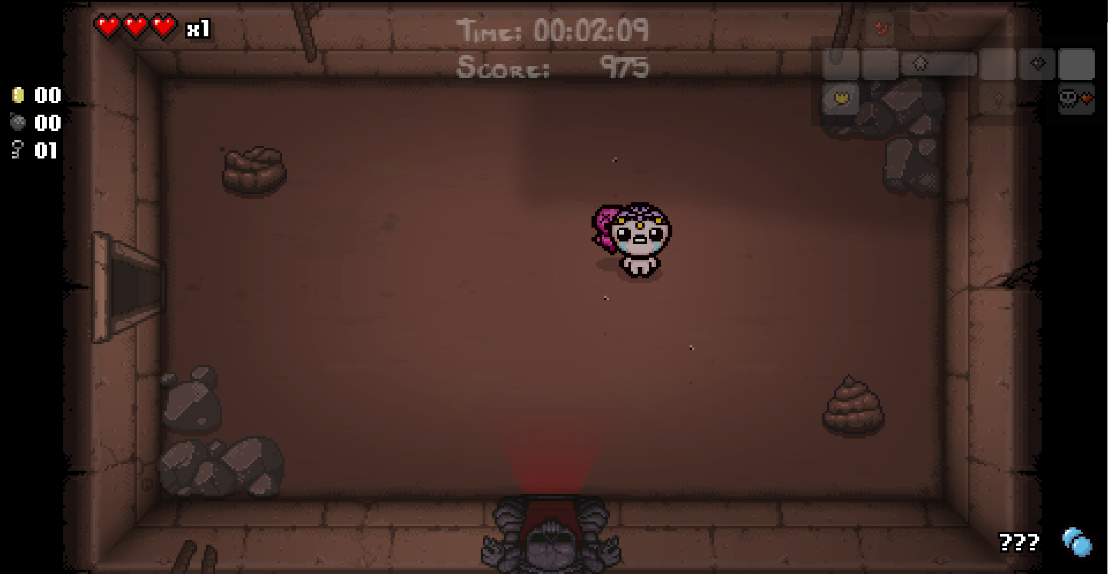

In binding of isaac the rooms fill the screen and when you interact with a door it near instantly changes the layout to that of the next room.

In contrast to welcome to the dungeon where the rooms are connected via corridors cluttered with destructive junk.

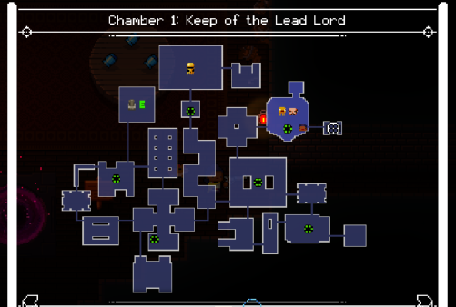

I chose to follow through on the binding of isaac method as it allows you to instantly go from room to room and stay in the action.

#### CurrencySee the source image

Currency is an important part of the game, it allows the player to buy items that give them a strategic edge over the enemies and perform better. The Binding of Isaac and Welcome to the Gungeon both have currency and a way to spend it. In the starting floors of binding of isaac, money drops irregularly with little purpose to begin with; as the shops will contain items you cannot yet afford due to them being too expensive.

Here you can see in the actual game, in which a player has 1 coin and cannot buy anything in the shop.

Welcome to the gungeon is much different, the enemies come in waves resulting in 5-10 enemies per room that results in a lot of the game currency. This allows the player to always afford something in the shop.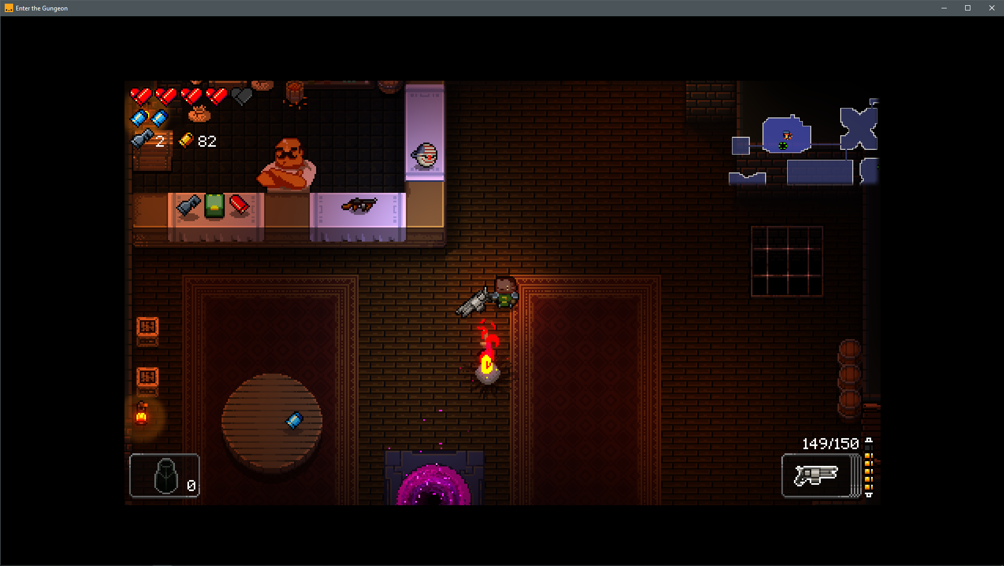

Here you can see a player with 82 currency in the level 1 store. This allows the player to have a greater choice when it comes to purchasing.

I have chosen to emulate welcome to the gungeon and give the player 1 coin every time an enemy is defeated. This is because there are now 3 items in my shop totalling 12 coins needed, generally my map generates with less than 12 enemies, this allows the player to always afford something but not everything.

#### Death Screen

In all dungeon crawler games and to an extent all games have a summary screen for when the character dies.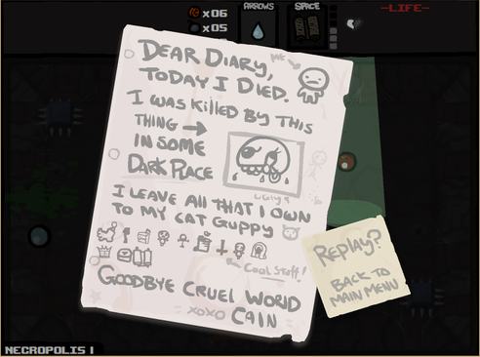

Binding of Isaac's death screen. As you can see it shows the enemy that killed and all the items that the character had on them.

What i like about this death screen is the juvional nature of it which helps release tension when you die in the fast paced game.

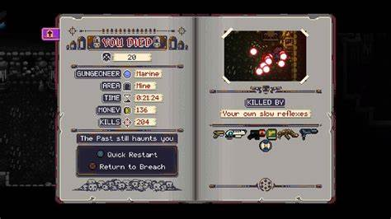

Welcome to the gungeon death screen. This death screen shows more information than most of the other death screens.

Another good example of a dungeon crawler is a game called nuclear throne, its death screen is fairly similar.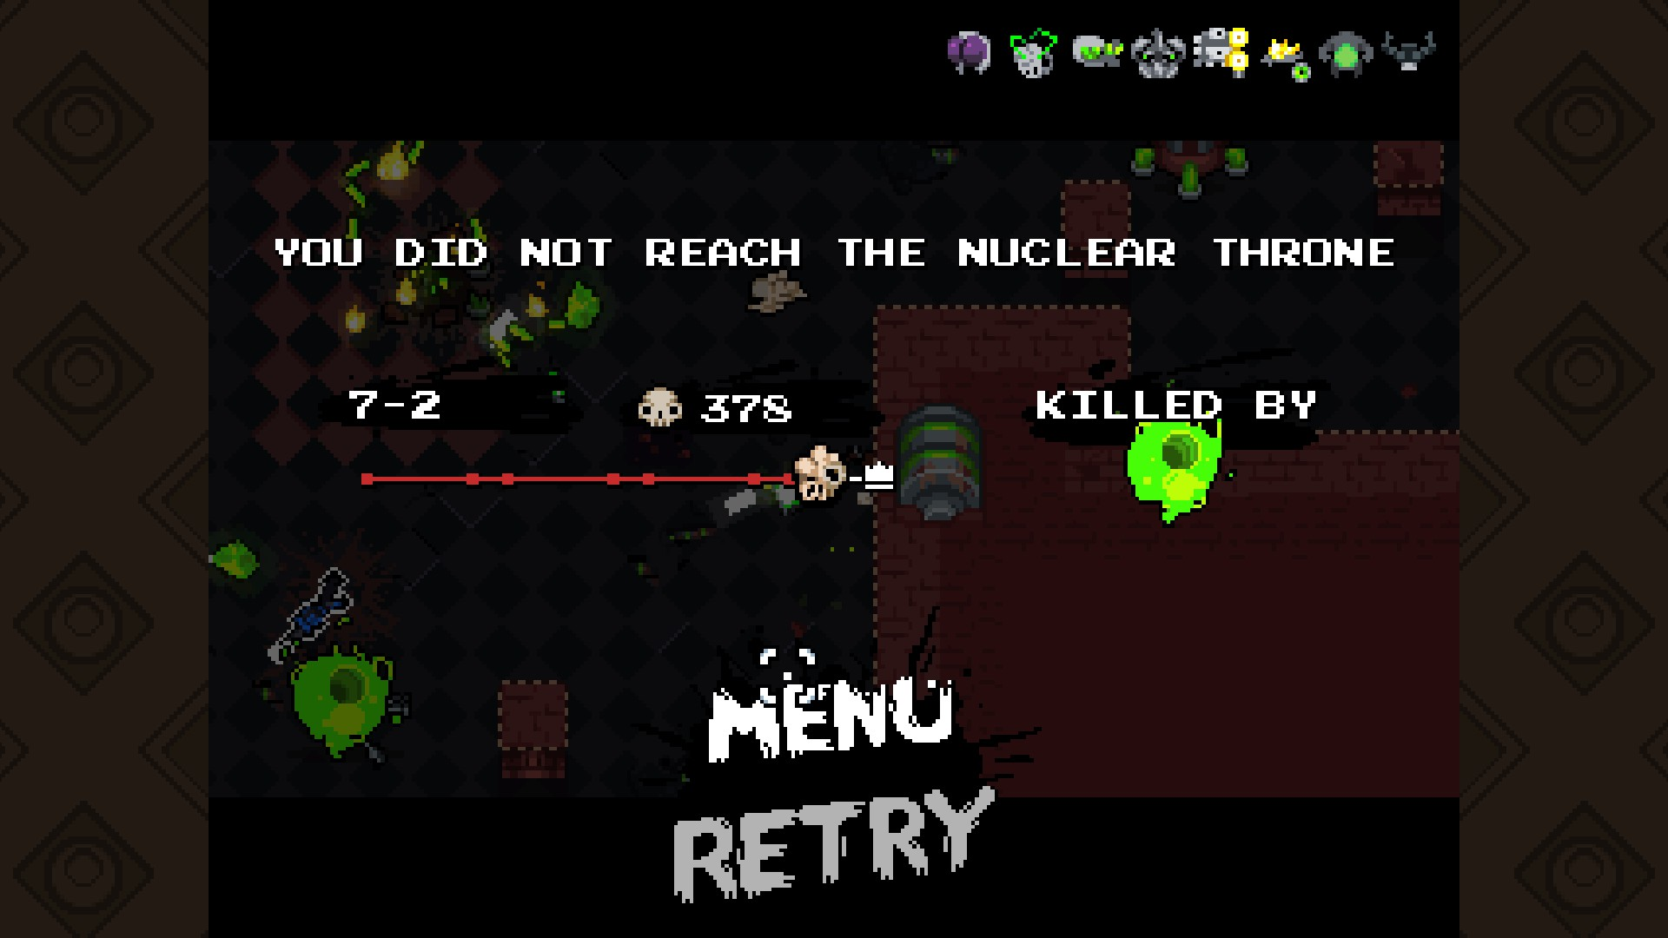

The nuclear throne death screen features a short message, what enemy killed the character and how close they were to completing the game.

For my game's death screen I plan to show what enemy killed the character, the characters items, their score and how many enemies they defeated.

#### Boss at the end of the game

In dungeon crawler games when you reach the end of a level you would be met with a boss or a large number of enemies that you must defeat to carry on

Binding of Isaac: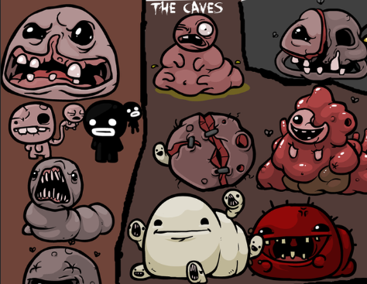

Cave Blazers:



While it would be interesting to try and implement and animate a boss of this complexity I decided to revisit the enemy sprite sheet I found and an enemy that is encountered towards the end of the game.

As for its attacks, I stuck to the enemy's original attacks of shooting one fireball but when phase two happens, it takes the attacks of a boss from the zelda NES game, which my sprites are from. In which three fireballs are shot at an angle. I also added the defensive move to make it more challenging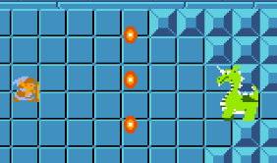

## The problem identification background

After researching similar games e.g. The binding of Isaac, Cave blazers and Welcome to the Gungeon. I had a list of fundamental aspects of dungeon crawler games that I aimed to implement into my game.

1. **Movement:** for movement controls, I looked towards the game Cave blazers, In cave blazers, the arrow keys are used for moving the characters and W, A, S and D are used to shoot arrows and throw items. This combination of the W, A, S and D paired with the arrow keys is an industry-standard for games.
2. **Melee attacks:** in my game, I plan to have both Melee and ranged attacks. As binding of Isaac only has Ranged attacks and Cave blazers use the CTRL button to attack which I felt was strange at first; I decided to use SPACE for melee attacking as it's easily accessible and in the game, there is no need to jump as you are looking down on the rooms.
3. **Ranged attacks:** for ranged attacks i plan to use W, A, S and D to shoot magic projectiles at enemies. I have chosen these keys as they are standardly used in games. When the inventory is open these keys will be used to select items but when the inventory is closed they will direct projectiles.
4. **Interacting with objects:** As most dungeon crawler games are fast-paced and you need to be quick to survive; E is a quick and easy choice to interact with items as the E key is close to W, A, S and D which are used for movement.
5. **Inventory:** Because I wanted my game to have an inventory that can hold items found in the dungeon I turned to Cave blazers and copied the way its inventory works and the controls used for the inventory, which are TAB to open and close it as well as W, A, S and D to choose what item to select.
6. **Music & Music controls:** In my game, I plan to have music which means I need a way to control it. to mute the music I plan to use M and to increase or lower the volume I'll use PLUS and MINUS. I’m giving the user music controls from computer to computer the sound volumes seem to change so i'll allow them to change I to a point that suits them.
7. **Dungeon Rooms:** In the binding of Isaac and Welcome to the Gungeon, the dungeon is split into rooms separated by doors that only open when all the enemies are defeated. I found that this style of dungeon is still fast-paced but it lets you breathe when you conquer a room. For the actual backgrounds of my game, I’m going to use the room and doors images that are used in the Binding of Isaac.
8. **Enemies:** in all games researched there are enemies; Without enemies the game would be dull and without challenge. In most of the games researched there would be dozens of enemies in the game and two or more enemies per room. While it would be possible to have multiple enemies in a room, it would be challenging for the player to engage with them given the game controls enemies AI; for this reason i will only have one enemy per room.
9. **Boss:** in all the games mentioned above; at the end of every floor/part of the game there is a boss that you must defeat to progress further into the dungeon. In my game the entrance to the boss room will be an ominous looking door and fast, high paced music, inside there will be a powerful enemy with a lot more health than the other enemies on that floor and typically once defeated the player will be rewarded with an item to make them stronger for the next part of the game; but as my game will only have 1 floor, this boss is the final boss and defeating it end the game.
10. **Arcade-style:** For the scoreboard, I have decided on an old Arcade-style approach. When the game starts you will enter your name and then be shown the current leaderboard which will contain the top 10 scores. When the player beats the game, their score will be saved to the SQL database and if it's good enough it will be shown on the leaderboard next time the program is run.
11. **Suttle details:** In dungeon crawler games the rooms are far from being static. In Welcome To The Gungeon, every room and corridor is cluttered with stacks of books, boxes and paintings that can be destroyed. In Binding Of Isaac some rooms have flies only a few pixels big that fly around as well as patches of grass that blow in the wind and campfires or rocks that can be destroyed to get items and even a subtle flashlight effect that moves with the character. These kinds of small details make the dungeon feel more alive which is something I want to emulate in my game.
12. **Roguelike:** Roguelike is a subgenre of dungeon crawler games, which makes it something I should look closely at. For a game to be roguelike there are certain criteria that the game needs to meet; this includes a randomly generated maze, permadeath (death resets you back to the beginning, nothing can be brought through to the next play of the game) and constantly being under bombardment by enemies. I plan for my game to meet this criteria.

For the game, the end-user would be other people that play these kinds of games.

Now that I have a list of fundamental aspects; i will break them down further to see what needs to be done and to track the progress of these elements.

## Objectives

1. The database will only hold 10 scores at a given time and only show those 10 on the scoreboard.
   1. SQL queries will be used to make this possible, You should be able to:
      1. Retrieve scores
      2. Update scores
      3. delete scores
2. The game should be intuitive and easy to grasp.
   1. Arrows are used for movement.
   2. W, A, S and D for ranged Attacks.
   3. Space for melee attacks.
   4. TAB for inventory.
   5. E to interact.
3. Enemies, items and to a certain extent; the map should be randomly generated every time the code is run.
   1. 1 enemy per room. (excluding shop and boss room)
   2. 1 item per room.
   3. The map will contain a Shop and a Boss room.
   4. Map in the top right corner so the player can navigate.
4. The character should have ranged and melee attacks.
   1. melee attacks will be sword-based.
   2. ranged attacks will be staff based.
5. The character should have animations and sound effects for almost everything they do, to help with immersion.
   1. Walking and attacking in each direction.
   2. Melee and ranged attack animations.
6. Create a boss room that contains a powerful enemy to end the game.
   1. Have a large health bar at the top (same as the binding of Isaac).
   2. Boss should have multiple attacks to challenge the player.
   3. Should be a reward for defeating the boss (all games researched have that).
7. Have a wide range of sound effects and music tracks for:
   1. attacking.
   2. walking.
   3. Background music.
   4. Boss room music.
8. Have an Arcade style leader board in the game.
   1. SQL database will keep the name and score of the players
      1. Name will be kept so that players get recognition for getting on the leaderboard
      2. Score will be kept so that the leaderboard can be sorted by score; Highest at the top and lowest at the bottom.
   2. The leader board will show the player's rank, name then score.
9. Have the main menu that would start and game and not just throw the player in.
   1. Instructions and keyboard controls.
   2. Their name will be entered here for the leaderboard.
10. Animate enemy movements just like the character.
    1. Enemies should be animated when they move towards the player.
11. Each room will have a slightly different background.
    1. backgrounds should have shader overlays for ambience.
    2. backgrounds will be randomly chosen between multiple options.

## Research

### Interviews/ surveys

When interviewing a pupil in year 13 I told them the current objectives and they had a few suggestions, such as an Inventory that can hold items, items that appear in rooms and then can be used whenever the player wants to. Another suggestion is a start menu that appears and the game starts when the user presses a button.

### 

### Technical Skills

A big part of all games is the physics engine that primarily deals with collisions as they are a fundamental part of any game. When I first tried to make a collision detector, I started with a coordinate system that fell short but this led me to find the intersects method which is exactly what I need and I plan to use it in the main code to detect when two images are overlapping.

While researching characters for the game I decided on an 8-bit Link from the Legend of Zelda game, I chose Link because his sprite sheet (an image that contains the character in all positions) is easy to get images from and then animate them. For the player to appear animated I will set different images to the player node when necessary.

It wouldn’t be a game without enemies for the hero to defeat. To do this I found a sprite sheet of all the 8-bit enemies used in the original Zelda game and I plan to implement them and have the hero defeat 6-7 enemies and then defeat a boss to complete the game.

While developing the game I plan to have a fixed map to test the functionality of the features I add. I then plan to make an algorithm to randomly generate the map and bring that algorithm into the main project and update all the current code to properly work with it.

### Research Table

|  |  |  |  |
| --- | --- | --- | --- |
| Research Type | Date | Description | Main comments gathered. |
| Collision detector | August, 2019 | Research on how to detect when images are overlapping. | Found the .intersects method. |
| Changing the players' image. | August, 2019 | Changed the players' variable type from a node to an Imageview. | ImageViews allow .setImage(PATH) which is how I will change the image attached to the hero. |
| Character Sprite sheet | August, 2019 | Using a sprite sheet of Link, I resized all the necessary images to 150, 162 pixels. | 17+ images of Link that can be used to animate the player. |
| Animating character | August, 2019 | Using timelines and key listeners. I can change the players' image when needed. | Using the pictures, I can animate the player to walk, run and attack. |
| Dynamic arrays. | August, 2019 | Learn to use and implement dynamic arrays that utilise classes. | I can now effectively add enemies and items to the game. |
| Survey with end-user | September, 2019 | End user-provided useful and constructive feedback. | Added to objectives:  Inventory, more items and a boss room |
| Translating objects | September, 2019 | Understood how the TranslateTransition method works. | Using this I can make the enemies and other objects can move and follow the player. |
| Sound effects | September, 2019 | Using the book JavaFX for dummies I found the MediaPlayer method. | I can now add sound effects and music to the game. |
| Score saving to a database. | September, 2019 | Using the SQL courses on w3schools I created a database and then a table that saves a name and score | When the game has been beaten the player can save their name and score to a database and scoreboard. |
| Survey with end-user | September, 2019 | Showed them the current model. | Added to objectives: Main menu that starts the game and Animating enemy movement. |
| Animating enemies | September, 2019 | change the image on the image view when needed. | harder than anticipated but enemies now look at the hero when moving. |
| Main menu | October, 2019 | learnt how to use scene transitions. | There is now a main menu and a control interface. |
| Music controls | October, 2019 | further learnt how to use media players. | sound effects and background music can be paused and resumed at any time. |
| Game Icon | October, 2019 | Learnt how to replace the JavaFX icon on the taskbar with my own icon. | The icon is now the master Sword from the Legend of Zelda franchise. |
| updated backgrounds | October, 2019 | removed numbers in the corners, added a shadow layer. | The point of this is to make the dungeon feel more alive and less static. |
| updated movement | October, 2019 | Arrows keys now set booleans to true or false then call a new procedure. | The hero can now move diagonally with multiple key inputs. |
| Optimizing global variables | October, 2019 | Changed 80+ global variables to local. | Variables are now declared in start then sent to where they need to go. |
| More boss attacks | October, 2019 | added two new boss attacks. | Boss now has a phase 2 where it randomly uses 2 new attacks. |
| new item added & item Ids | October, 2019 | added attack boost item. | new item added to shop and item Ids now used when creating items in the inventory. |
| Map | October, 2019 | a map can now be found. | when the map item is picked up, a Map appears in the top right corner. |
| addiction of external library: animateFX, 70+ animations | November, 2019 | 70+ animations now available for use | animations being used for small quality of life improvements. |
| Random map generation | November, 2019 | Dungeon map now randomly generates | Random map every time the program is run as well as amending other procedures to work with a new style of map. |
| huge adjustments to the game to phase out the fixed map and bring in the random map. This includes changes to the fundamentals of some game mechanics. | November, 2019 | creation of 7+ procedures and changes to enemies, the boss, the shop and ranged attacks. | near flawless integration of the new map system. |
| A new physical map. | November, 2019 | With the fixed map you could find an item in a fixed room that displays the dungeon layout. There is now an algorithm that creates the map and displays it when the item is picked up | The map can be brought in the shop. The map then appears in the top right corner. |
| Map indicator | December, 2019 | There is now an image that overlays the map to show the room that the player is in. | Player will now know what room they are in at all times. |
| Menu improvements | December, 2019 | game title, moved button and textfield and added a cascading style sheet to make them fit in. | overall better menu. |
| Enhanced enemy movement and animation | December, 2019 | new procedure called SubEnemyAnimater and changes to enemyMover and enemyAnimater. | When an enemy is moving, its image will swap to make it look like it's running. |
| Enhanced the attack handler procedure | December, 2019 | re-coded to improve efficiency. | works as well with less lines. |
| Death screen | January, 2020 | when the player dies there is now a death screen instead of the program closing | new death screen |
| item descriptions | January, 2020 | Items now have a description in the inventory | added functionality to inventory and made items user friendly. |
| attack handler bug | February, 2020 | a bug allowed the space key to be rapidly pressed as a way of movement. | bug has been resolved. |
| map rarely generating without shop or boss room | February, 2020 | a bug caused smaller than appropriate maps to be created. | through use of a do while, the bug has been resolved. |
| restart feature | February, 2020 | The restart feature on the death screen now works. | the game can now be reset when the player dies. The program doesn’t need to restart anymore. |
| Improved inventory functionality | March, 2020 | Player’s inventory is now represented by a 2D array. | This allows more control of where the items are placed and how the inventory functions. |

## Storyboard

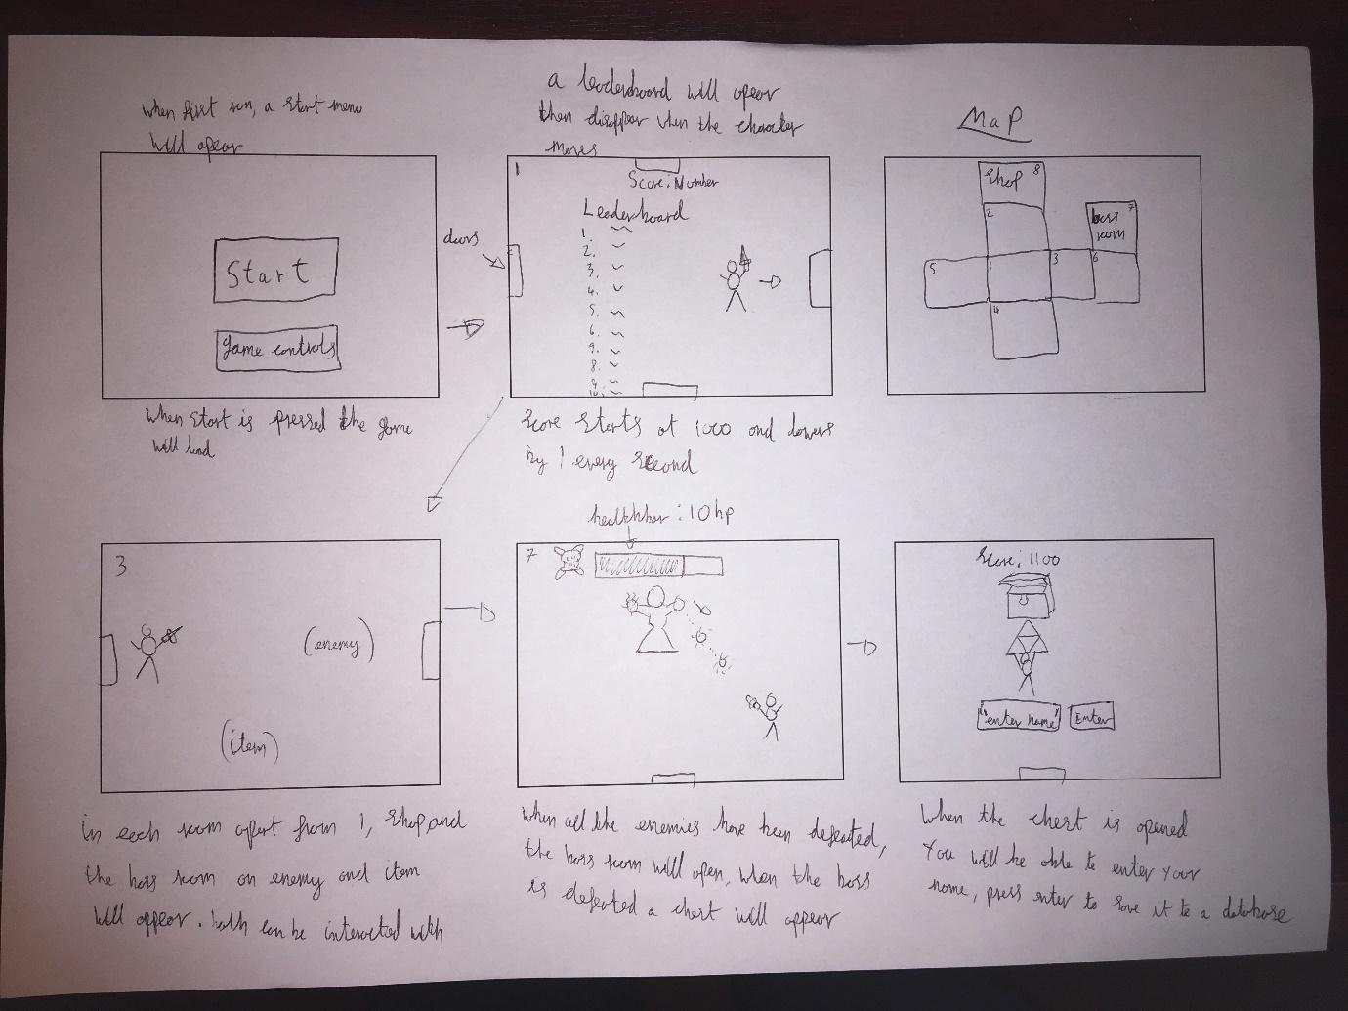

# Design

## Design introduction

* 1. When the program is run it initialises the hero, controls image, background image, title, a textfield and a button, This makes up the menu. While this is going on, it starts the background music and generates the dungeon using a recursive algorithm; it will then generate items, enemies and backgrounds according to the map. When the player inputs their name and presses the enter button the scene changes to the dungeon, the hero is moved into the dungeon and the starting room is set up accordingly. At the same time the scoreboard is shown to the player. When the player first moves, the scoreboard will disappear and their own score will decrease once every second. At this point the game has now started. Meaning that the player can now move (Arrow keys), attack (Space) and pick up items (E).

Every time that the player moves several procedures are called, first of all the player and the sword hit boxes move, then the image attached to the player is changed accordingly to direction. It will then check for smaller things such as making the scoreboard or inventory disappear if they’re visible, checking if the score countdown has started, playing the walking sound effect as well as making sure the player isn’t colliding with a wall. Finally it checks if the player is intersecting with one of the doors.

If the player is intersecting with one of the doors; It will start the sequence to change the room. Firstly the player is moved to the opposite side of the screen, Then the items, enemies and backgrounds are changed to reflect the new room. At the same time if the player touches a Shop door, the shopkeeper and his stock (map, staff and attack boost) appear. This gives the player a change to buy an item to improve their chance of beating the game. On the other hand, if the player has defeated all enemies and then touches the boss door, they will be thrown right into the fight with the boss.

Once the boss fight starts, the player cannot leave and the boss will start attacking. During phase 1, The boss only has 1 simple attack, It will create a fireball and throw it at the player. When the player attacks the boss enough to get the boss to 50% health it will enter phase 2; in phase 2 every 5 seconds the boss will do 1 of 2 new attacks. While the battle is happening, the music would have changed to the boss music and sound effects will be played when a fireball is sent out. When the boss reaches 0 health (after 20 hits from the player) the boss will be defeated and the player’s score will be saved to the leaderboard.

Every time the player attacks, the inventory and scoreboard are hidden if they were previously shown. Then the sword hit boxes will move to the correct places and finally the image attached to the hero is updated accordingly, the player may be moved for image correction then a two second timer starts that will revert the image when two seconds pass. While this is going on, The direction of the player is used to check if the correct sword hit box is intersecting with an enemy or the boss. If the sword hit box is intersecting with an enemy, that enemies health is updated (if the health reaches 0, the enemy is deleted) then a sound effect is played to signify a hit. Where as if the sword intersects with the boss, The bosses health bar changes width to signify health loss. This process is more or less the same with the staff (Used with W,A,S and D). The staff creates a magic projectile in the direction that the player is facing then shoots it in that direction and reverts the image after two seconds. When the projectile hits an enemy or the boss it does the same as if the player was using their sword.

For the player to interact with items, they’re required to press E. This causes a procedure to branch into two parts, picking an item off of the ground or, using an item from the player’s inventory. When the player picks an item off of the ground, it deletes that item from a dynamic array whilst getting the ID of that item to generate a replica in their inventory. However for the player to use an item in their inventory, they need to press E when the selected icon is hovering over the item that they want to use.

In the event that the player’s health reaches zero, the game fades to black. As the screen darkens, the scene swaps to the death screen, a timer then starts that adds objects to the screen starting at the top of the screen and slowly moving down. Finally two buttons appear, Exit and reset. The reset buttons will generate a new map, reset variables and arrays as well as putting the player back in the starting room.

## Hierarchy chart

* 1. This is a diagram showing how the procedures call each other.
  2. 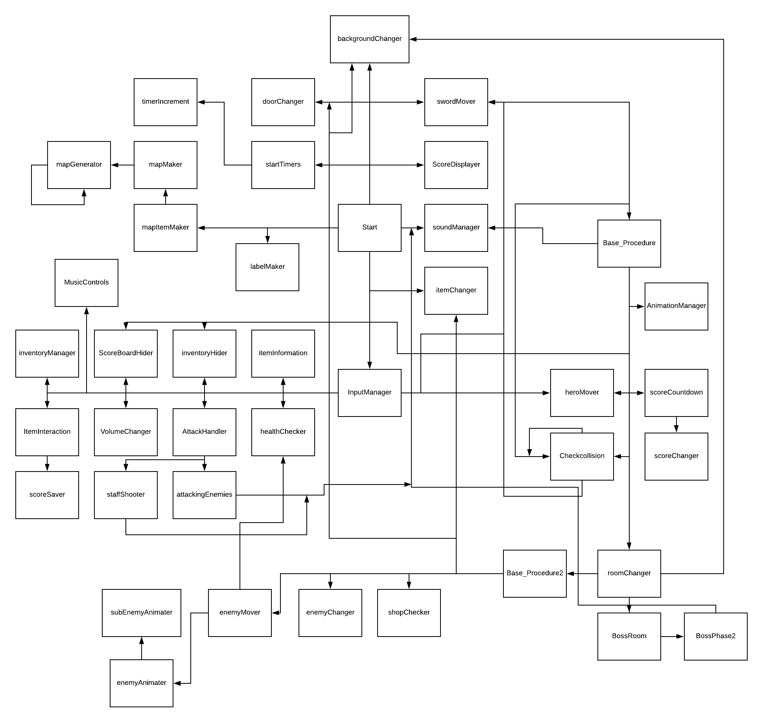

## Non-Standard Algorithms using Code or pseudocode/Technical skills

### Collisions

To do Collisions between two rectangles, I got the coordinates of the bottom left and top right corners of the rectangles then tried to set up if statements that would detach if they are overlapping. This didn’t work but it led me to find .intersects which creates two boxes around the objects then detects if they are overlapping.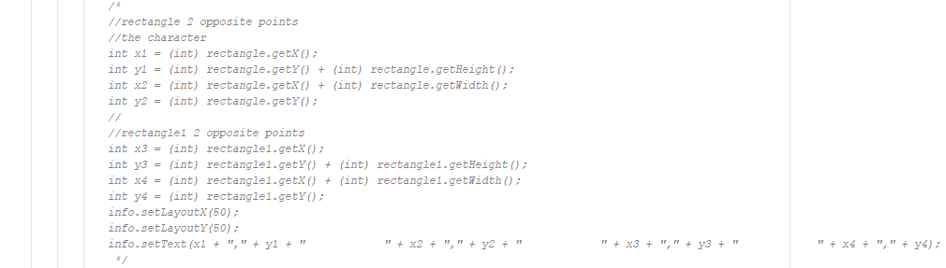

This is the code that detects if two objects are overlapping. While it logically makes sense when I ran the code if the character encountered an obstacle it would be teleported instead of pushed back. Changing the direction variable to a global fixed the problem.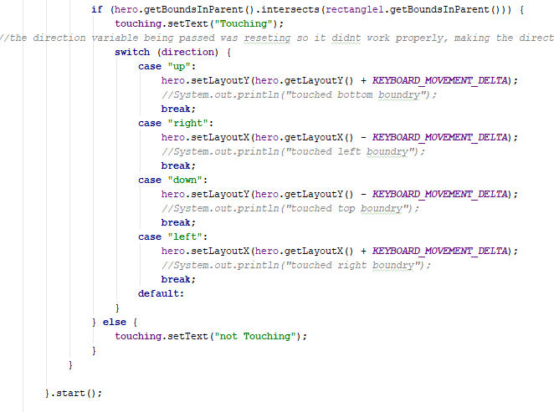

### Character Movement

This is the code that handles the moving animations. For movement, I have 2 pictures in each direction that switch every 0.5 seconds to make it look like the character is running.

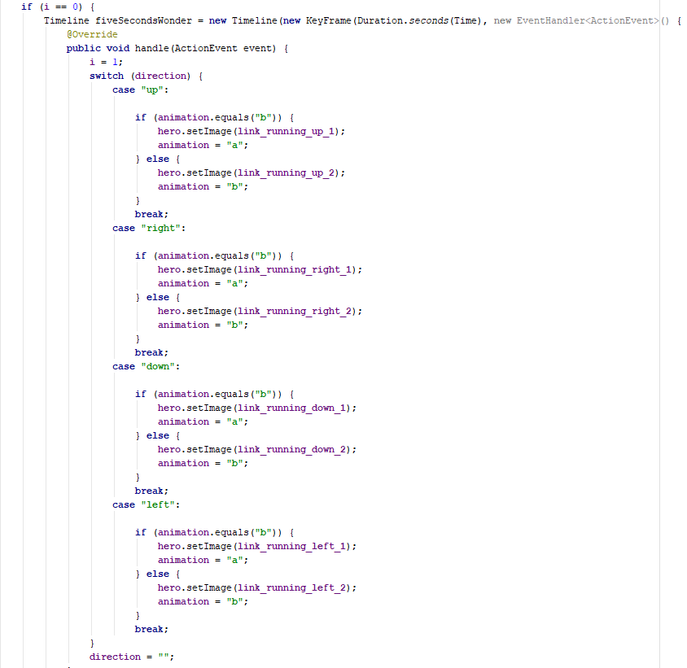

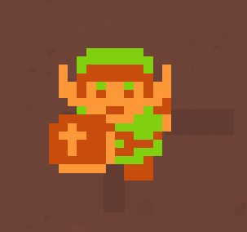

### Attacking Basics

Next, I added attack pictures; I plan to give the sword its own hitbox then detect if it touches an enemy by using invisible rectangles that overlap with the position of the sword and move with the player.

Here you can see the rectangles around the player which overlap with the sword in his attack images.

### Health Basics

I also decided to add a timer to the sword animation changing it back to the direction the character is facing so the sword isn’t always out.

I also added a health aspect and a function to monitor and change it.

Full health – 6 Half health – 3

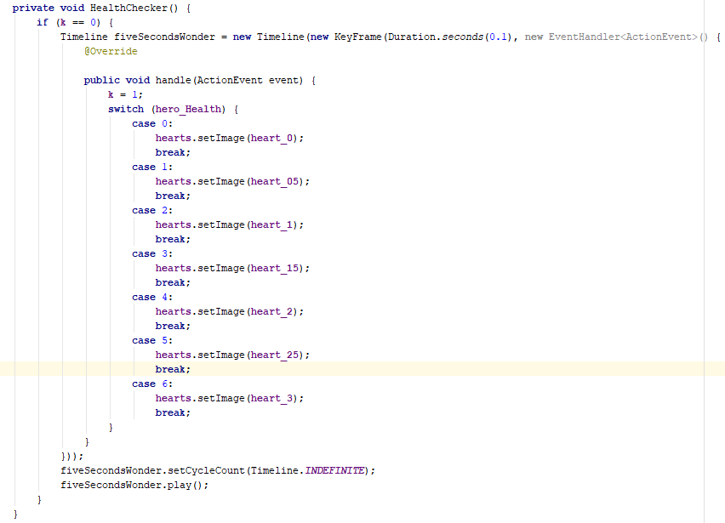

After I made a fixed map I ran into a problem where when you leave the current room the sword hitboxes don’t move with you, I fixed this by making a check time in the background that moves the swords relative to the character and not the movement of the character.

This is what I made: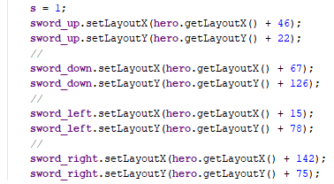

When you go through a door, the sword hitboxes will go to these locations.

### Basic Sound Effects

Next, I wanted to add sound effects. Using a book called “JavaFX for dummies” I discovered the MediaPlayer method which led me to make this code.

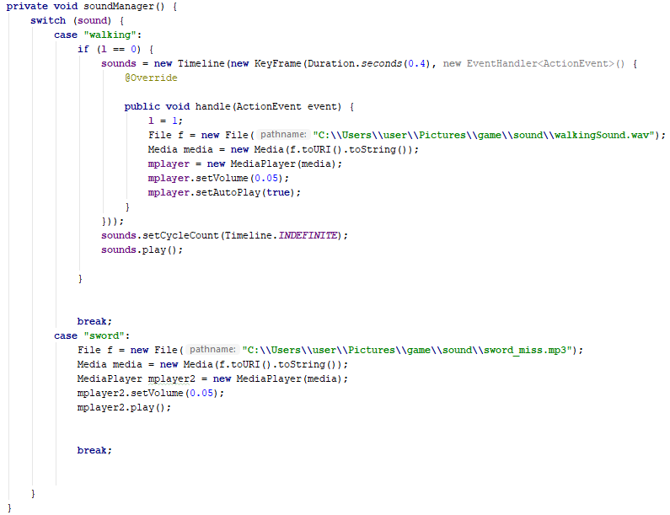

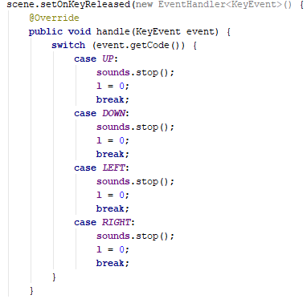When you hold down the arrow keys to move it plays the walking sound every 0.4 seconds and when you release the key it stops. One problem I ran into is stopping the sound, at first, I tried to stop the mplayer but that would only stop the current sound then carry one. I then tried stopping the timeline which worked successfully.

### Implementing Items

I then made a dynamic array of images that I’m going to use to randomly generate items and then use the same idea for enemies. 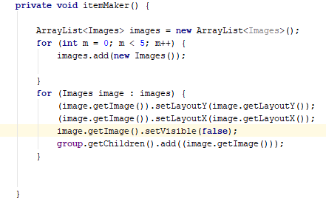

There is now one item in every room.

I also created a procedure called itemChanger that changes the visible item in each room.

It does this by getting the substring of the variable currentFloor and matching that to an array position.

### Making An Inventory

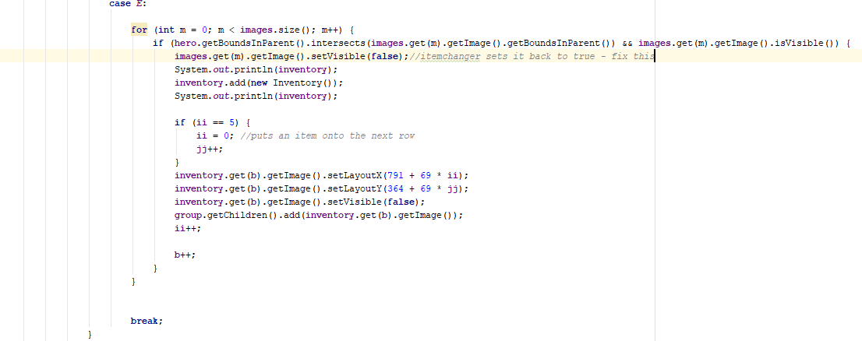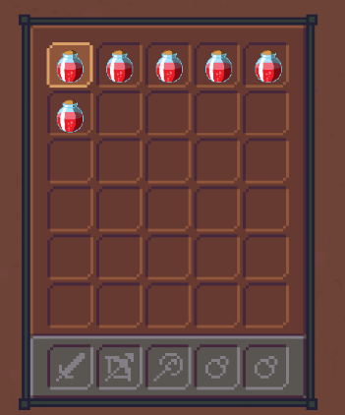

One problem I ran into is removing the item from the dynamic array when picked up. Using .remove deleted the position and the item in the next position took its place, since the items appearing in the items is relative to the array position this was not the intended effect. A fix for this is just to make the item you pick up invisible and then create a new item in the inventory dynamic array which will set its x,y.

Next, I'm going to make it possible to use items. Pressing E when a health potion is selected will increase health by 2 and then remove it from the inventory.

### Picking up Items

The complete code for picking up and using items: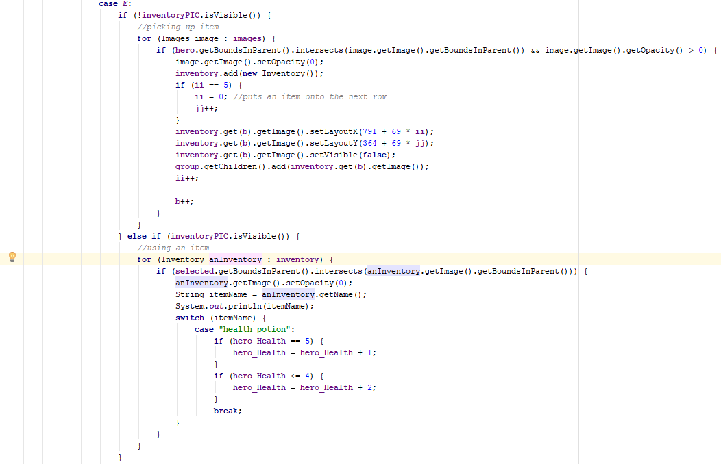

After that, I fixed a problem with how the map is constructed. This is the complete code for that: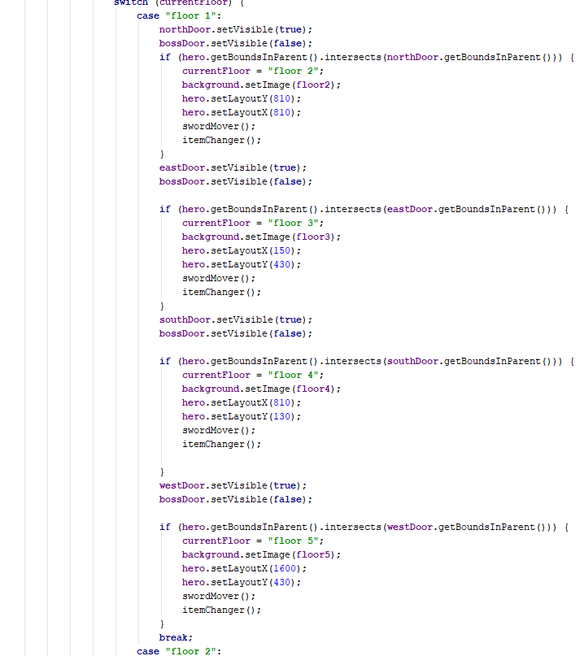

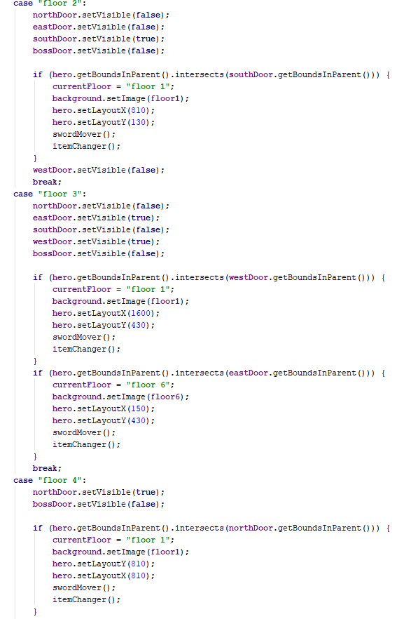

Whenever the character touches a door, this procedure changes the background, doors, items and enemies to properly fit the next room.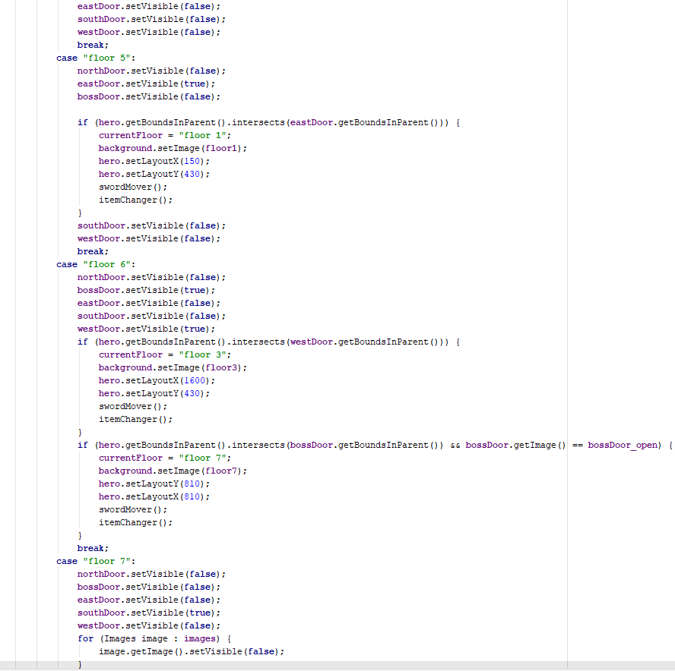

### Implementing Enemies

To add enemies, I made a dynamic array and class that places an enemy in each room. To attack the enemies I made a procedure and had it called each time, space is pressed.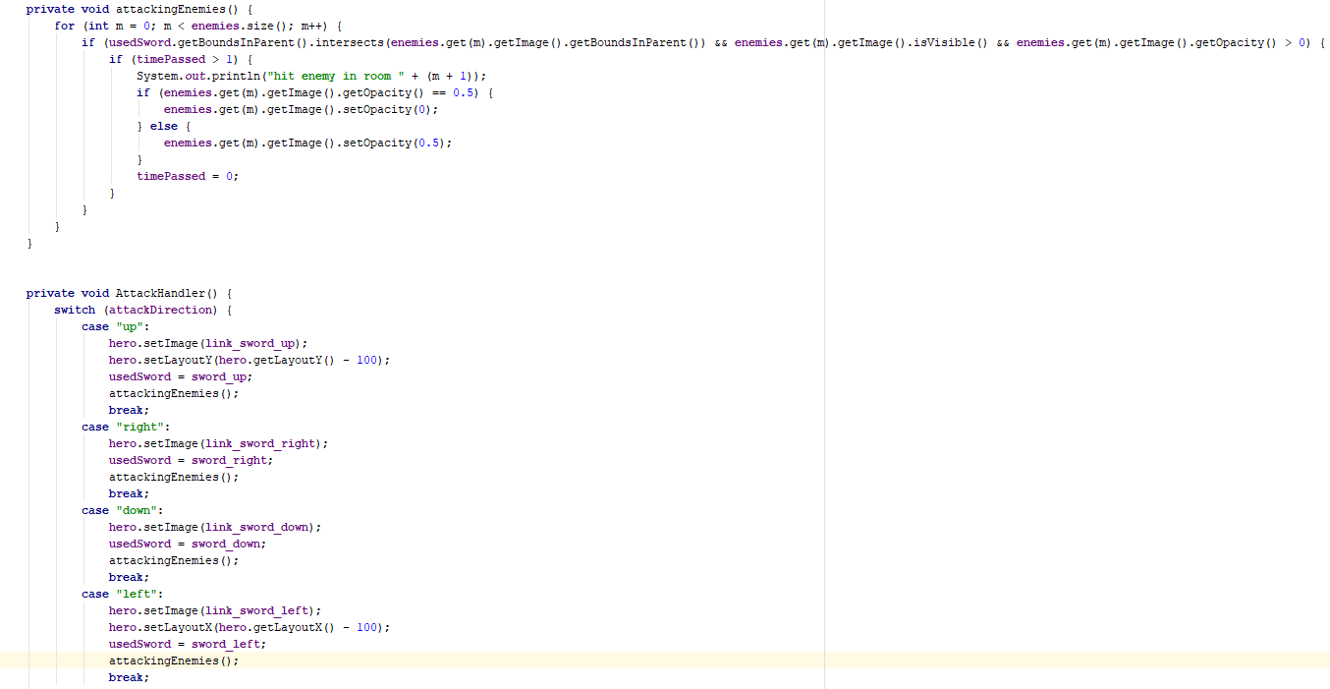

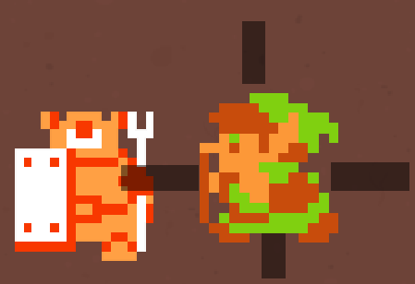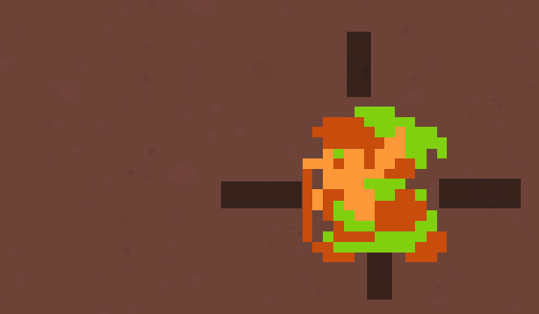

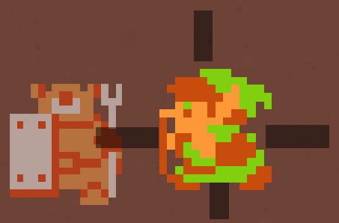

Before a hit, opacity = 1. After one hit, opacity = 0.5 After two hits, opacity = 0

### Enemy Movement

This is the movement code for the enemies. It uses translate transitions to move images over time.

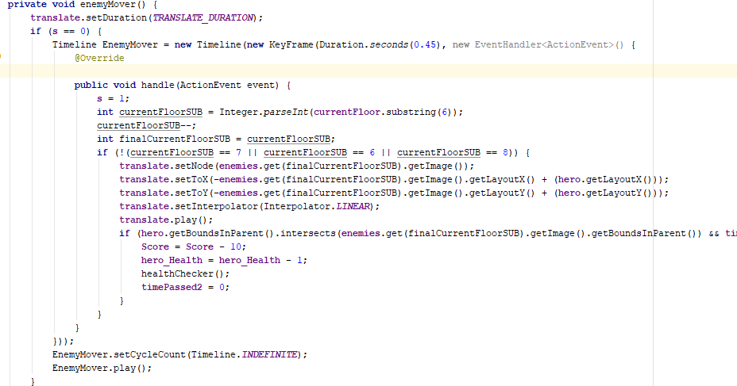

### Improved Sound Effects

I added some more sound effects to the soundManager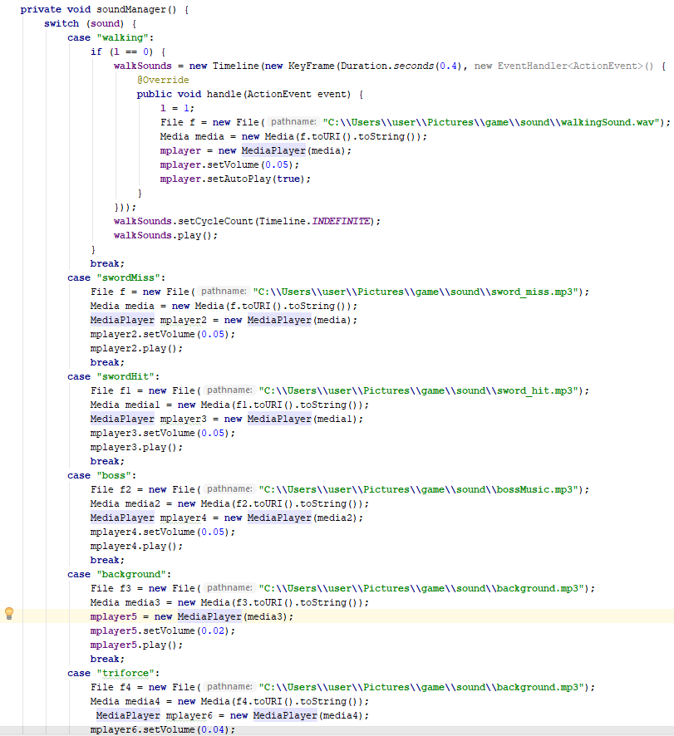

### Implementing a boss

I then started to implement the boss.

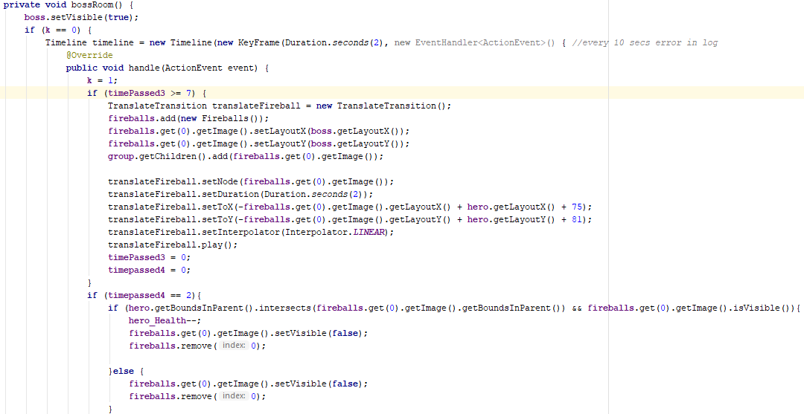

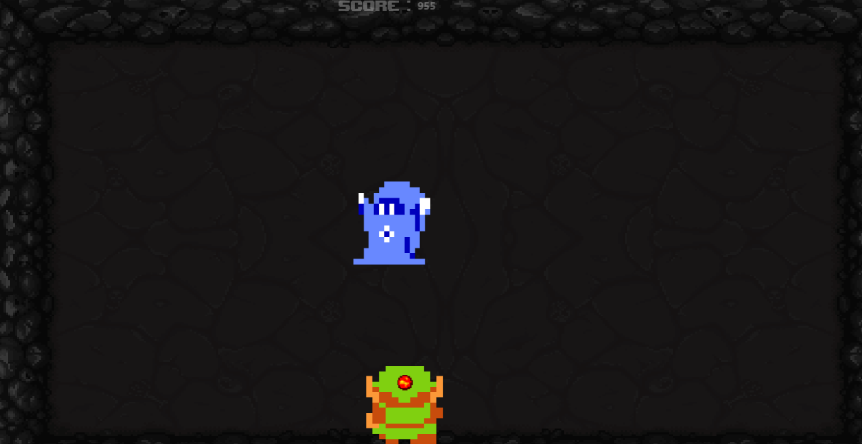

I then added collisions for the boss and a health bar.

To make the health I bar loaded into an image then overlapped a red rectangle that reduces in width when the boss is hit.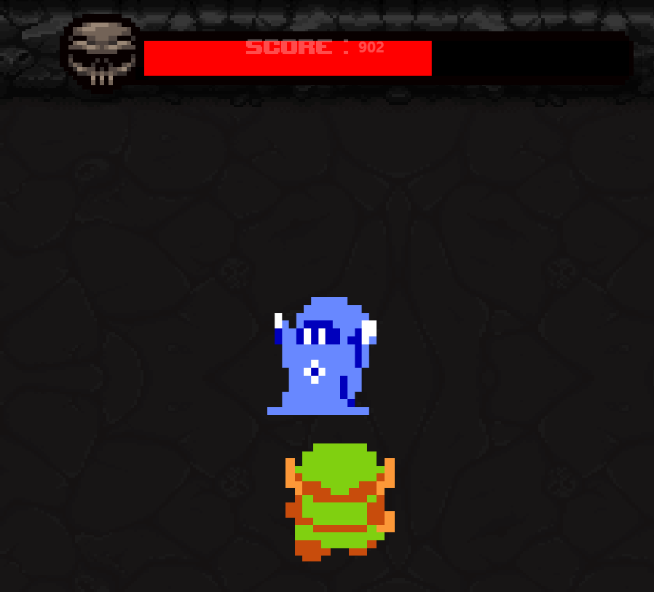

This is the boss after 4 hits.

As a reward for defeating the boss a chest will appear that contains the triforce which is an item made by the gods in the Zelda franchise.

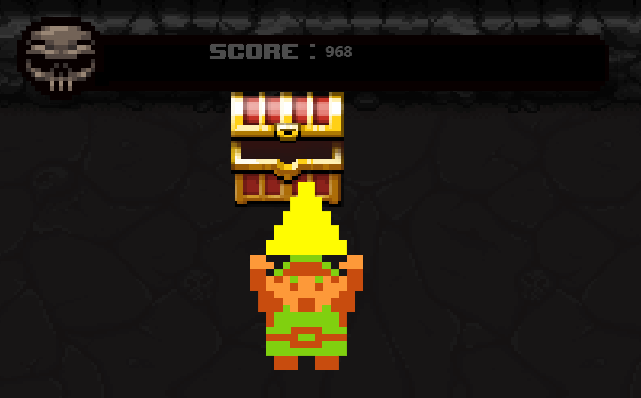

While testing the boss I found a bug to do with how the player attacks:

When swapping images the x and y coordinate align by the top left corner, this would be okay but when I was implementing the attacking images if you were to look up or left then press space It would align and push and character away but ideally you would take the character to stay in the same place and the sword move forward to hit the enemy. To fix this when you look up or left and press space to attack I change the coordinates of the character to make it appear the sword is moving out in the direction the character is looking and then change the coordinates back 1 second later. The problem I found with this is that you can look left or up and continually press space to seemingly teleport the player across the screen. To fix this I added a check that only moves the character if they aren’t already in the sword animation.

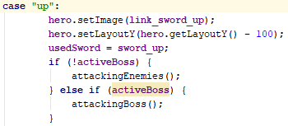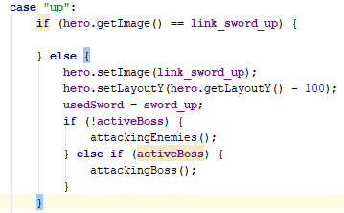

Before After

Adding on that issue, if the character is moved up or left while in the attack image for that direction it would teleport them 100 pixels in that direction because it skips the check above. To fix this I added a check when movement occurs in those directions.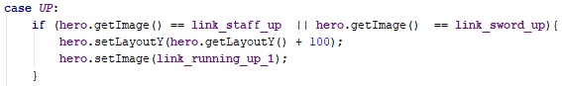

### Ranged Attacks

To make the character better equipped for the final boss and make use of the shop idea, I added a staff which will be a ranged attack that fires projectiles.

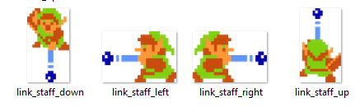

I first added that staff pictures to the attack handler to change the pictures when necessary

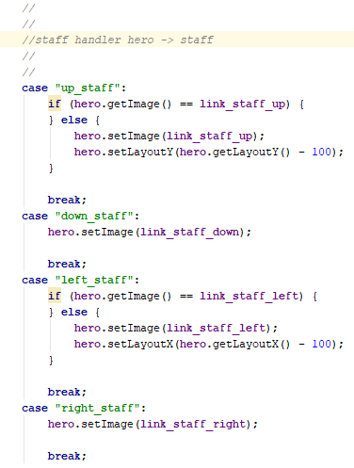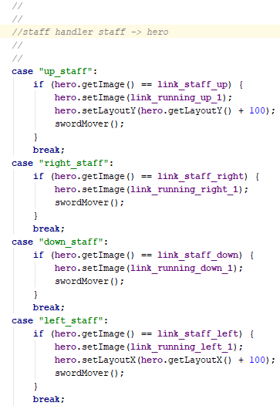

To use the staff you will first need to buy it from the shop using coins that enemies drop when defeated.

### Shop

This is a picture of the shop and the shopkeeper.

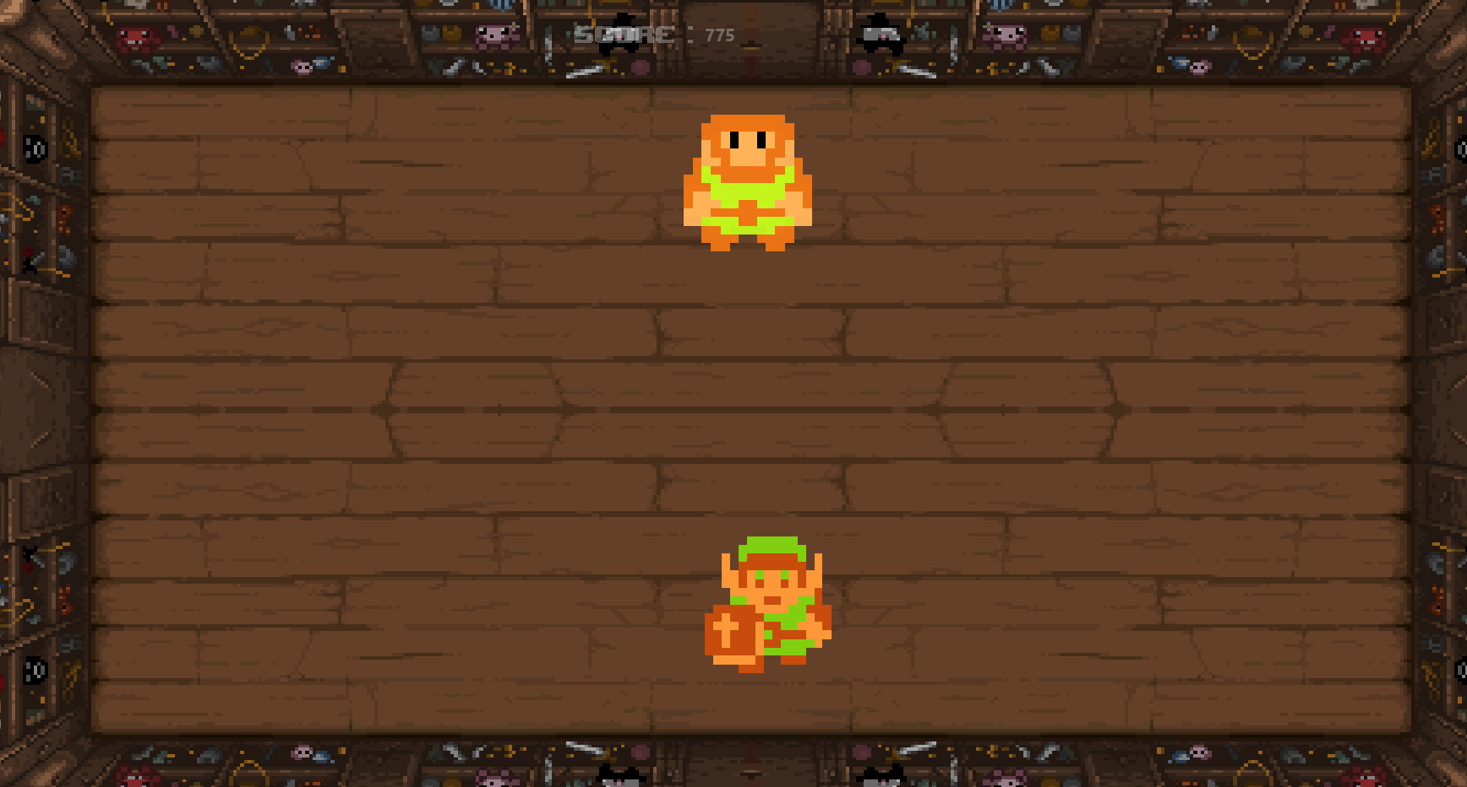

### Addition to Ranged Attacks

I then added that staff to the shop with a price of 3 coins 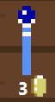

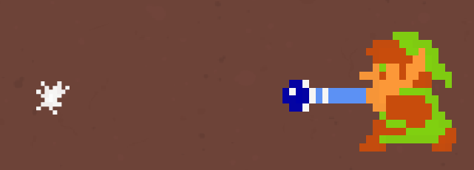

Once the staff is purchased it can be used with A, S, W and D keys to aim it. It then shoots out a ball of magic that will damage enemies.

This is the code that creates and moves the balls of magic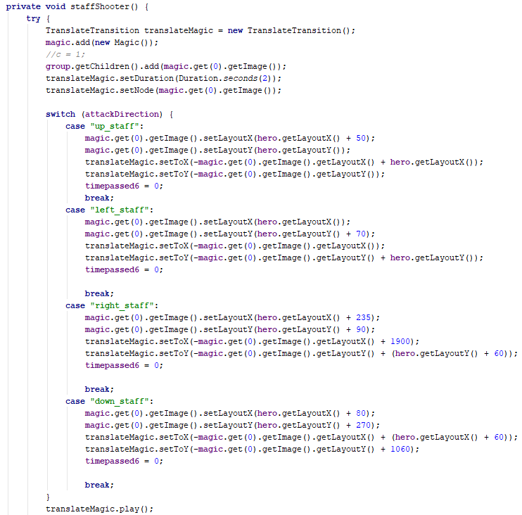

I then added functionality for the staff so it can damage enemies.

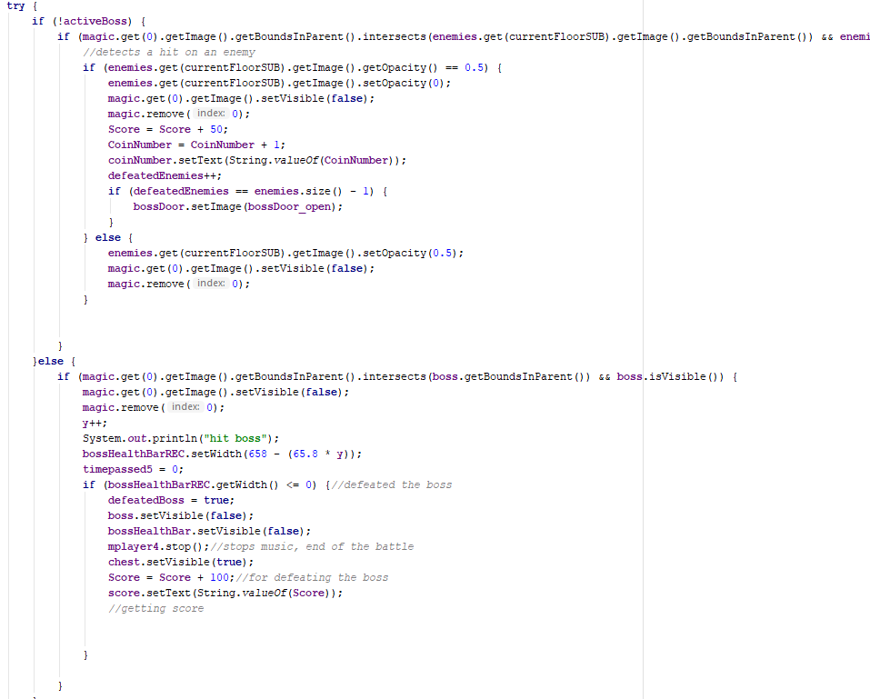

Then I added an if statement to the input manager so you can only use the staff once you’ve purchased it from the shop.

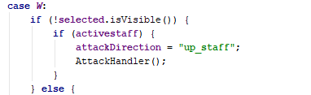

### Game leaderboard

To add on to the boss fight, when the boss is defeated the Score will be saved to a sql database to create a scoreboard.

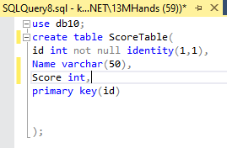

As a test I used this command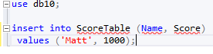

It worked.

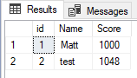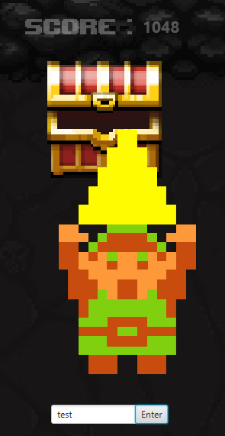

As you can see when the boss is defeated the game successfully writes the name and Score to the database.

This is the code that writes to the database: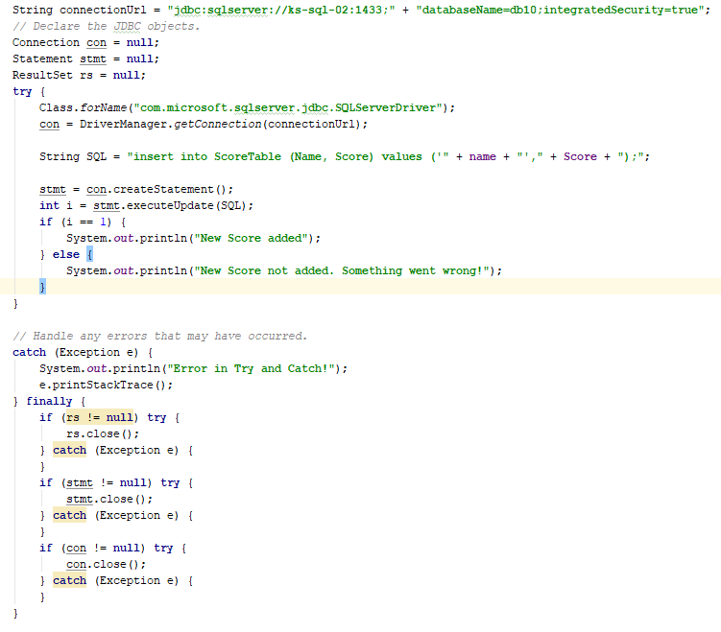

Because of user feedback I made a procedure that reads from the database and displays it all in order when the game starts.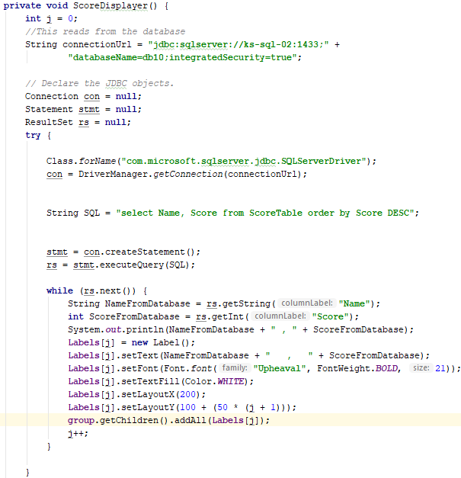

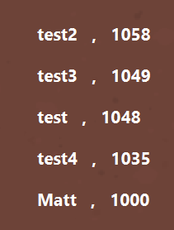

The scoreboard disappears when the character first moves.

I then made a scoreboard image and overlapped it.

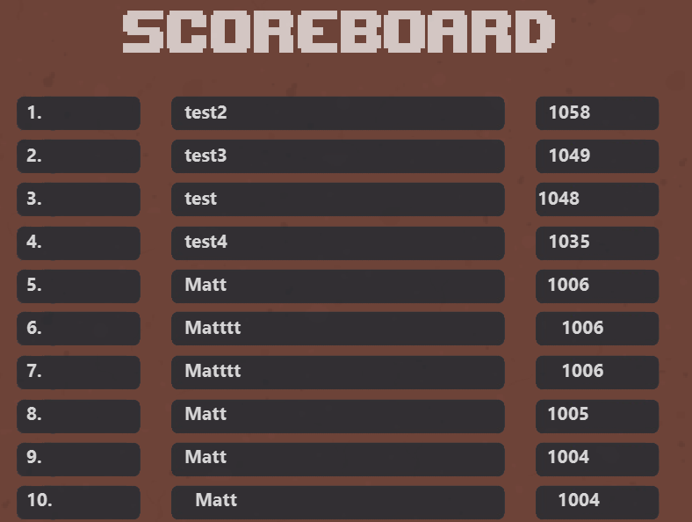

I’m going to change this to a 2D array as a longer name will result in the Score being further to the right.

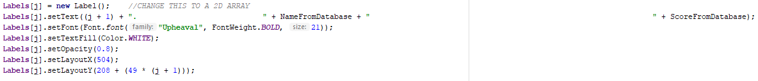

When I changed it to a 2D array of Labels, this was the result.

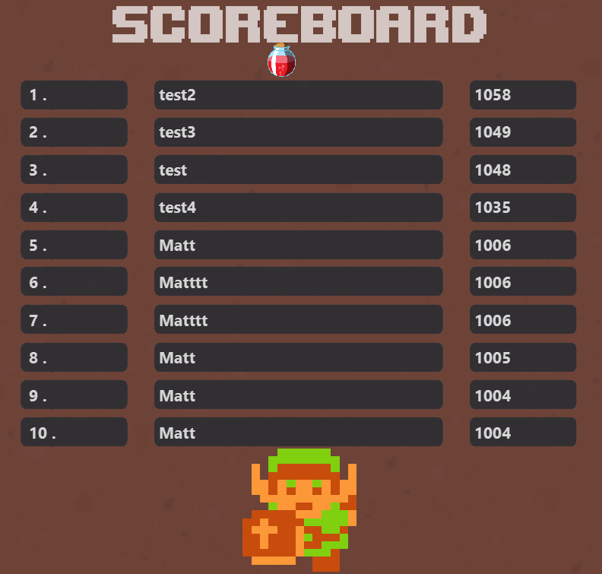

As you can see, the names and score line up much nicer as they are each given their own x and y coordinates and not separated by a lot of spaces.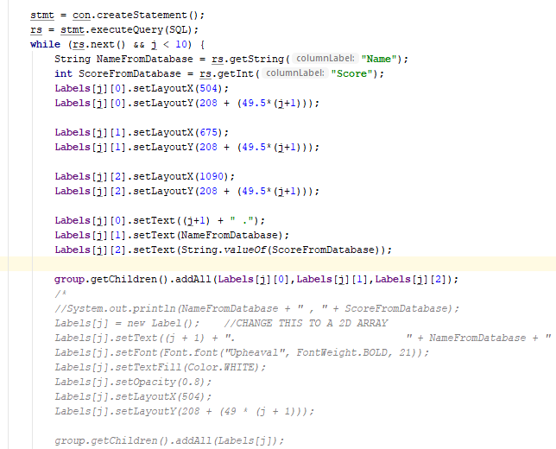

### Addition to Ranged attacks

I then did a small change that starts the Score countdown when you first move and not when the program first starts. This will give the player a chance to look at the leaderboard without the score plummeting.

While testing that the score saver procedure worked, I realised a problem with how the enemies are attacked. Part of the enemyMover procedure is a timeline that checks if the enemy is in contact with the hero and then damage the player. The problem with this is that the first time you attack an enemy in any room, the player will take damage if you hit the enemy because you are technically touching the enemy so you take damage. To fix this I made a Boolean that tracks when the hero is in attacking and then add that to an if statement in the enemyMover procedure. Now the enemy cannot hurt the player if the player is attacking the enemy.

To add further functionality to the staff I added a sound effect that plays when the staff shots a projectile.

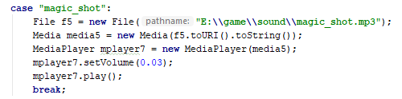

I also added a staff cooldown because previously you could shoot again as soon as the projectile makes contact with the enemy. Now when you shoot the projectile you can’t shoot it again for 2 seconds.

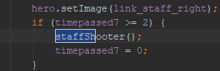

### Animating Enemy Movement

To animate enemies I added a .setImage method to the enemies class but when testing I came across a bug. To get the coordinates of the enemy in the room I would use .getlayoutX and .getlayoutY but these didn’t work on moving images which lead me to find .getTranslateX and .getTranslateY.

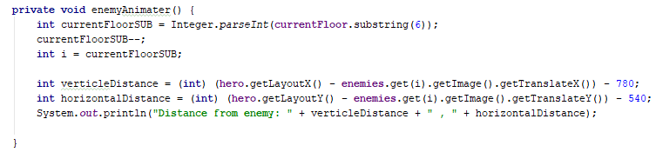

When it came to animate the enemies it much harder than I anticipated; When I came to a solution the enemy could ‘see’ where you are and then act appropriately. To make the enemies ‘see’ I calculated the gradient between the enemy and the player and then depending on the gradient I know what part of the screen the hero was in.

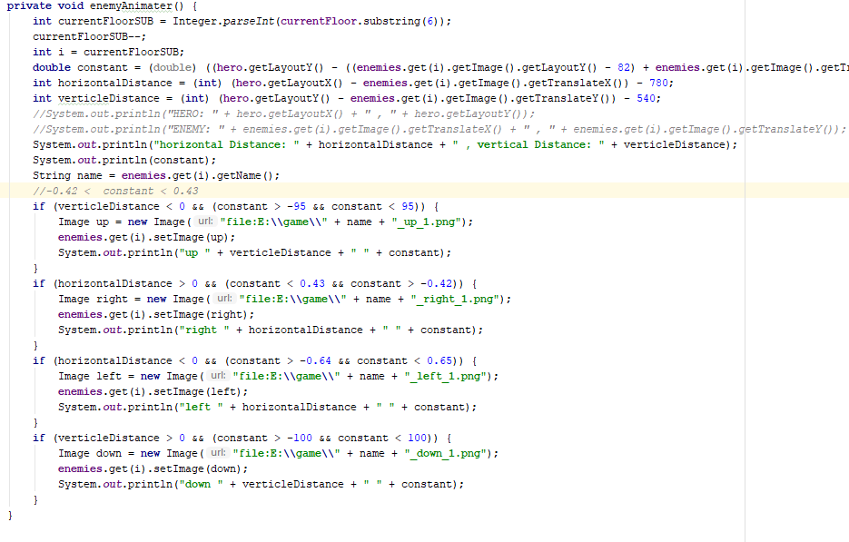

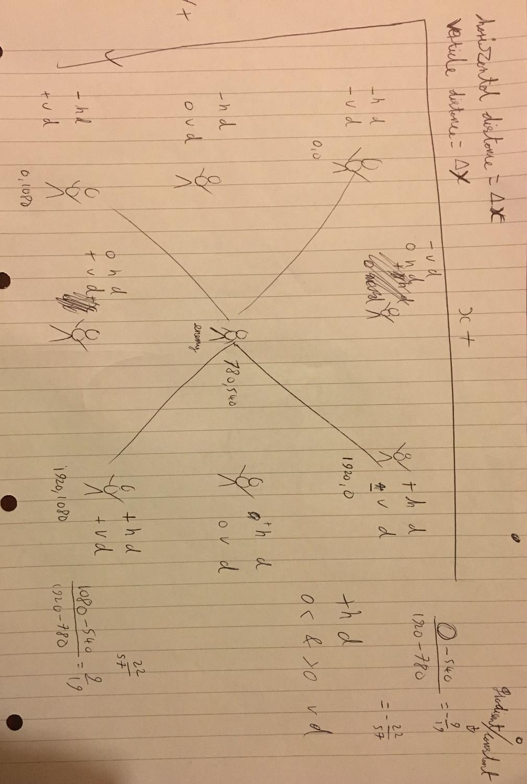

### Implementing Inheritance

The main program uses 5 classes, 2 of which called Enemies and Images are very similar; because of this, I made a base class for the other classes to inherit from.

This is my new base class:

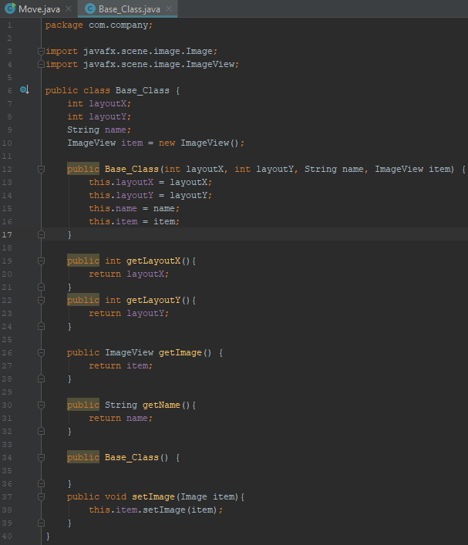

This is my updated Enemies and Images class:

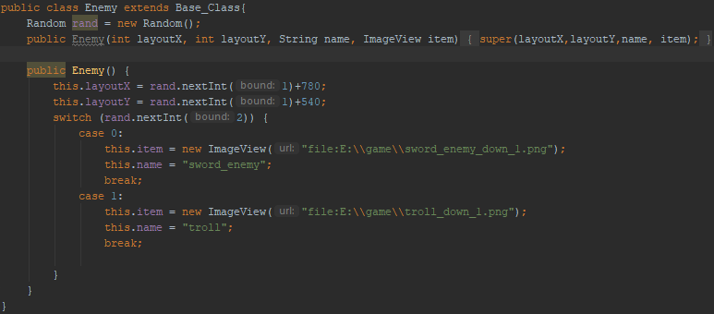

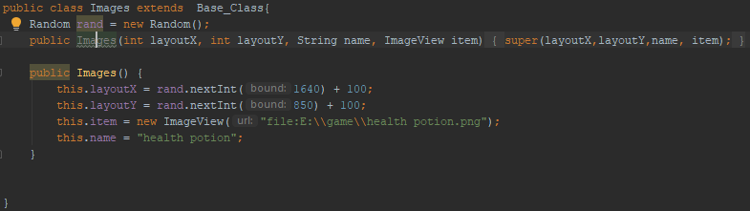

After creating the animating the enemies I realise a way to optimise the hero animation.

Before: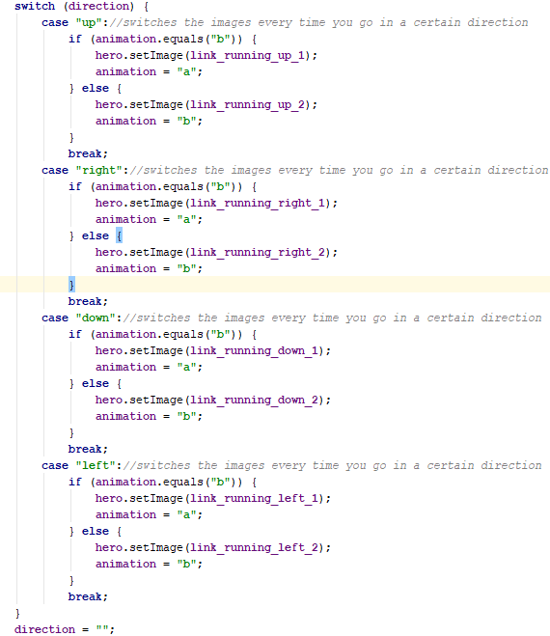

### Updated Character Movement

After:

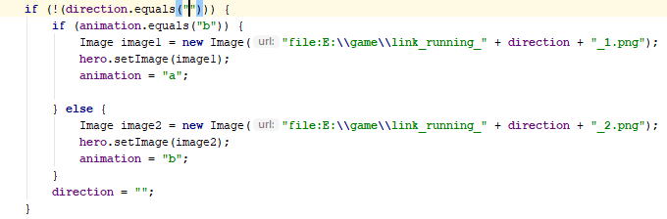

It works just as well with fewer lines.

I then extended it to the Magic and Fireballs class to further optimise it.

### Optimisation

I then make a Base Procedure to optimise the input manager.

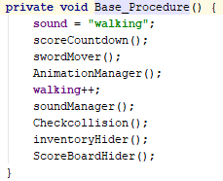

Previously in each movement case, all 9 statements above would be called. Now the Base Procedure is called instead.

### Game Menu

I then decided to make the main menu for the game using scene transitions.

Code: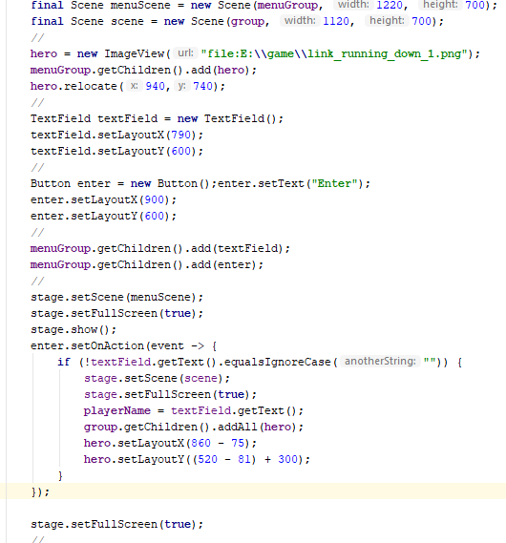

I took a picture from the game Cave blazers and used that as the background then I moved the text field and enter button from the post boss fight to this screen. When the button is pressed it only starts the game if the text field contains text. I then created an image that shows the game's controls and added it to the menu as well. I also added the input manager so the controls can be brought back when i is pressed.

This is what the menu looks like:

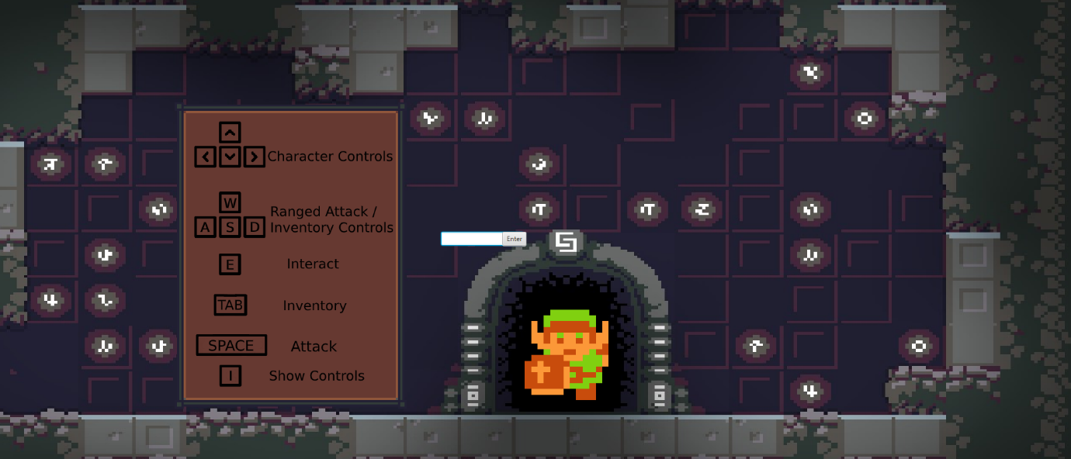

### Sound controls

I then added sound controls for the music and sound effects in the game.

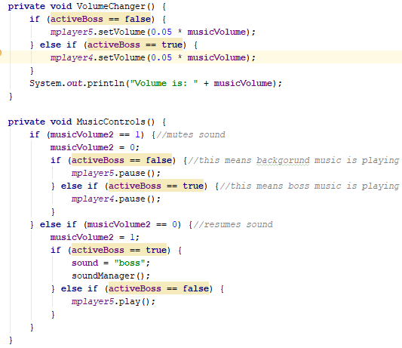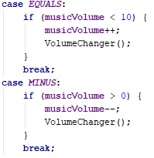

I added these options to the input manager: If M is pressed, the current music is paused. To raise and lower the volume I've decided to use - and + because it made the most sense to me.

### Optimisations / QOL improvements

I then learnt about the .mute command and changed the music controls to this: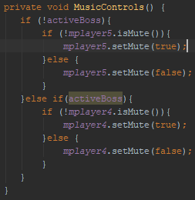

Because of the recent progress I showed my current version of the game to my end-user and let them test it. While testing it I noticed a few things that weren’t quite. one of which is when the staff is used; if you press space after it will use the staff again instead of the sword, this leads me to update the procedure that swaps the images back.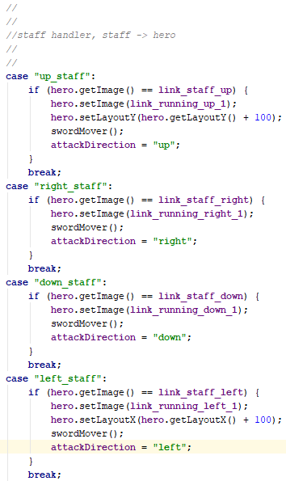

BEFORE: AFTER: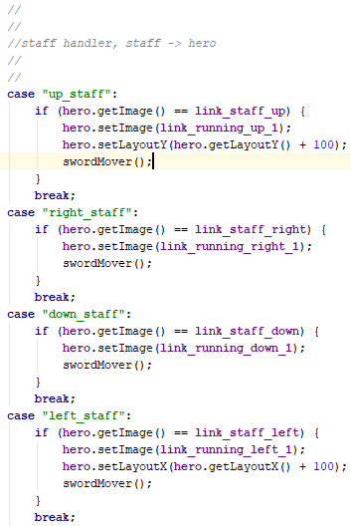

Another issue is that if the boss is defeated while there is a fireball moving. That fireball freezes in place and doesn’t get removed to fix this issue I added to the attacking enemies procedure so that when the boss is defeated all fireballs are removed from the array.

If space is held or rapidly pressed when the boss health bar reaches zero, the win condition seems to be skipped and the boss remains alive while at 0 and even below 0 health. To fix this I moved the win condition into the boss room procedure so it is checked earlier and cannot be skipped.

One more issue is that if space is rapidly pressed it skips the attack ‘cooldown’ of 1 second and allow you to defeat and enemies and the boss near instantly. To fix this I moved the time check further up the call structure so it checks earlier.

One of the more pressing and confusing bugs is one with the walking sounds. When I first implemented sound into my game I made it so when an arrow key is held it repeats the walking sound and when that arrow key is released, it stops the sound. This worked well unless you press two arrow keys at once or if you are holding an arrow key when press another arrow key. This will cause the walking sound to not stop and continually play the walking sound no matter what. As a fix to this issue, I made an Int called walking and that int increased when an arrow key is pressed but the sound only plays when the int is equal to 1.

To make my backgrounds look less static and I first added shadows to the rooms for ambience.

Before:

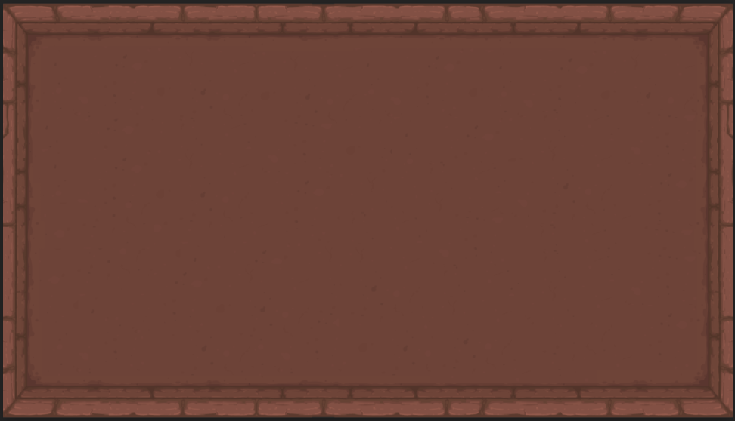

After:

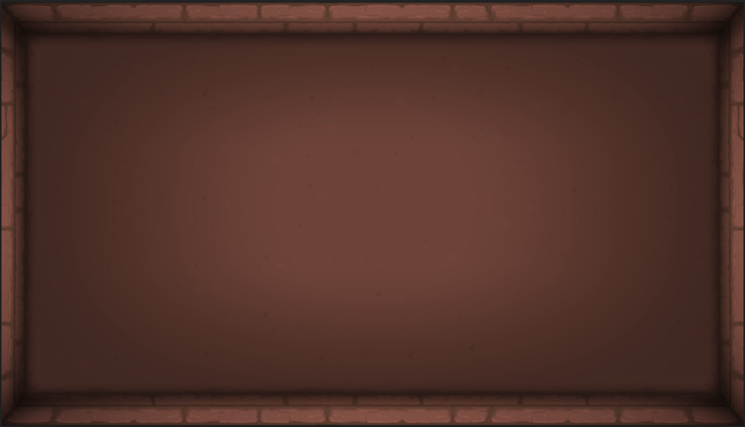

I made it so the shadow is its own image that overlays the backgrounds and doors but not enemies, the hero or items.

Using photoshop i made a patch of grass in 3 different positions that I will animate.

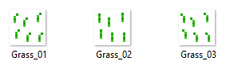

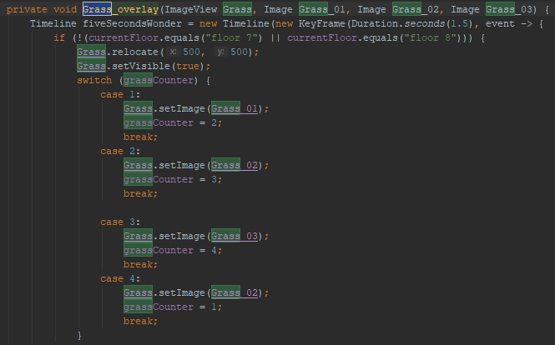

When I showed the grass to my end user they said there should be grass blades of different length, multiple patches in the rooms as well as vines on the walls.

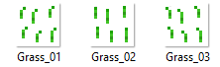

Then i added vines to the walls

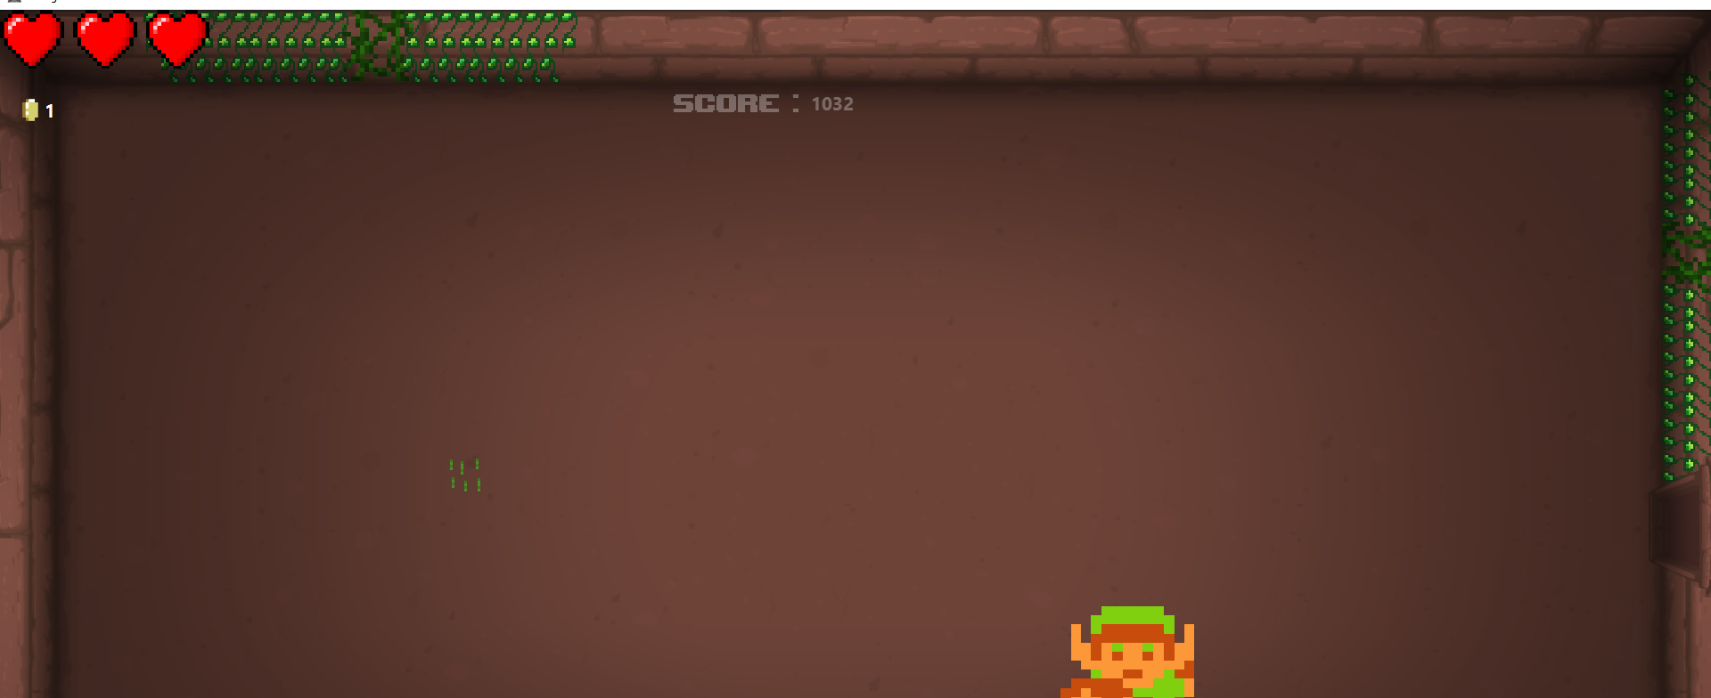

I then darkened the vines, added imperfections and connections between themselves.

### Updated character movement

Based on user feedback I changed the movement to allow multiple key inputs. Moving now sets booleans to true or false then calls a new procedure.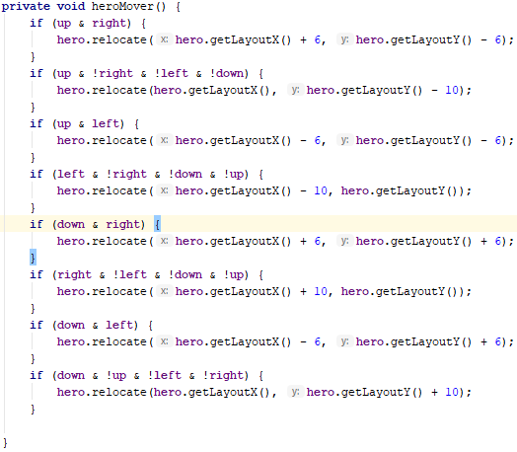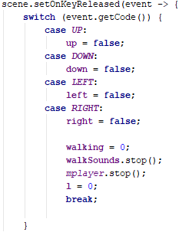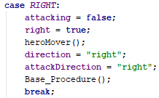

I then added a catch that stops the walking sound when you attack. previously if you held down a movement key then attacked while still holding a movement key, the walking sound would play while you’re standing still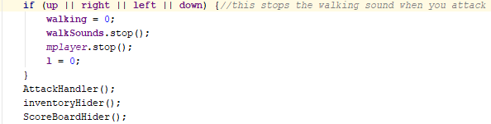

I then watched someone play my game to see if I missed anything else, When they unlocked the staff they used it on enemies as I expected. two shots defeated the enemy then they fired a third shot and the enemy was ‘resurrected’, While they thought it was part of the game I quickly released what I did wrong to cause this. In the staff shooter procedure there is an if statement that checks the opacity of the enemy when the projectile hits it. The if statement is suppose to check the opacity of the enemy in the current room but it was checking the opacity of an enemy in another room which would cause the else to be triggered, setting the opacity of the enemy in the current room to 0.5 and therefore ‘resurrected’.

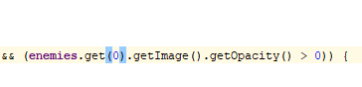Before

After

### Variable optimisations

While I've been creating the game to make things easier I would declare variables as global. This has persisted throughout the project resulting in about 100 global variables (most of which are pictures). To remedy this I moved 50+ variables to be declared at the start and then sent to where they need to go.

My two largest procedures are called inputManager and mapGenerator. I had to send most of the variables to these two then let them funnel down to the correct procedure.



### Better boss mechanics

While my end user was fighting the boss they suggested a more varied attack pattern.

Now when the boss is at half health, it enters phase 2. In phase 2 every 4 seconds it using 1 of two attacks, Fire Blast or Fire Circle. This is the code for the fire circle.

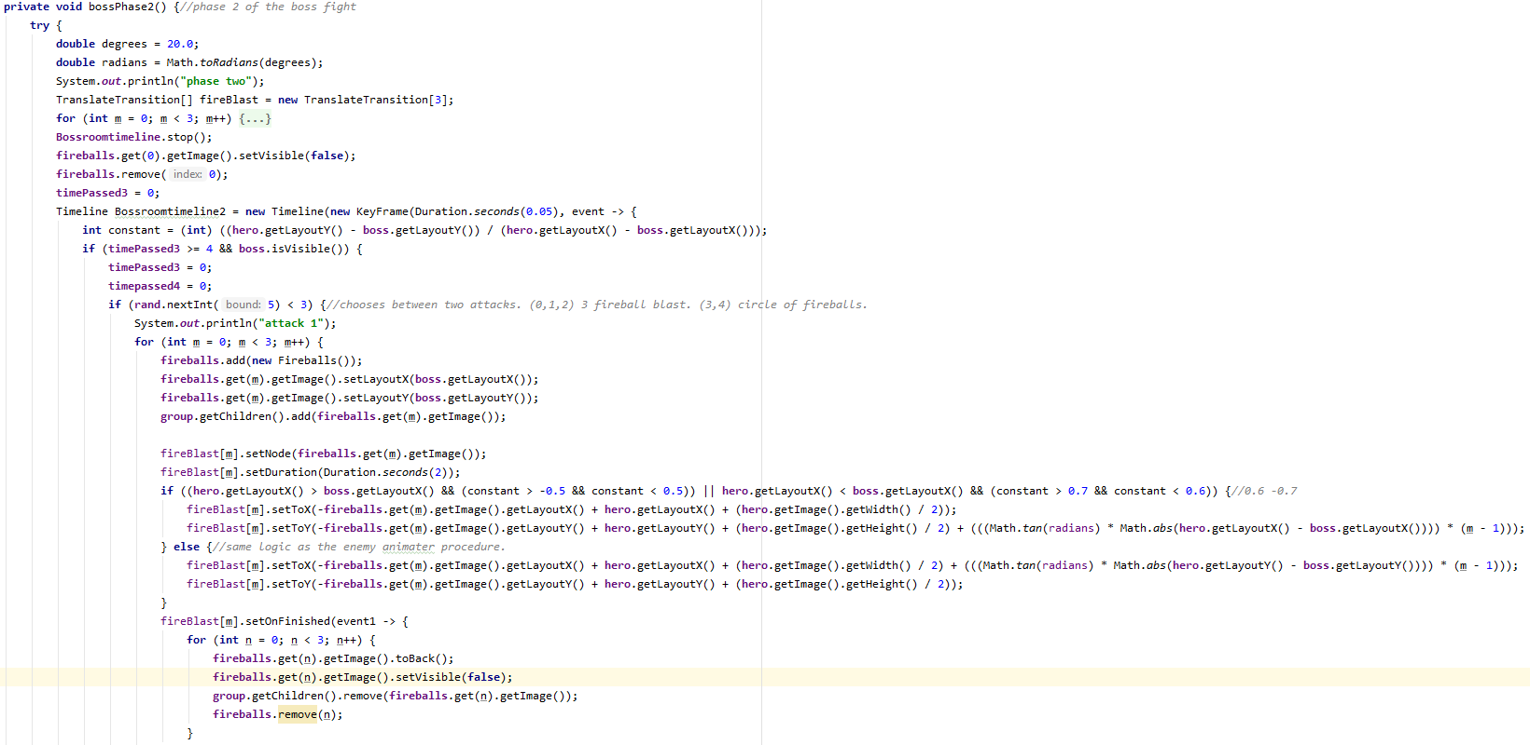

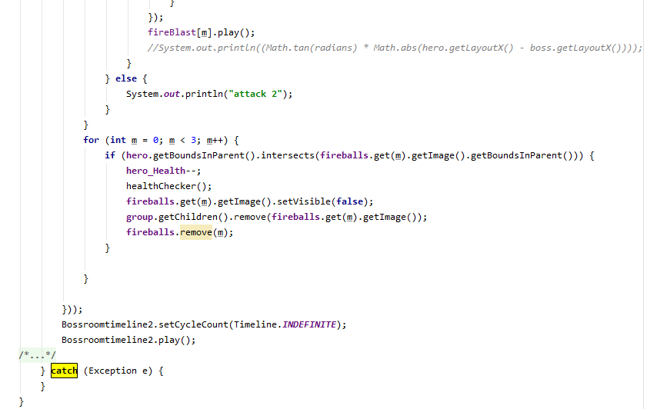

While I was creating the first attack I learnt about the .setOnFinished method for transitions. This is far easier than removing the projectiles using timers.

This is the attack in action:

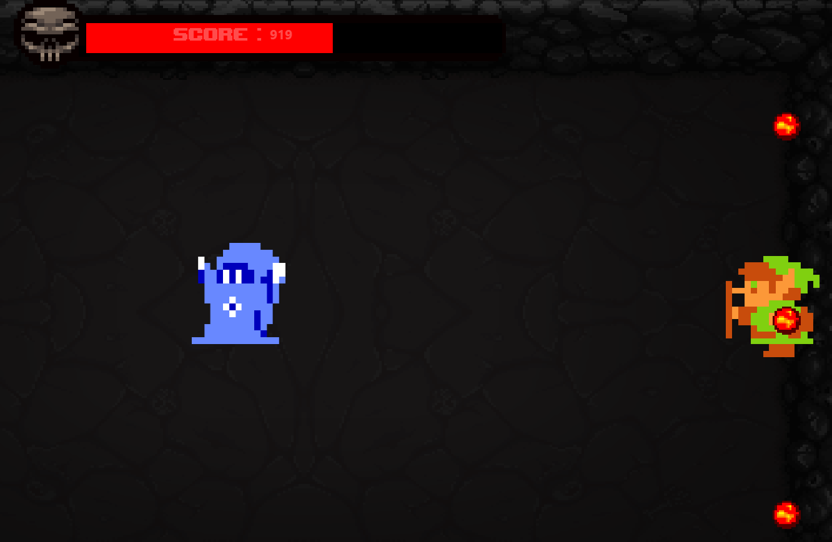

This is the code for the second attack. The fire circle.

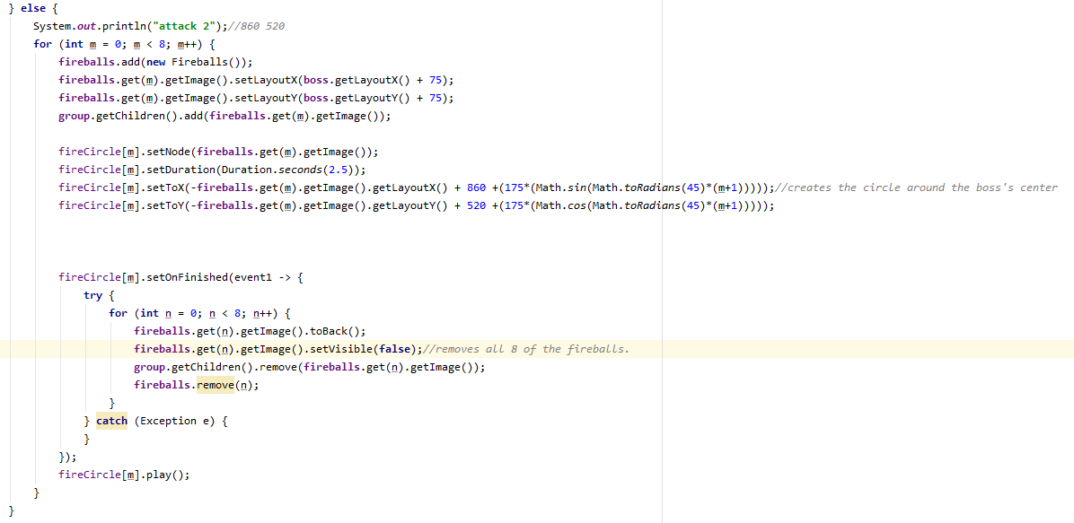

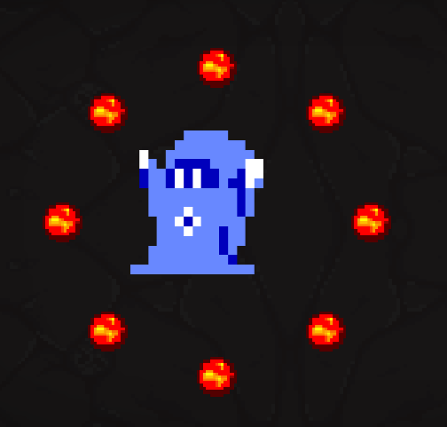

This attack is meant to be defensive that should keep the hero away or else they’ll get burnt.

Below is the pseudo code for the fire circle attack:

TranslateTransition[] fireCircle = new TranslateTransition[8]

for m 0 to 8

fireCircle[m] = new TranslateTransition

for m 0 to 8

new fireball

fireball.relocate(Bosses hand)

fireCircle[m].attach(fireball.get(m))

fireCircle[m].setDuration(2.5)

fireCircle[m].setToX(fireball.get(m)+(175*sin(45*m))) These two lines

fireCircle[m].setToY(fireball.get(m)+(175*cos(45*m))) create a circle

### Dungeon map

For a while, people have been suggesting a map for the dungeon but I wasn’t sure how to implement it. One idea was to do it the same way Binding of Isaac and Welcome to the Dungeon slowly reveal the map as you progress through the level; whereas in Zelda games (Specifically The Legend of Zelda on the Nintendo Entertainment System) the dungeon map can just be found lying around and it would reveal the whole dungeon layout, This is the method that I chose to implement.

To add the map I simply got a cinematic map image and added it to Floor 5 in my game, I then made a dungeon map in the style of Binding of Isaac.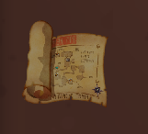

When this map is picked up, the map of the dungeon appears in the top right of the screen.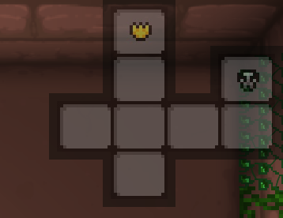

### New items in shop

So far in my game is lacking in consumable items e.g. the health potion that restores 1 heart of health. In order to get ideas for items, I consulted my end-user who suggested an attack boost item. To implement this item I found a good self-explanatory logo and added it to my shop at the same price as the staff, this forces the player to choose between the staff or an attack boost. The attack boost allows you to defeat the boss in 16 hits instead of 20.

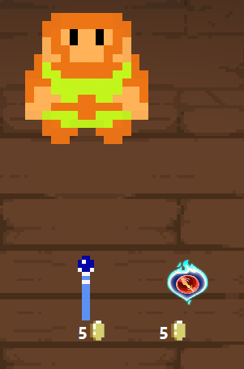

When picked up, the item transfers to the inventory to be activated at will.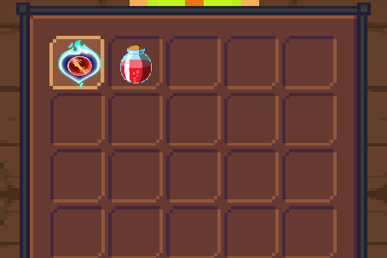

When implementing the item and adding logic for the inventory I ran into a problem that resulted in me adding item Ids. Now when an item is picked up, it sends a number to the inventory class when its called.

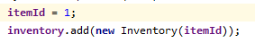When a potion is picked up.

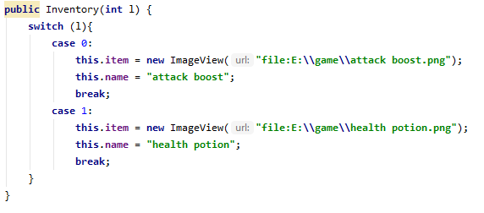

### Addition of external library to enhance game animations

After adding an AnimateFX external library, small quality of life features can be added,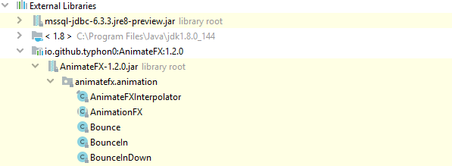

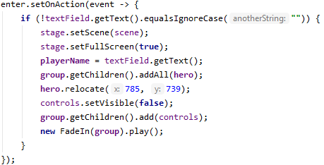

When the scene changes from the menu to the game, it now fades in.

When TAB is pressed the inventory now fades in instead of just appearing:

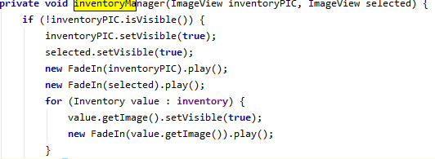

When the boss now shoots a fireball, it pulses:

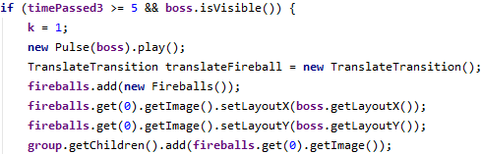

As well as other small addictions to subtly improve the game.

### Randomly generating a dungeon map

A start to random map generation.

Using a recursive algorithm I created a random map where 1 represents a room and 0 is empty space.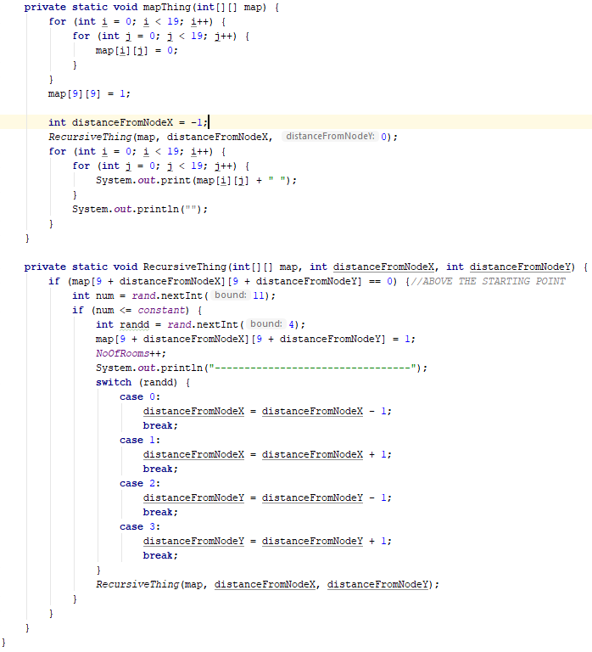

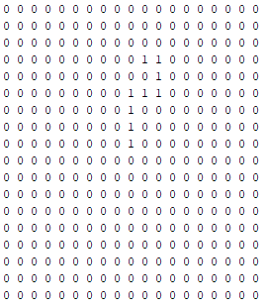

I then wrote this pseudo code for the algorithm

mapGenerator(map,distanceX,distanceY,randomNum,numOfRooms)

if numOfRooms < 12

randomNum = new Random(0,3)

map[9 + distanceX][9+distanceY] = 1

numOfRooms+1

switch RandomNum

case 0

distanceX-1

case 1

distanceX+1

case 2

distanceY-1

case 3

distanceY+1

mapGenerator(map,distanceX,distanceY,randomNum,numOfRooms)

I then extended it to add a boss room and a shop.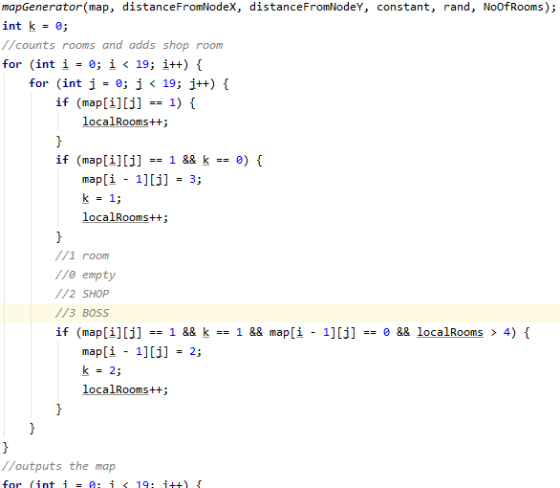

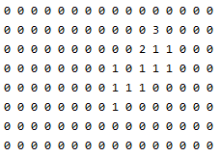

### Navigating the dungeon

I then needed a way to navigate between the rooms. This led me to create this procedure.

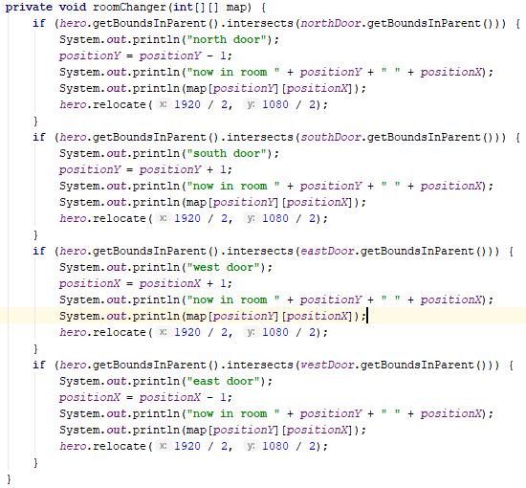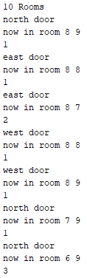

Using this procedure I navigated from the starting room to the shop (2) then to the boss room (3)

### Updating enemies and items to work with new map

changing the map from static structure to a 2D array would result in some of my code that relates to the map no longer working, such as items or enemies; which is why i decided to re create that code first.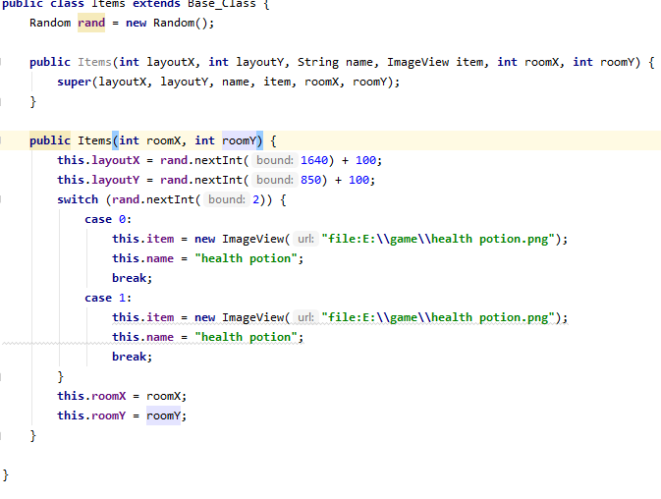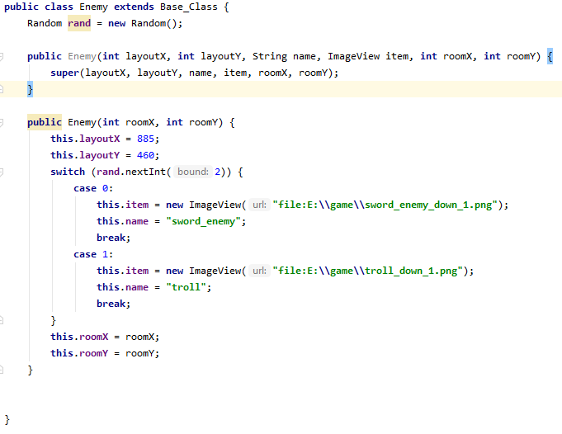

The new and improved Items (previously called Images) and Enemies classes.

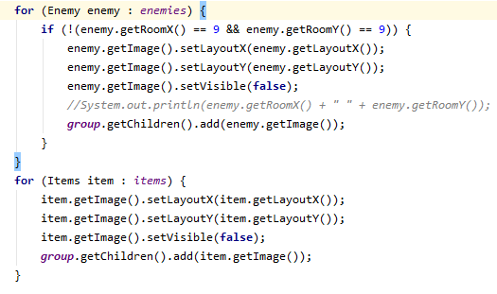

This creates the correct number of items and enemies.

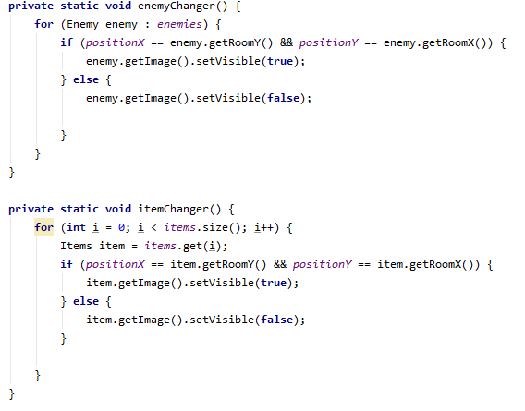

These procedures are called when the character interacts with a door.

When introducing this new system to the game I immediately noticed a problem; in my game i substring a String called CurrentFloor, e.g. CurrentFloor = floor 5. This is get the number on the end and use that as the array position to interact with enemies and items. With the new map system, this never would have worked so I was forced to make modifications to the procedures: enemyMover, enemyAnimater, attackingEnemies and staffShooter.

### Dynamic background generation

With a set map whenever you enter a new room it would change the background to a pre decided image.

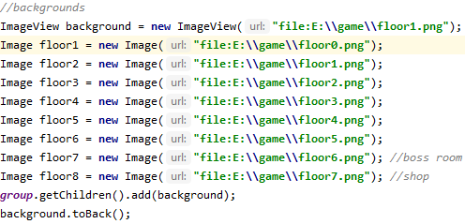

To do this with a randomised map I made a dynamic array that generates the backgrounds.

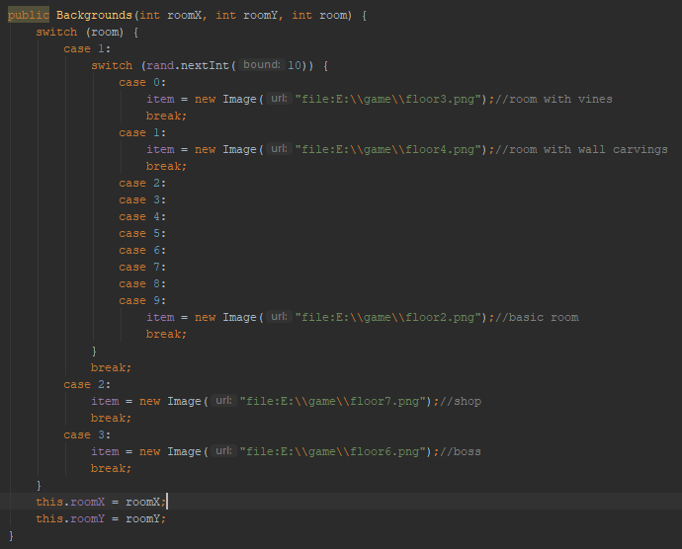

I then made a backgroundChanger procedure and added it to the roomChanger procedure it be called when necessary.

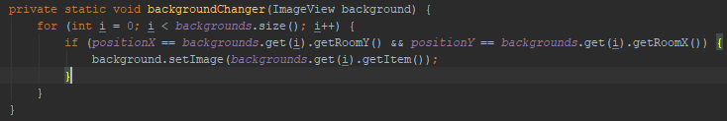

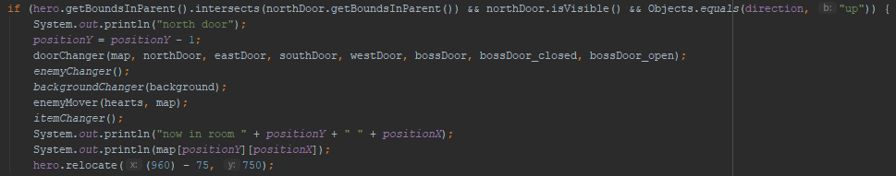

To add the boss back all i had to was called bossRoom when the character intercepts the boss door then the rest handles its self.

### Further optimizations

I then added the shop back to my game. To do this i made a procedure called shopChecker and its called when ever you enter a new room. It simply checks if the room is a 2 (shop) then makes the shopkeeper, staff and damage boost visible.

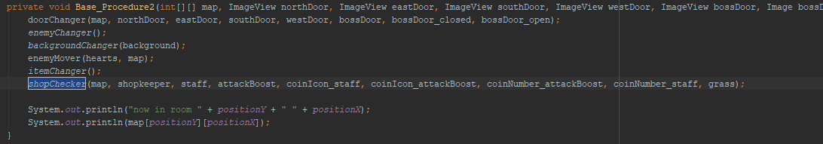

For simplicity the Base_procedure2 is called when you enter a room then it called all the required procedures.

### Creating the mini map

In my previous version of the map i made a physical map that appears in the corner of the screen, obviously with a randomly generated map it becomes a bit harder to do that.

I first tried to get the X and Y array position of the highest and lowest room as well as the leftmost and rightmost room. then isolate that ‘mini’ map (to remove the hundreds of 0’s that represent empty space) then generate the physical map.

This managed to get the X and Y positions but failed to isolate the map.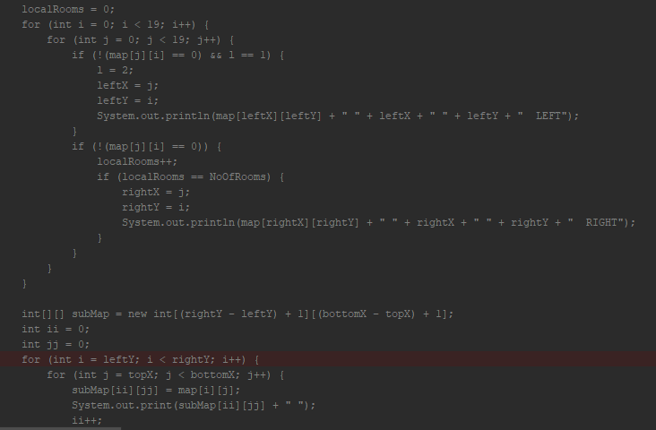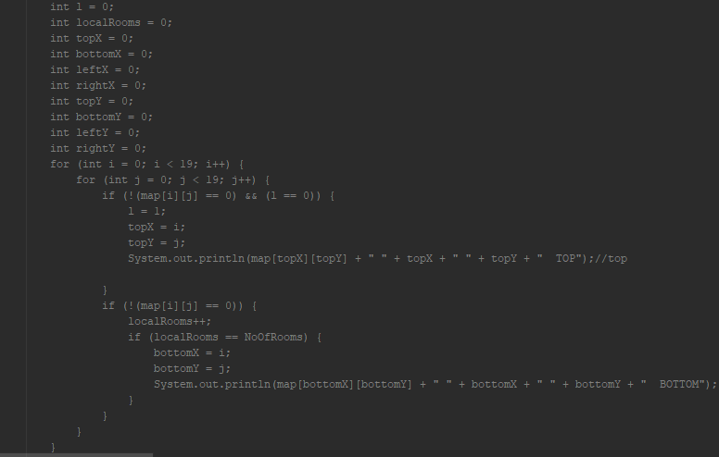

Another way of doing this was to just send the whole map to the class and adjust the map so that it fits in the corner.

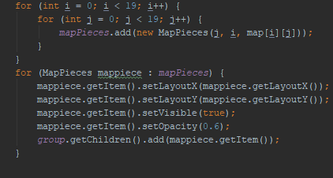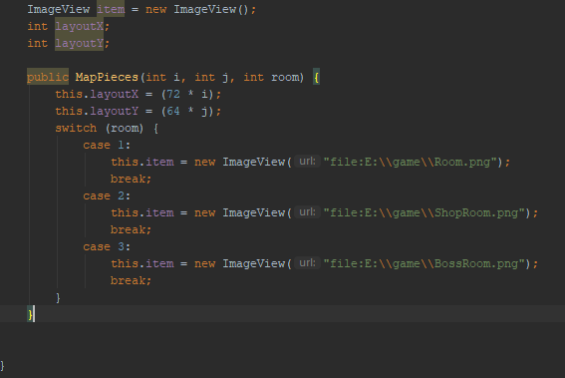

This is the new mapPieces class that sets the position and image accordingly.

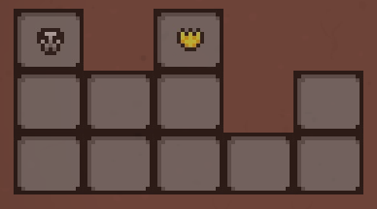

Currently the map is displayed in the middle of the screen because i send the class the whole map array. To amend this, I am now getting the array position of the highest room then moving all of the rooms up so its inline with the border.

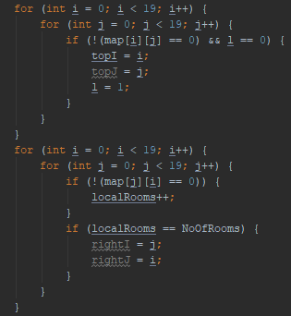

This gets the array positions of the highest and far most right room.

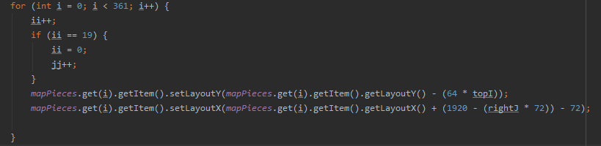

This makes it line up with the top right border.

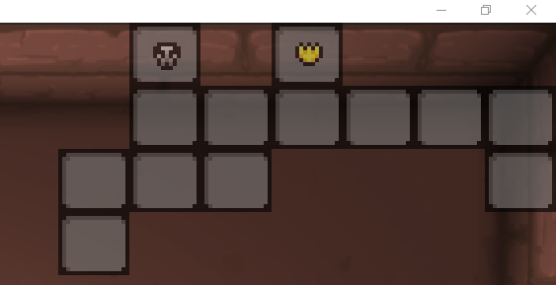

### Addition of map to the shop

Based on user suggestion I added the ability to buy the map to the shop instead of finding the map in the dungeon.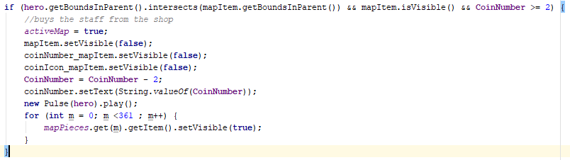

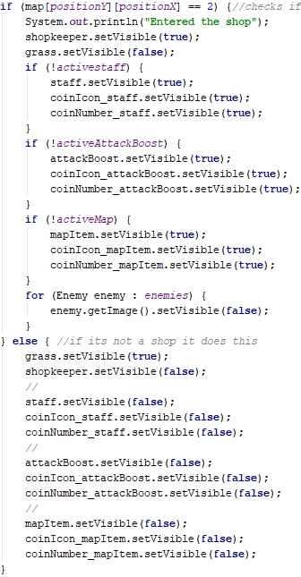

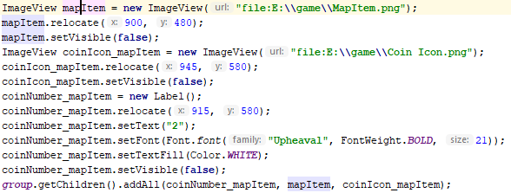

This code creates the image, label and coin icon then added it to the shop and checks if it interacted with.

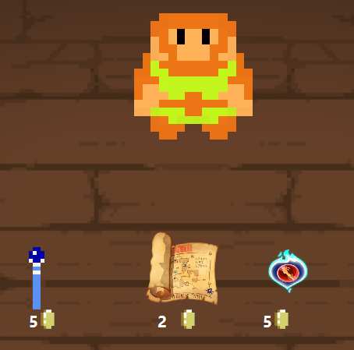

### Room indicator on the map

I then added a map indicator to show the player what room they are in.To do this i took the room image and light a lighter version of it

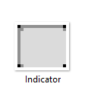

I then overlaid it on the starting room

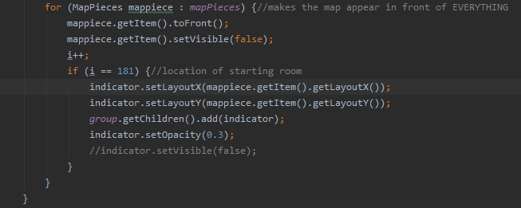

When creating the map I made a for loop that runs at the very end of the start procedure, the loop hides all the images but also moves them to the front. For the indicator i added an if statement that places the indicator image over the starting room.

I also added to the room changer procedure to move the indicator when the player touches a door.

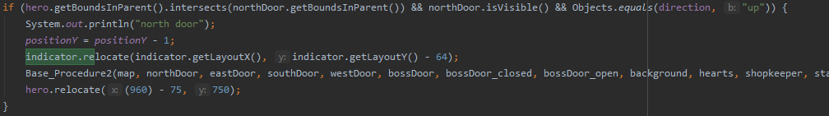

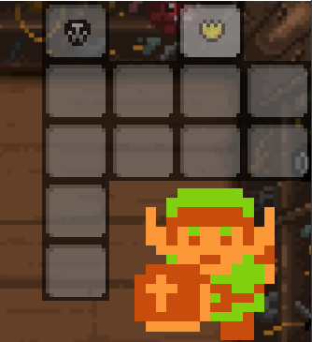

Here is what the map looks like when the character buys the map in the shop.

### Updated menu design

I then improved my opening menu screen by giving it a title. To do this I made 5 test titles and had people vote on their favourite.

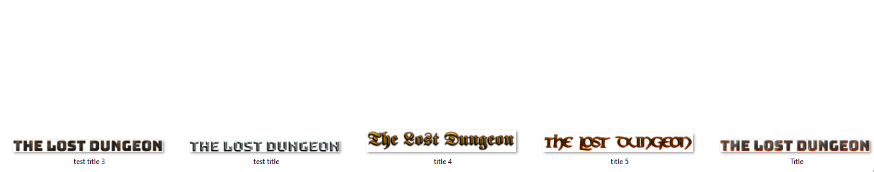

out of these five, the far right one was the most popular so I added it to the title screen.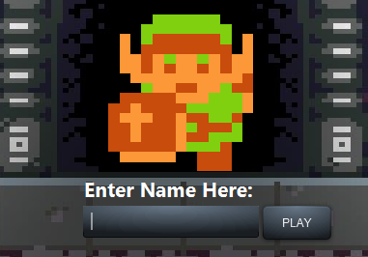

on the menu there is a button and textfield, both of which are blank and unfitting. To fix this i used css to modify them.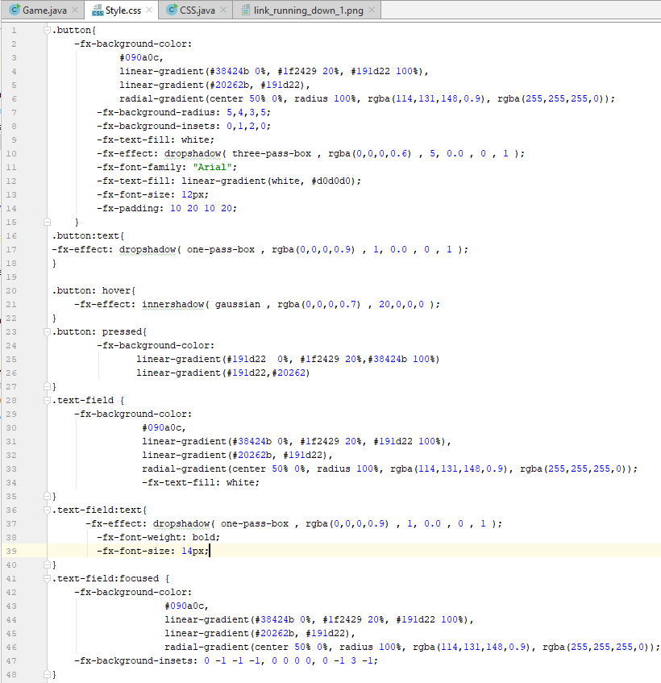

In the css file there are segments for hovered (cursor over the button) and pressed. When the mouse hovers over the button or textfield, an outer shadow is applied to indicate that they can be interacted with. When the mouse clicks either of them; the gradient reverses to indicate that the button has been pressed.

This is the complete menu screen.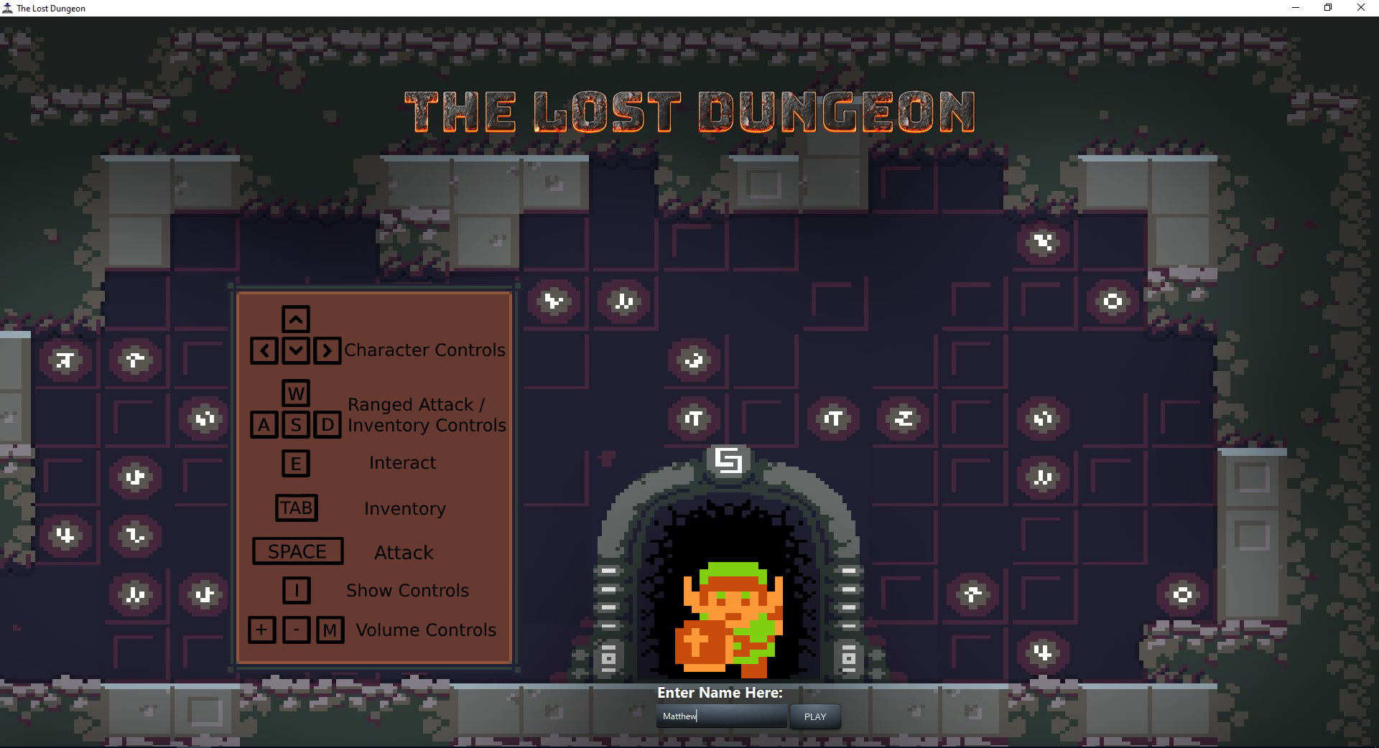

### Ability to use items by clicking on them

for the games design i think that the small details are more important than the big ones; The subtle details that they may not notice at first but when they do, they appreciate it. This is why i asked someone to play my game just to see how they would intuitively play it, when it came to using items they opened the inventory and clicked the items using the cursor which didn’t work but it's what they first thought of so i added it to the game.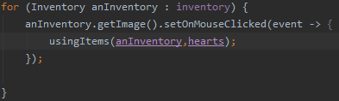

When an item in added to the inventory this triggers which applies a set on action which sends the item clicked on to the new using Items.

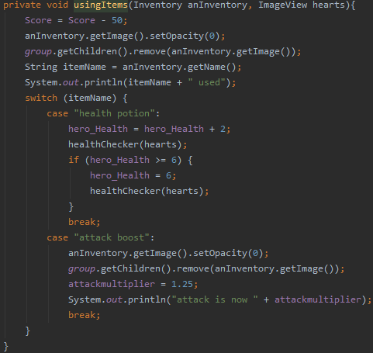

This code use to be in the else that used items in your inventory but this code would need to be triggered in the set on action so i made it into its own procedure.

### Improved character name submission

When someone tried my game they put the username as all spaces which worked. Currently there is a check to make sure it's not empty but there wasn’t a check to make sure that the username doesn’t contain any spaces, so I added it to improve the names that you can submit.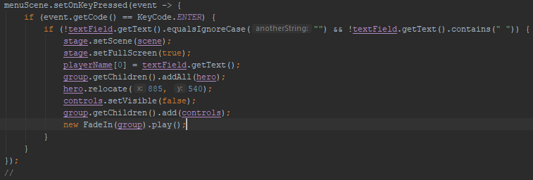

Menu scene listener.

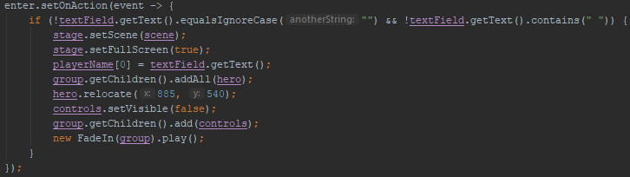

Enter button listener.

I also added a length check so that the username needs to be between 6 and 15 characters.

### Adding inheritance to all classes

The eight classes I use now all inherit their getters, setters and variables from the base class.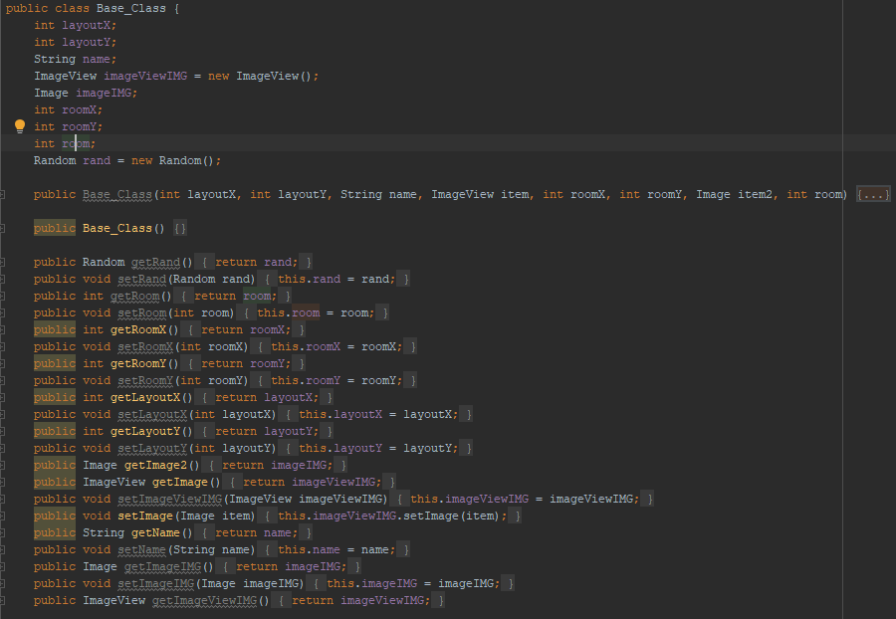

### Updating enemy animation

Using the spritesheet I got these images.

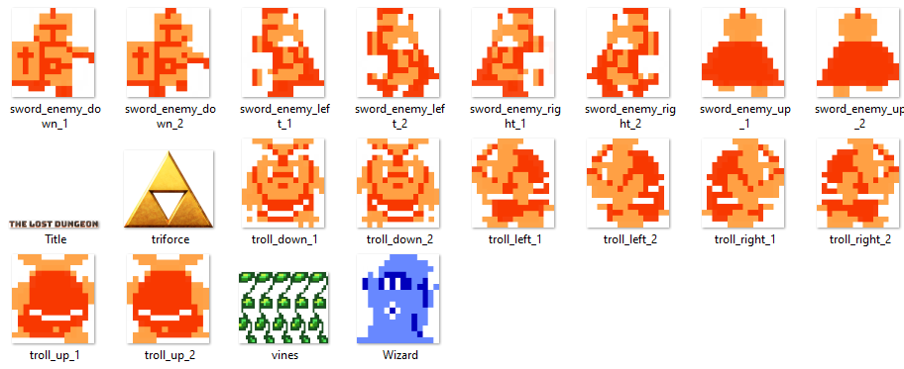

I then made this procedure:

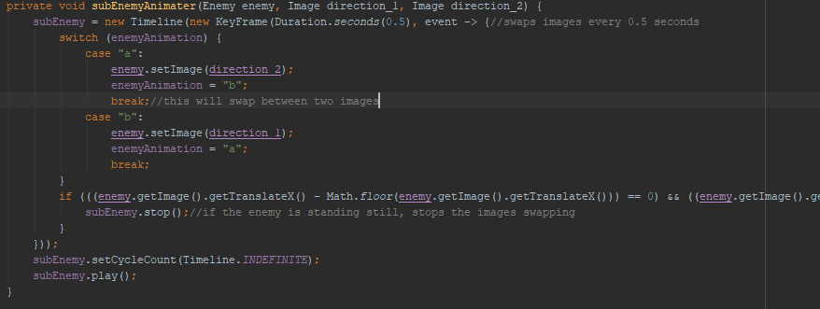

This procedure is called in the enemy animator procedure,

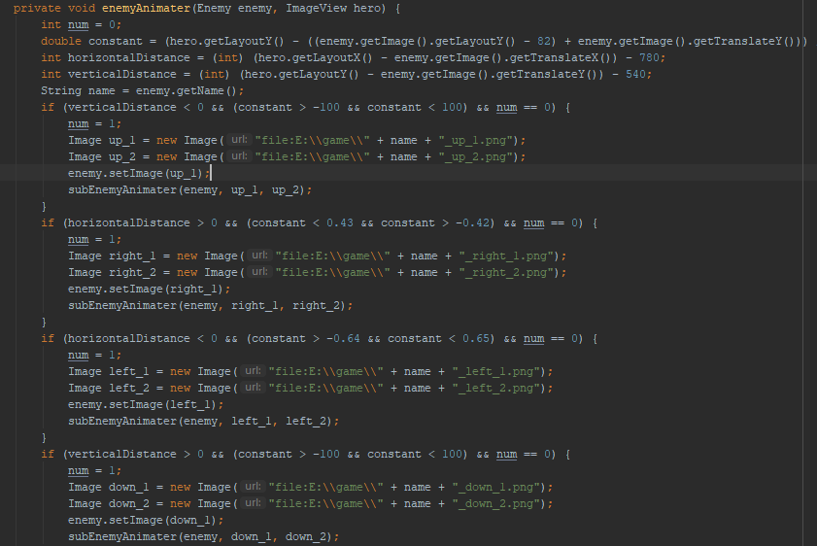

When the enemy starts to move if checks the gradient/constant, sets the appropriate image then sets num to 1 so that only one if statement is activated and finally it sends the enemy and the two correct images to sub enemy animater.

While the code above didn’t work as intended, it led me to further improve multiple elements of enemy movement and enemy animation.

Firstly i altered the constant/gradient calculation to improve its accuracy and the boundaries of the if statements.

When testing it i realised a way to simplify how i was detecting if the enemy had stopped. previously i did this:

When looking back on this I remembered the optimisations made earlier to the wand’s magic and the bosses fireballs involving .setonfinished, I then added that here to make this:

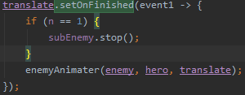

because enemyAnimater is simply 4 if statements, sometimes it would activate 2 at once and therefore call subenemyanimater twice resulting in very strange movement. It is able to call two at once because the up and down statement were at the top and the conditions were broad enough to be called when it shouldn’t be.

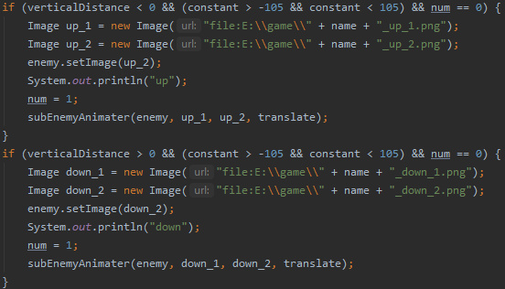

so sometimes when the hero was to the left or right of the enemy it would call one of these then left or right statement to correct it, this worked fine with just images; but when procedures and timelines are involved, it breaks the code. Therefore I moved the up and down statement to the bottom to allow the correct ones to be called in the correct order.

For an extra precaution it checks a check to see if the timeline is running before it calles enemyAnimater, if it is, it then stop the timeline.

After making the subEnemyAnimater, it more or less worked well but it was the enemyMover and enemyAnimater procedures that had to be amended to accommodate the subenemyAnimater.

One problem I found with this is that because it only changes the image when the translate stops, the first time the translate starts e.g when the game starts and you leave the first room, the enemy will not be animated.

I then wrote some pseudo code for the enemy animation:

enemyAnimater()

if player is right of enemy

enemy set image right 1

subEnemyAnimter(right 1, right 2)

if player is left of enemy

enemy set image left 1

subEnemyAnimter(left 1, left 2)

if player is above enemy

enemy set image up 1

subEnemyAnimter(up 1, up 2)

if player is below enemy

enemy set image down 1

subEnemyAnimter(down 1, down 2)

subEnemyAnimter(direction 1, direction 2)

new timeline every 0.4 seconds

switch enemyAnimationString

case a

enemy set image direction 2

enemyAnimation = b

case b

enemy set image direction 1

enemyAnimation = a

to fix this I added a for loop in the if statement that controls the number of timelines,

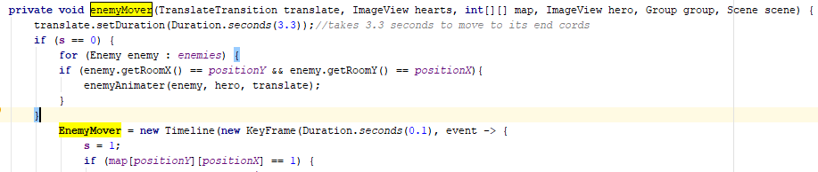

this gets the first enemy that you encounter and animators it, at first the enemy was facing the wrong way, because the enemyMover procedure is called before the hero’s X and Y position is updated when it touches a door. To fix this I simply updated the hero X and Y before the enemyMover procedure is called.

### Updating checkCollision procedure

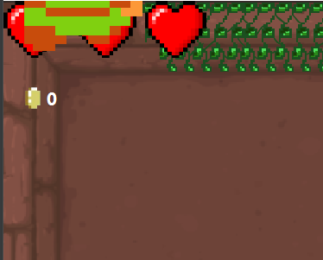

While playing the game, I found that when you run diagonally towards a corner of a wall you are able to glitch out of the walls.

Here you can see the player half way through the wall:

To fix this i made the checkCollision procedure recursive.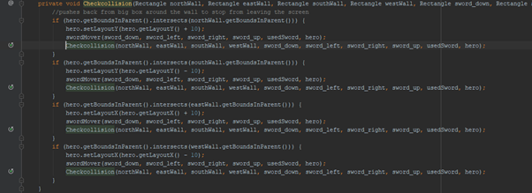

### Restricting login names to only characters

I added this to the if statement that checks the username:

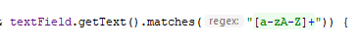

This makes it so only the characters A to Z can be used, therefore no special characters can be used e.g. £$%(+[@.

This allowed me to remove the space check as the a-z check covers it.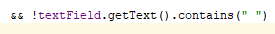

I then made a message that pops up if your username doesn’t fit the criteria

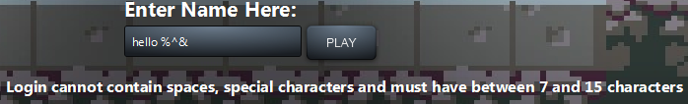

### Attack Handler optimization

The attack handler is a procedure that is called when you press space or W,A,S and D when you buy the staff. Its main function is the swapping of images, setting variables and calling sub procedures that deal with attacking enemies; When the attack handler procedure was made, it was made purely to function but looking back on it now, it can easily be optimized.

The attack handler procedure is made of two parts. Setting the image and resetting the image after 1 second.

Before: 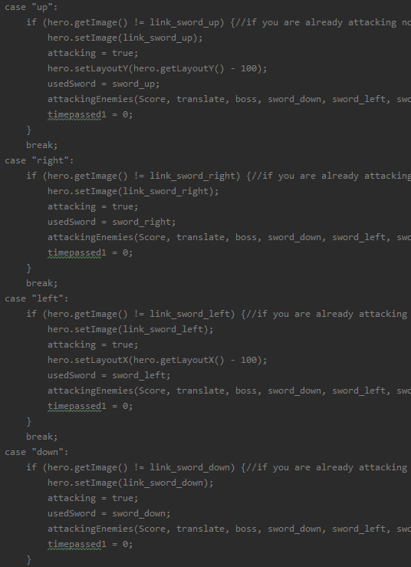

This changes the image to an attacking image with the sword.

After:

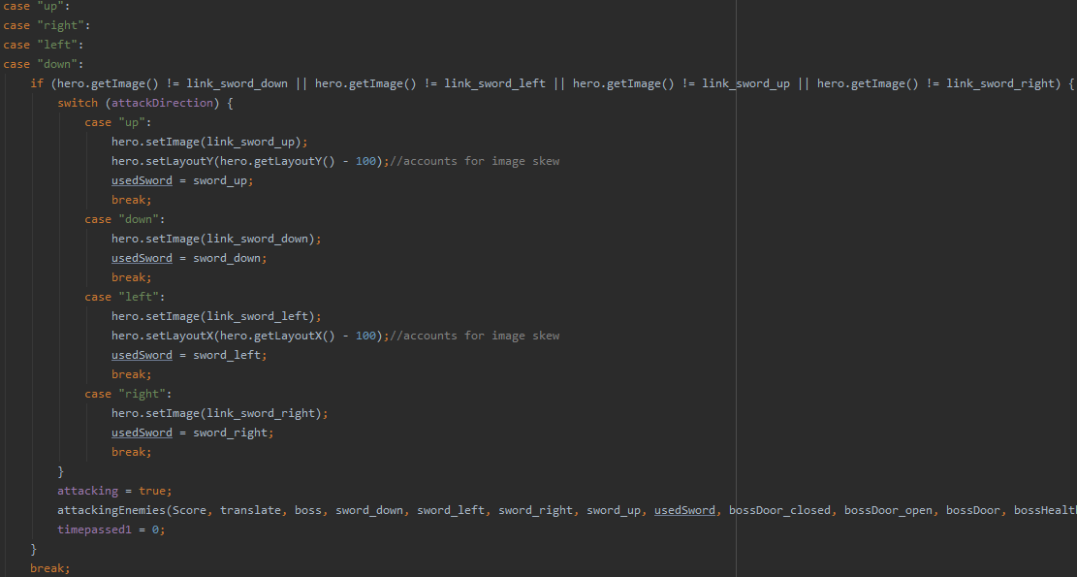

Before: After: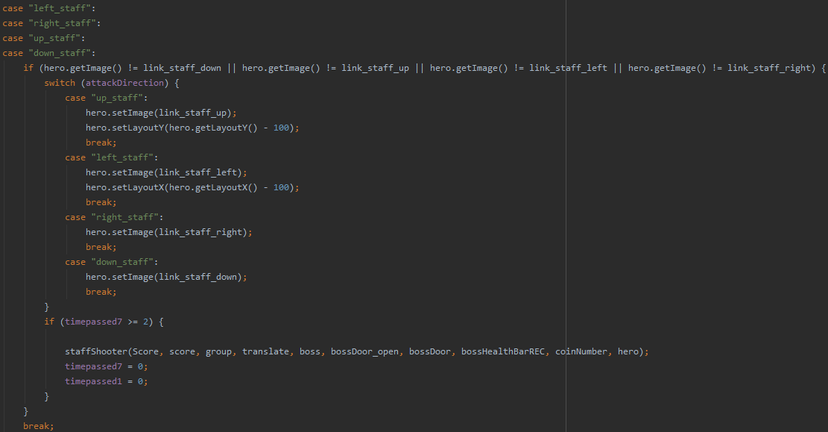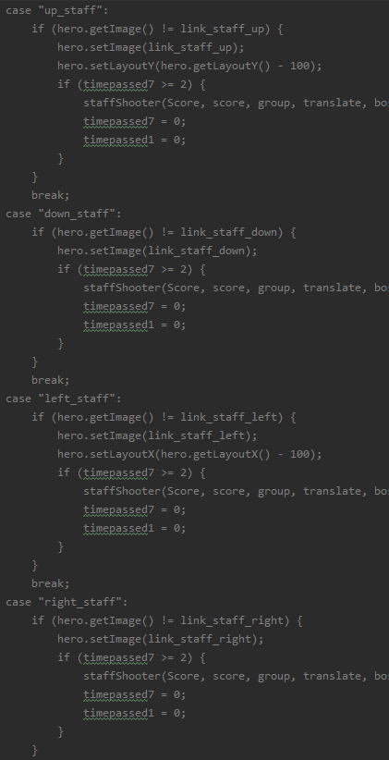

This changes the image to an attacking image with the staff.

I then did the same changes for the image reversing, in which is changes from attacking back to walking

### Death Screen

To start this i made a new procedure called DeathScreen that is called when health reaches 0

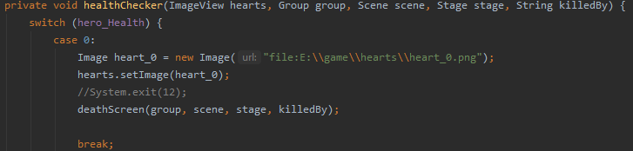

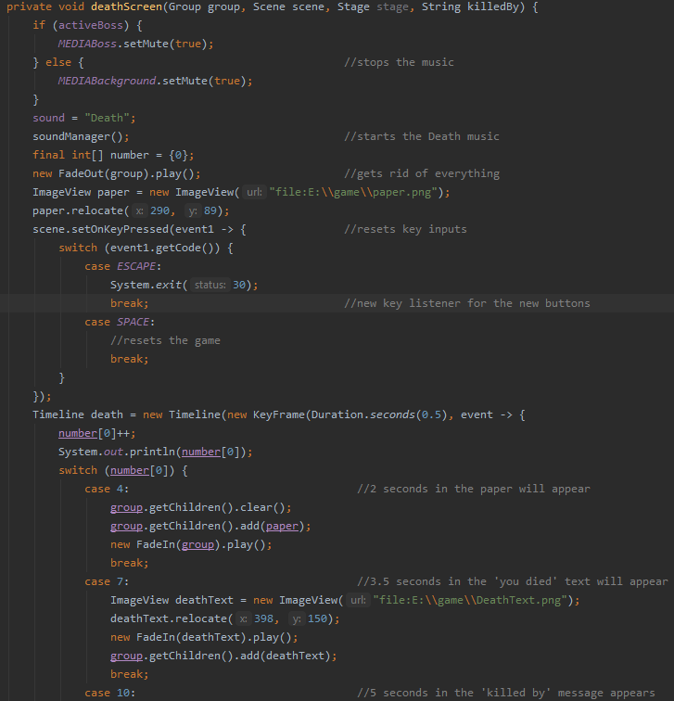

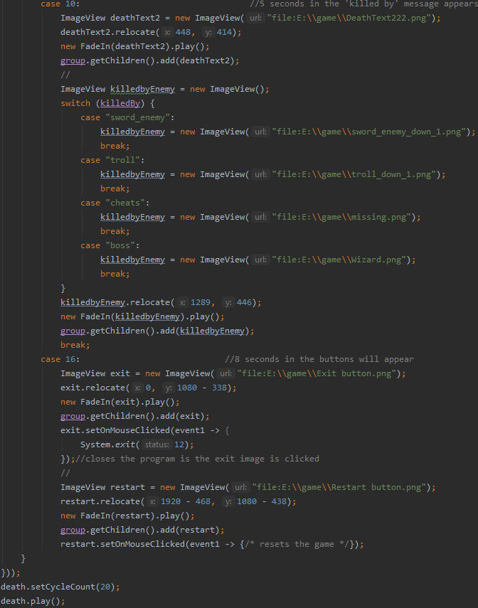

For now the reset button has no working function as I plan to add that later.

After the player has died and 8 Seconds have passed, this will show: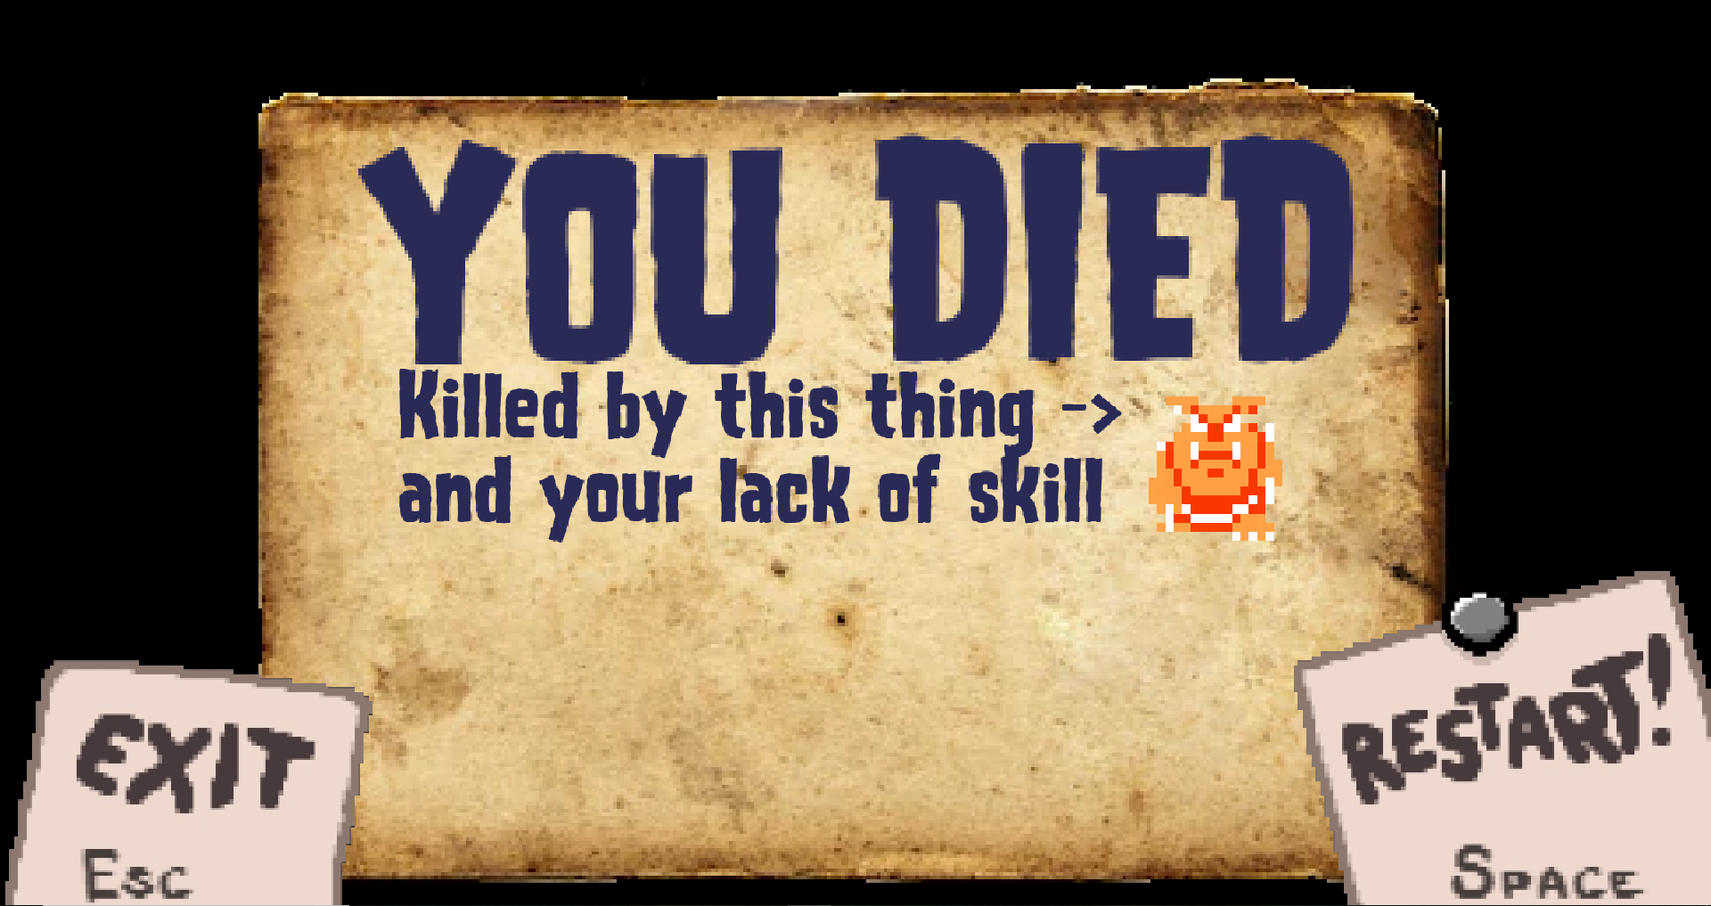

### Item Description & improved inventory functionality

I got this idea from the game cave blazers in which the inventory has a side panel that displays information about the selected item.

I started by updating the inventory picture overlay.

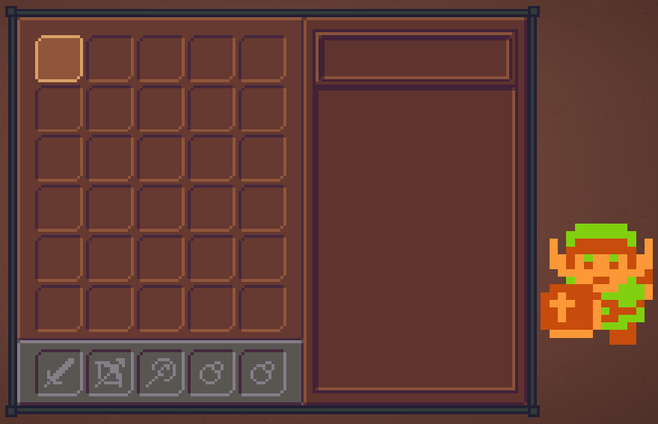

I then re centered the image as it was off to one side, this resulted in me needing to adjust where the selected icon can move as it is hard coded and no longer works if the inventory image moves.

I then updated the inventory class:

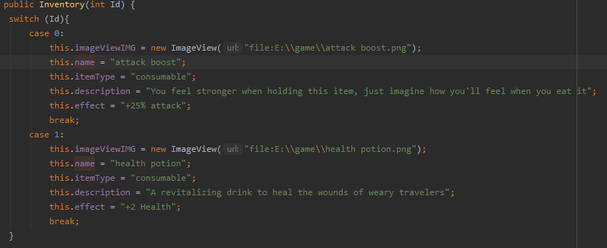

I then made 4 more labels to put the information in as well as a new procedure called itemInformation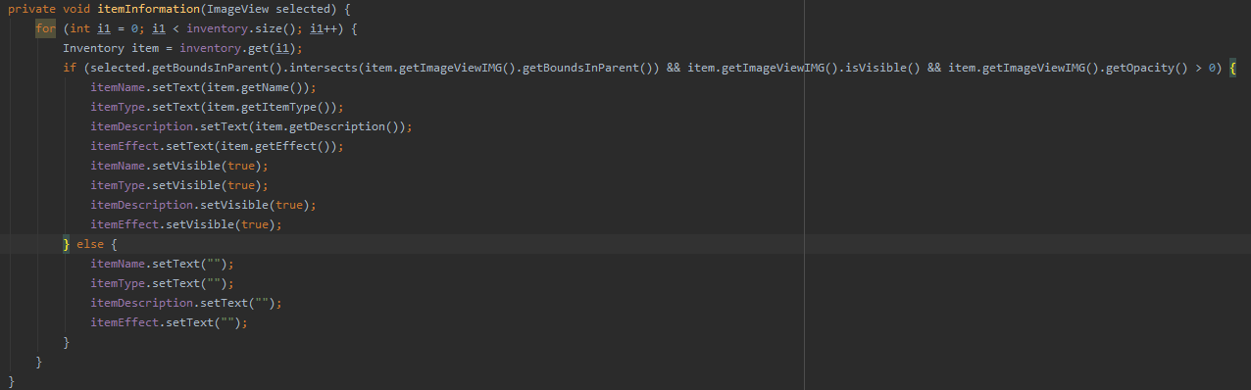

While programming the logic for when the labels should and shouldn’t appear, i came across a bug where it would only show the labels for the last item.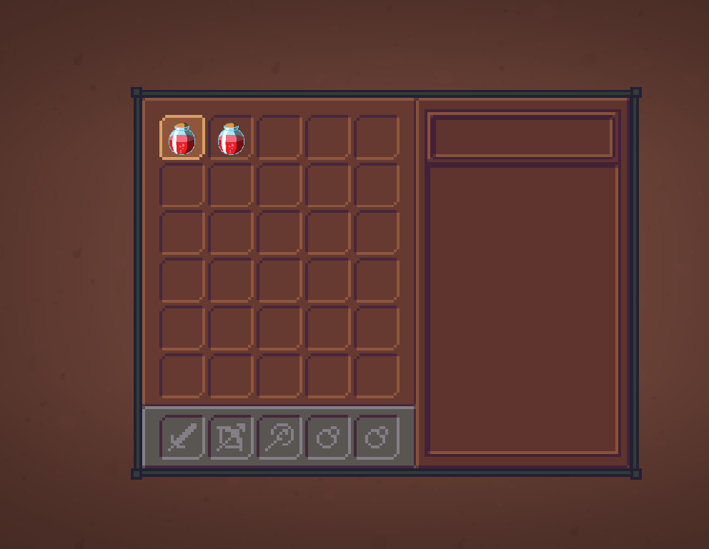

(labels should appear temporarily to the left of the inventory)

I soon realised the flaw in the itemInformation procedure. everytime W,A,S or D is pressed it runs the for loop that finds the item, the problem is that is doesn’t stop when it finds the item. In the example above the label should technically appear then it checks if the 2nd potion is ‘selected’ and since it isn't, the labels are cleared of text.

The simple solution to this is to stop the for loop when it finds the item that is selected.

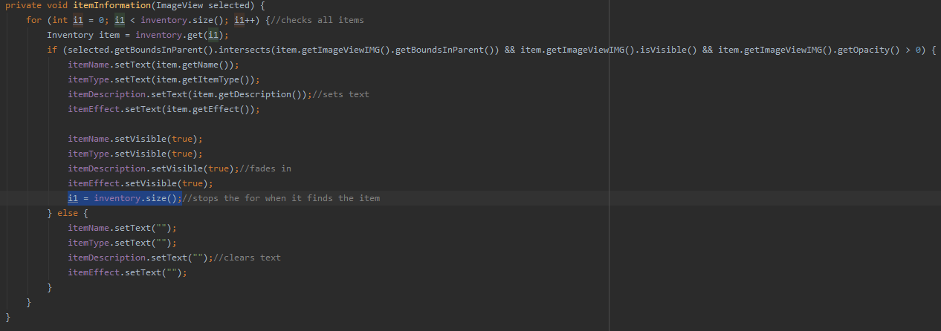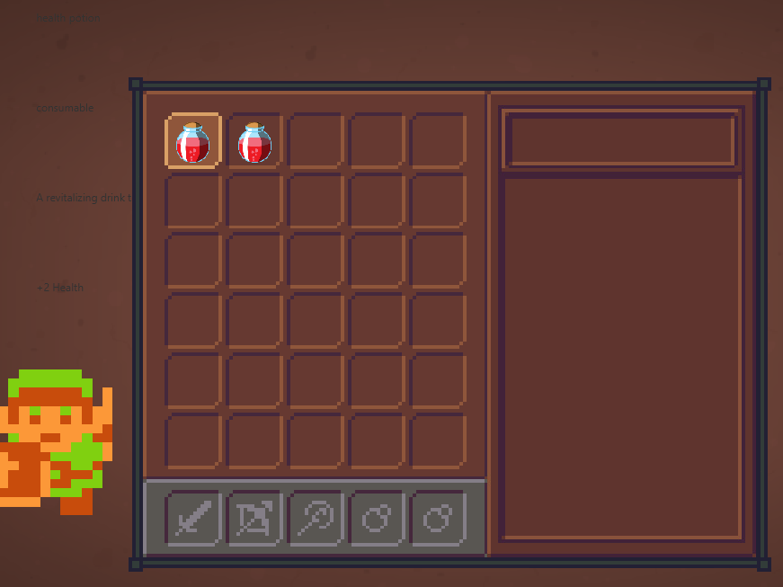

(Labels faintly appear to the left of the inventory as they currently should.)

After properly formatting the labels and some adjustments, i finished with this

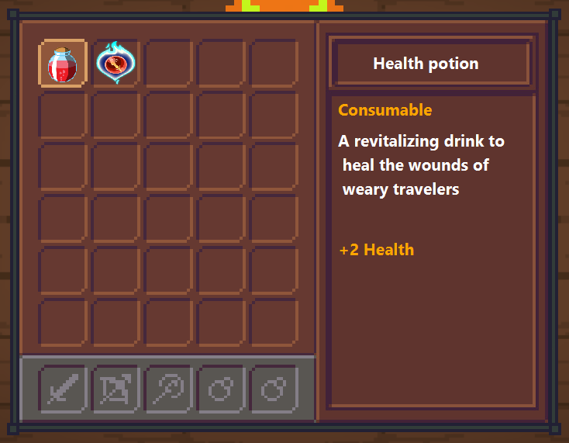

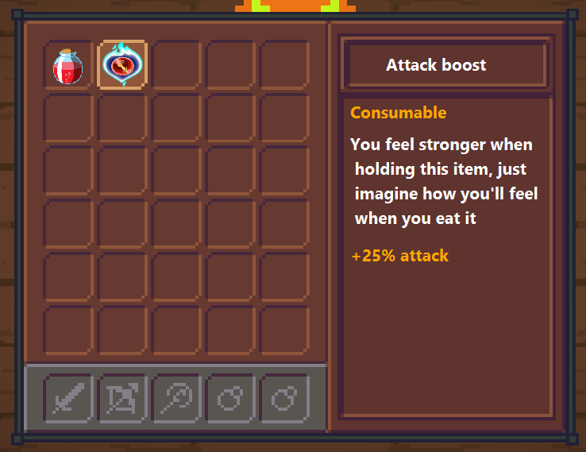

While testing this i came across a strange bug that i wouldn’t of found without the item descriptions. When TAB is pressed, the inventory and its items would fade in, it has been like this for a while but this results in invisible items being able to be used without stopping. I tracked the bug to this for loop in the inventory manager procedure:

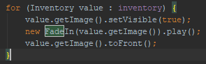

I then updated it to this: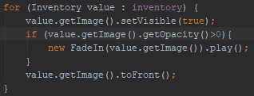

Strangely when something fades in, it tricks my if statements into thinks its visible and has an opacity of more than 0

### itemInformation bug:

while someone was playing the game, they noticed a bug where if the selected is at the border of the inventory and it moves ‘outside’ the border then the item information won’t show.

Before: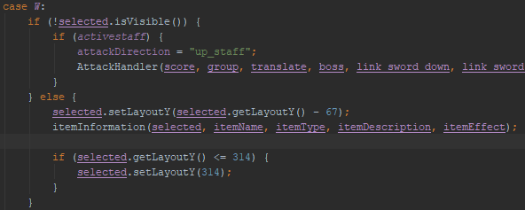

After:

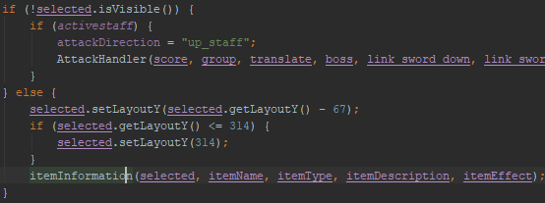

It now re adjusts the selected image before getting the item information.

### Attack handler bug:

While playing I ran into a bug that I thought I had already fixed. it turns out i put || instead of &&. I then fixed this to finally solve the bug.

### map generator addition:

While an end user was trying the game they quickly noticed that the map didn’t create a shop. While this isn’t a bug, it does have a very small chance of happening. To solve this I put the whole of the mapMaker procedure in a do while so the procedure repeats itself if there isn’t a boss or shop room.

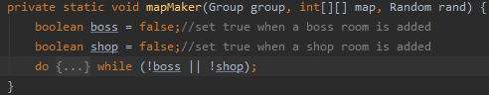

the code that generates the map is inside the {...}

### Updating scores in the database:

When my end user was playing the near final version, they asked if 1 person could get on every leaderboard position. This made me realise that there is no check in the scoreSaver procedure to prevent this.

I did a test and confirmed that it is possible:

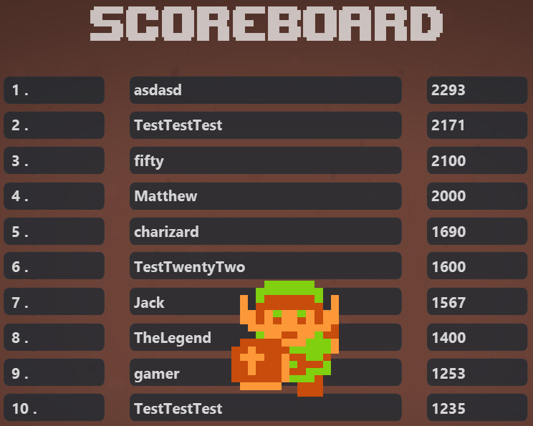

This code checks the player name against the names in the database, then determines if that player has a new high score. If they have, it will update the score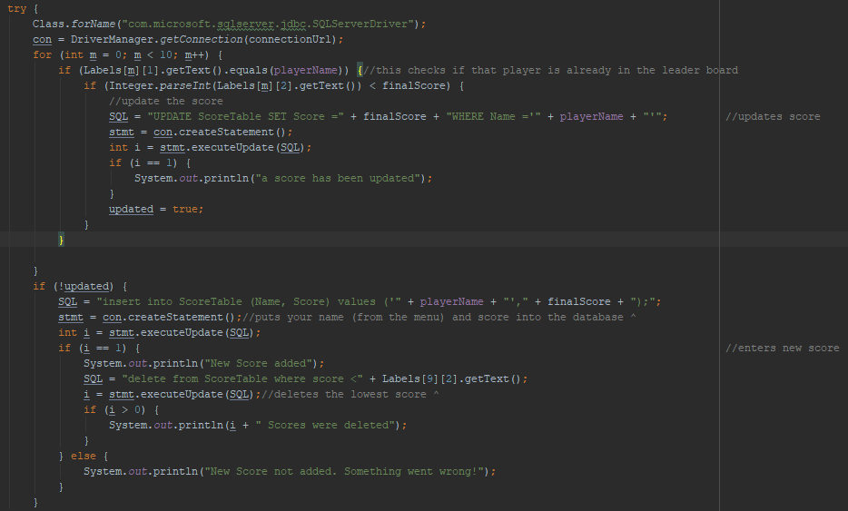

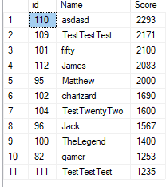

I entered the name james then complete the game to get it in the leaderboard

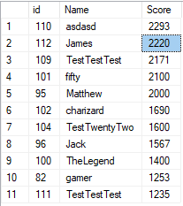

I then entered the name again and got a better score so that it would update the score.

### Restart feature

The restart button on the death screen now works.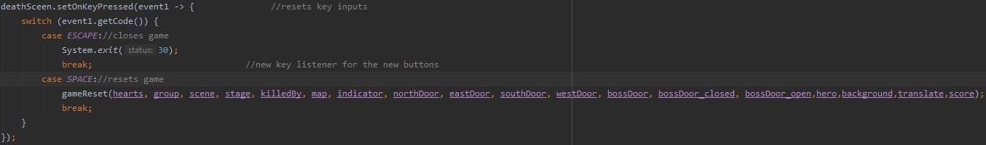

The for loops are needed to fix a strange issue with intellij. If i were to just clear the arrays, the images of the items, enemies etc would still be there. To fix this I turn the images invisible then remove them from the group. 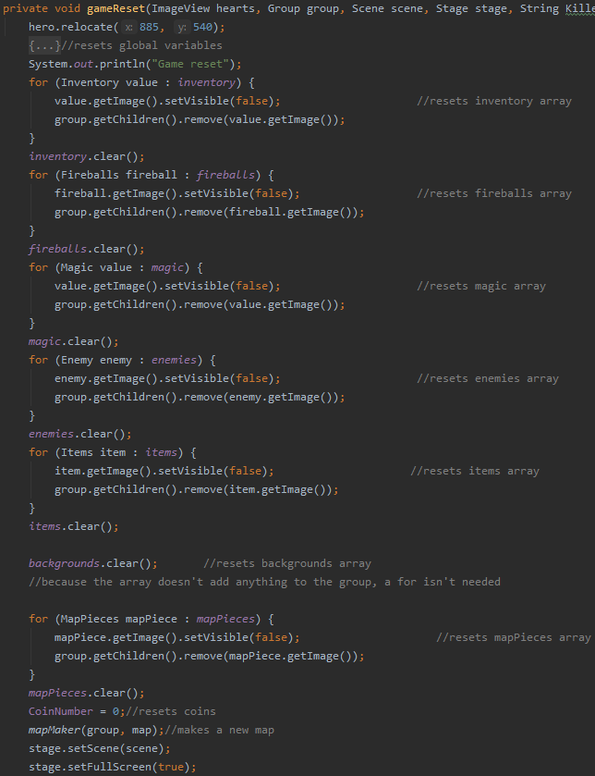

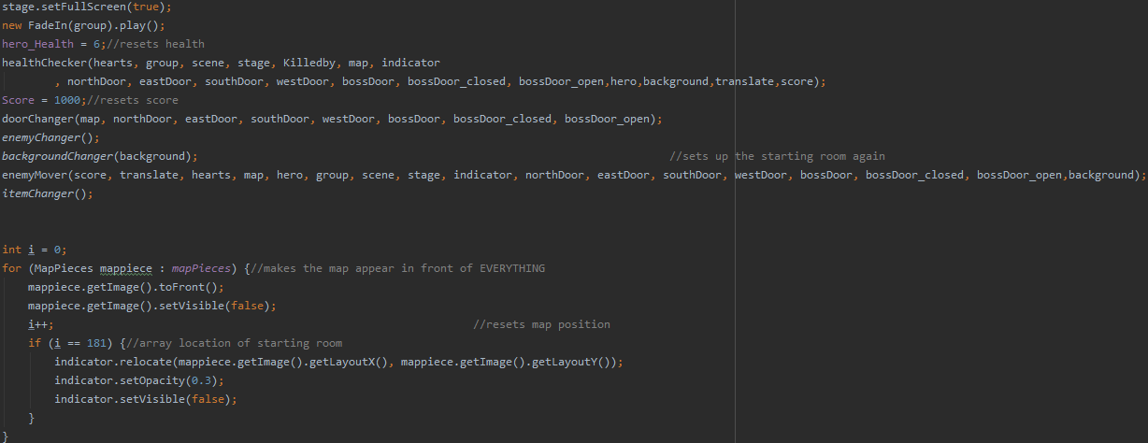

### Inventory enhancements

Currently for keeping track of what's in the inventory, i only have the dynamic array that’s used to create the items. But to advance my inventory system I needed a way of keeping track of what's in the inventory at any given point. Taking inspiration from my map, I created a 2D array to represent the inventory that the player looks at. This is to act as a mid way between the player and the inventory class.

The Array is a 5x6 and set to all 0’s (representing a free space)

To pick up items it seemed fairly easy, put the item in the first 0 found, then position it relative to that point.

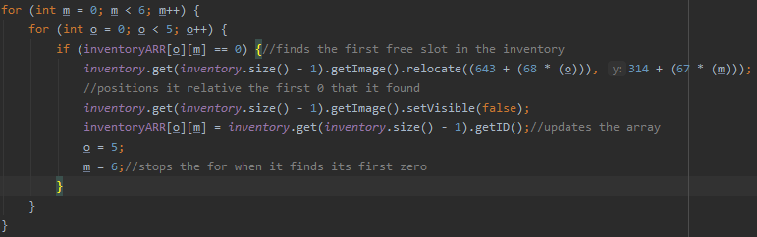

to properly format the 2D array, I added an ID field to the inventory and items class to link them together when making and using items.

If 1 health potion were to be picked up, the array would look like this 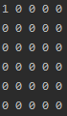

where a 1 is a health potion.

Putting numbers into an array is the easy part, the difficult part was taking them out. When an item is used; the array must be updated to accurately represent the inventory. To do this I get the X and Y or the item used and work backwards to find an array position.

Since the top left corner of the inventory has an X and Y that i know, and take the items separate themselves at a difference that i also know. The X position of an X is the starting position + an integer number X spacing.

To find X/array position I set up while loops.

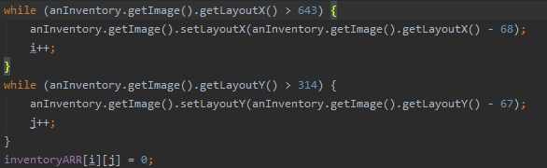

This system also allows me to properly set the locations of the items.

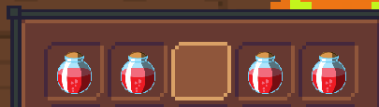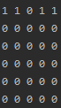

In the old system if i picked up another item, it would be forced onto the next row. But now it's placed in the next available slot.

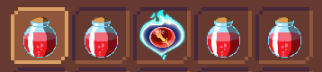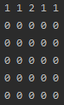

Another benefit is that it allowed me to discard 3 global variables that i used to track the inventory

## Object diagrams and class definitions

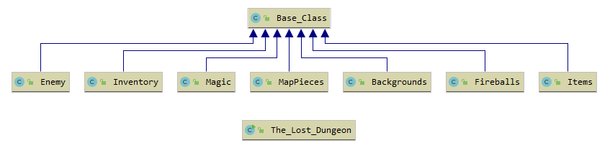

Class diagram showing the inheritance relationship between the classes

## 

## Design data dictionary

|  |  |  |  |
| --- | --- | --- | --- |
| Variable Name | Variable Type | Access Type | Description |
| PositionX | Integer | Static Global | Holds the X position of the player relative to the map 2D array |
| PositionY | Integer | Static Global | Holds the Y position of the player relative to the map 2D array |
| enemyAnimation | String | Global | Holds the current animation of the enemy in the players room. So the enemy can compare then swap |
| activeBoss | Boolean | Global | Holds true or false if the boss is active. Used when coming to attacking enemies. |
| activeStaff | Boolean | Static Global | Changes when the player buys the staff from the shop. |
| activeAttackBoost | Boolean | Static Global | Changes when the player buys the attack boost from the shop. |
| activeMap | Boolean | Static Global | Changes when the player buys the map from the shop |
| direction | String | Global | Changes when the player moves and used to animate the player. |
| attackDirection | String | Global | Changes when moving and attacking. |
| attacking | Boolean | Global | Changes to true when the player attacks and to false to when their animation changes back. |
| defeatedEnemies | Boolean | Global | Increases by 1 when an enemy is defeated. When size is equal to size of enemy class, The boss door opens. |
| up | Boolean | Global | Changes to true when the player moves up. Used to walk diagonally. |
| down | Boolean | Global | Changes to true when the player moves down. Used to walk diagonally. |
| left | Boolean | Global | Changes to true when the player moves left. Used to walk diagonally. |
| right | Boolean | Global | Changes to true when the player moves right. Used to walk diagonally. |
| hero_Health | Integer | Global | Holds the hero’s health, between 0 and 6. |
| CoinNumber | Integer | Global | Holds the hero’s coin number, this increases when an enemy is killed and decreases when an item is brought from the shop. |
| Score | Integer | Global | Holds the player’s score, Starts at 1000, Decreases by 1 every second.Saves to the database every boss is defeated. |
| PlayerName | String | Global | Holds the player’s name when they enter it at the menu. Saved to the database when the boss is defeated. |
| MEDIAWalking | MediaPlayer | Global | Contains the walking sound effect for the player. |
| MEDIABackground | MediaPlayer | Global | Contains the background music played throughout the game |
| MEDIABoss | MediaPlayer | Global | Contains the boss music played during the boss fight |
| backgrounds | Arraylist | Local | holds the unique background image for each room generated. |
| enemies | Arraylist | local | Contains the enemies for each room. |
| magic | Arraylist | local | contains the magic projectile when the staff is used. |
| fireballs | Arraylist | local | contains the fireballs for when the boss is attacking. |
| inventory | Arraylist | local | Holds the items in the players inventory. |
| items | Arraylist | local | Holds the randomly placed items for each room |
| mapPieces | Arraylist | local | Contains the image version of the randomly generated map. |
| inventoryARR | 2D array of Integers | local | holds a copy of the players inventory to improve functionality. |
| animationHero | String | local | Holds the current animation of the player so that when moving, the player’s image swaps. |
| group | Group | local | Contains all elements seen in the main game |
| menuGroup | Group | local | Contains the elements seen in the menu |
| deathGroup | Group | local | Contains the elements seen in the death screen when the player reaches 0 health. |
| itemName | Label | local | contains selected item name to be displayed |
| itemType | Label | local | contains selected item type to be displayed |
| itemDescription | Label | local | contains selected item description to be displayed |
| itemEffect | Label | local | contains selected item effect to be displayed |
| hero | ImageView | local | the player’s character that they control. |
| boss | ImageView | local | the boss you find in the boss room |
| map | 2D array of Integers | local | holds the numerical version of the generated map. |
| distanceFromNodeX | Integer | local | Used in generating the map. |
| distanceFromNodeY | Integer | local | Used in generating the map. |
| staff | ImageView | local | can be found and bought in the shop. Used to shoot projectiles |
| mapItem | ImageView | local | can be found and bought in the shop. Reveals the dungeons layout. |
| attackBoost | ImageView | local | can be found and bought in the shop. Makes the player stronger. |
| sword_up, sword_down, sword_left, sword_right | Rectangle | local | Hitboxes for the players sword. They move with the player and are activated when space is pressed to detect a collision. |
| hearts | ImageView | local | Displays the players health in real time. Updates when damaged or healed. |
| score | Label | local | shows the players show, decreases by 1 every second and increases and an enemy is defeated. |
| scoreboardLabels | 2D array of Labels | local | The top 10 scores from the leaderboard are pulled from an SQL table and put in here to be displayed to the player. |
| timer | Timer | local | a timer that increases 6 Integers by 1 every second. These Integers are used for cooldown and invulnerability phases. |
| rand | Random | local | A randomly generated number used for generating the dungeon map and randomly choosing the boss’s attack. |

## data structures

### 1 Dimensional arrays

#### FireBlast - Boss attack

When the boss goes into phase 2, it creates an array of TranslateTransitions for the fireBlast attack then initisises them.

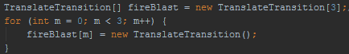

If it randomly chooses to do the fireBlast attack, it will run this code:

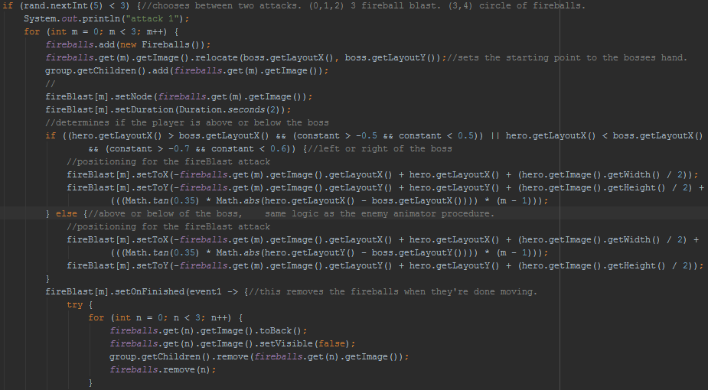

And cause the boss to do this:

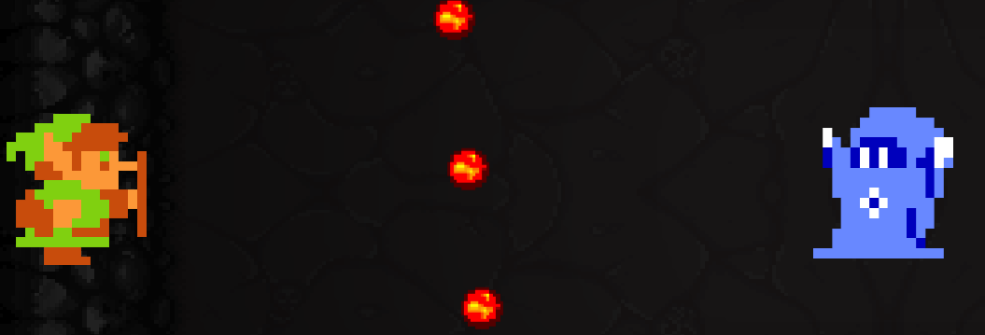

#### FireCircle - Boss attack

When the boss goes into phase 2, it creates an array of TranslateTransitions for the fireCircle attack then initisises them.

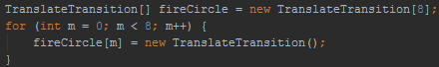

if it randomly chooses to do the fireCircle attack, it will run this code:

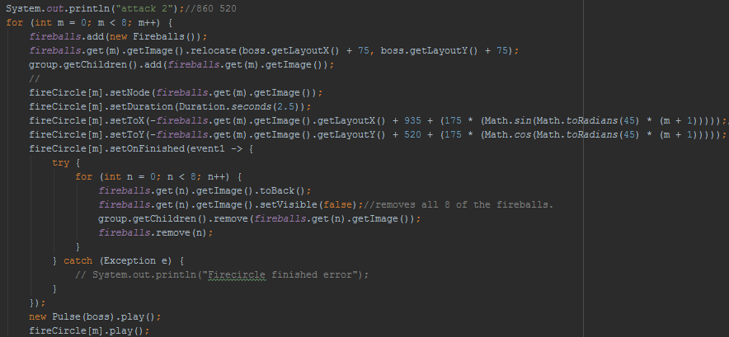

And cause the boss to do this:



### 2 Dimensional arrays

#### Dungeon Map

To randomly generate the map I decided to create a 2D Array that would be used to make and navigate the dungeon map. First of all; a procedure called mapMaker is called which calls mapGenerator which is the algorithm that makes the map.

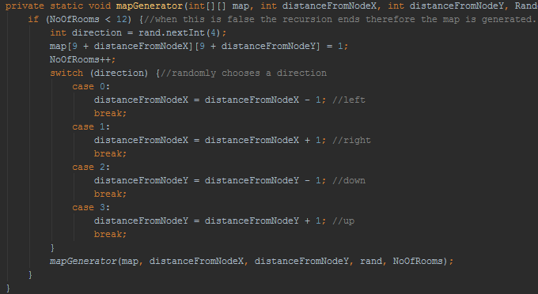

When this algorithm is complete it will continue to add a boss and shop room, then add the items and enemies

#### Scoreboard

When the program is run, it will connect to an SQL database and retrieve the scoreboard, containing the top 10 scores, pull them back and format them to be displayed to the player.

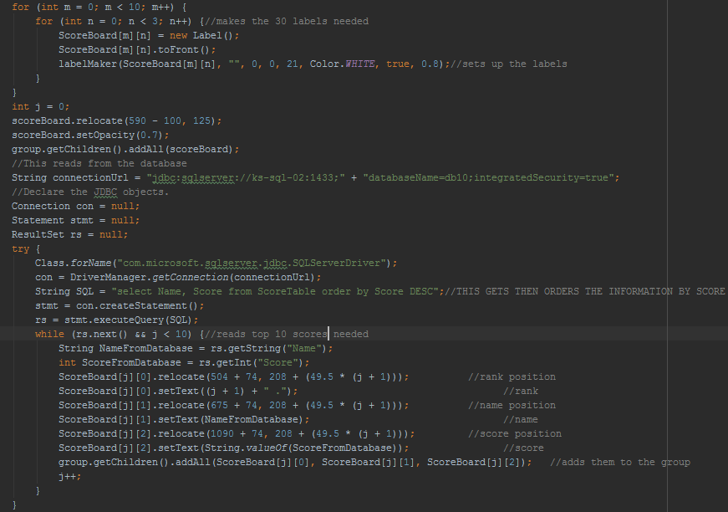

This results in the scoreboard being displayed when the player enters their name.



#### Inventory

The Inventory 2D array is a numeric version of the players inventory at any given point. This allows greater organisation and management of the inventory. For example, when picking up an item it now goes into the first available slot it finds instead of at the end, leaving gaps.

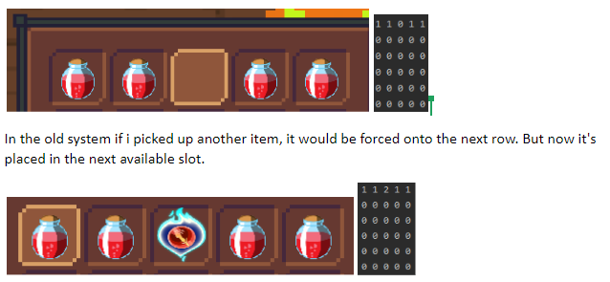

### Dynamic arrays

#### Backgrounds

Based on user feedback I added an element of randomness to the dungeon backgrounds, to do this I made the Backgrounds class that is populated in the mapMaker procedure and checked if it should be changed every time a door is interacted with.

These are the 5 floors that the game utilises:

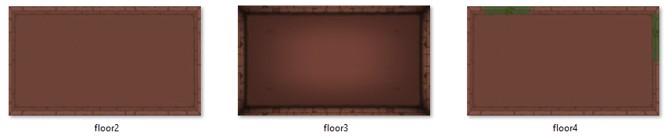

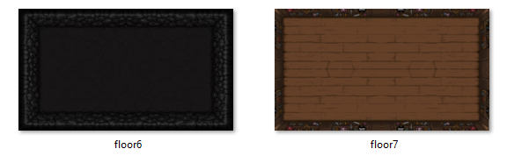

As mentioned before, the Backgrounds class is populated in the mapMaker procedure, after the map is generated and the boss and shop have been added, this will run:

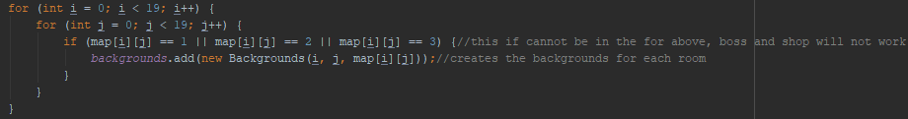

This is the background class that creates the images.

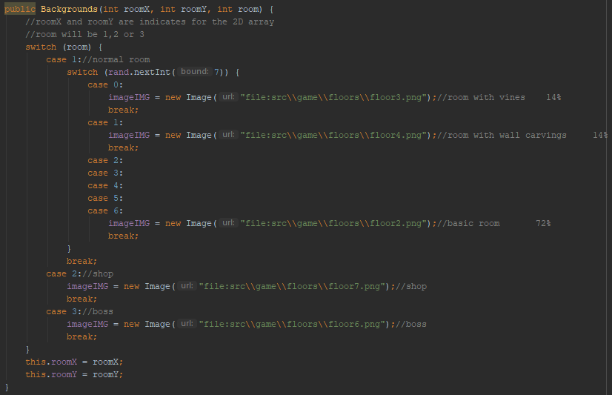

This procedure is called every time the player interacts with a door so that the correct background is displayed.

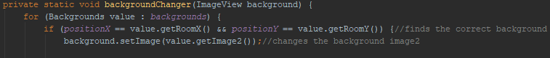

#### Enemies

The enemies array is populated in the mapMaker procedure after the map has been generated. It creates a new instance of the enemy class whenever a 1 is found in the map array. For the enemies to change and move when appropriate, a procedure called enemyChanger is called when interacting with a door, enemyMover is then called which moves and animates the enemy.

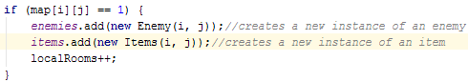

This is the enemy class that randomly chooses an enemy

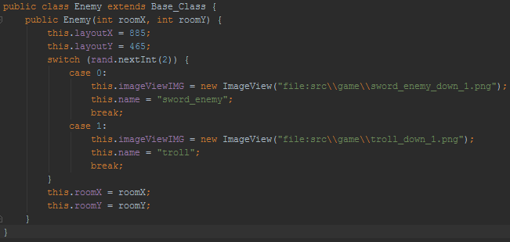

When the player interacts with a door it calls the enemyChanger and enemyMover procedure

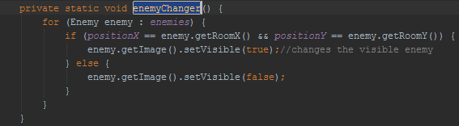

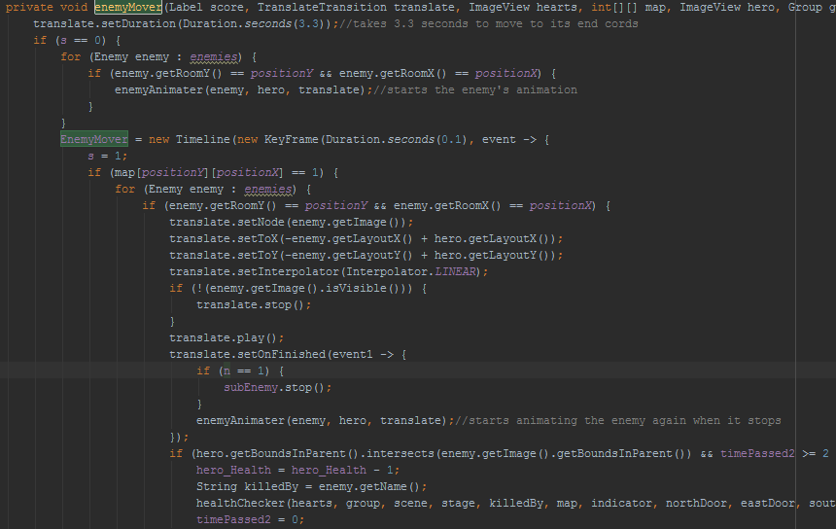

When it comes to attacking enemies, whenever space is pressed, the program checks if the hero’s sword is interacting with an enemy. If it is, the enemy’s opacity will be lowered; if its lowered to 0 the enemy will have been defeated. It will then be removed from the group and dynamic array.

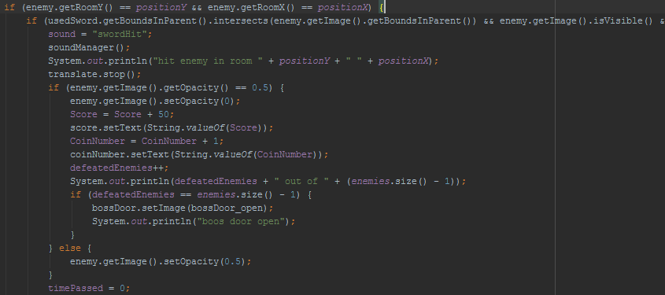

#### Items

The items array is populated in the mapMaker procedure after the map has been generated. It creates a new instance of the item class whenever a 1 is found in the map array. For the items to swap when appropriate, a procedure called itemChanger is called which shows the item in the players room.

When a new instance of the class is made, it randomly positions it chooses the item that appears.

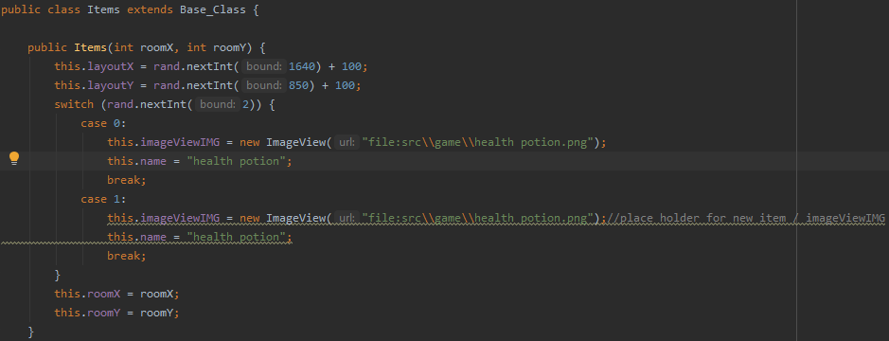

#### Inventory

For an item to be added to the inventory, it must first be picked up. To do that the player must be intersecting with the item and press ‘E’. Pressing ‘E’ this run this code:

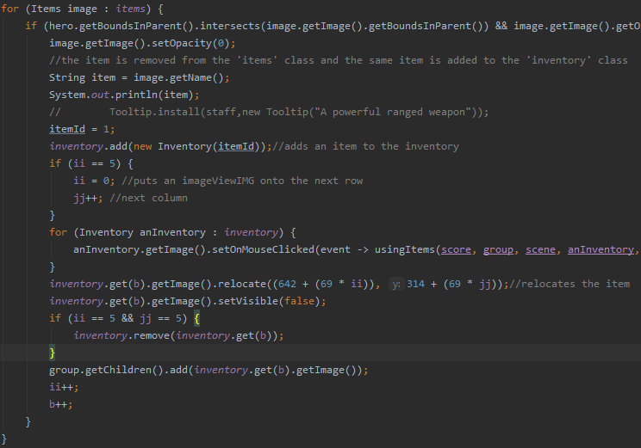

it then creates a new instance of the class depending on its ID:

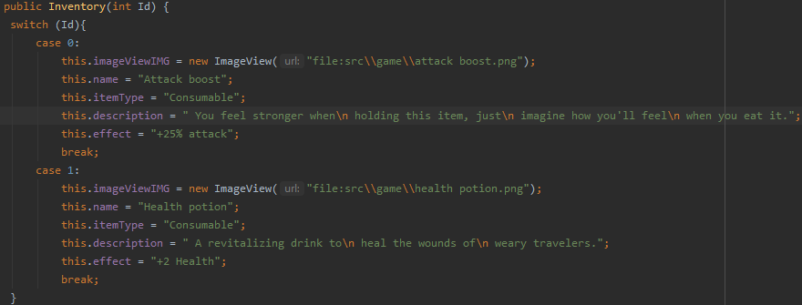

The item that you picked up would then appear in the inventory

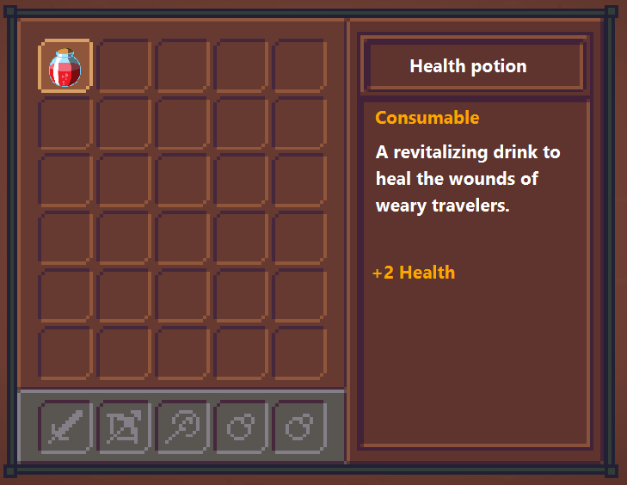

#### MapPieces

Shortly after the map is generated, a procedure called mapItemMaker is called that sends the map array to the MapPieces dynamic array to create an image of the array in the corner of the screen.

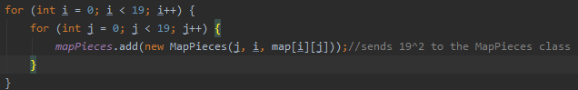

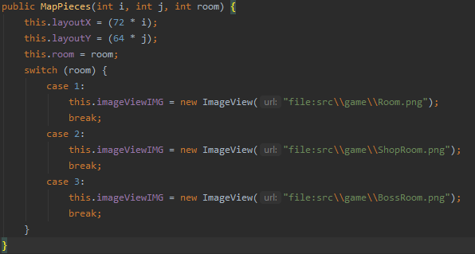

These are the three possible choices for a room.

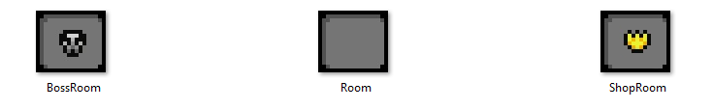

It takes this And turns it into this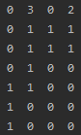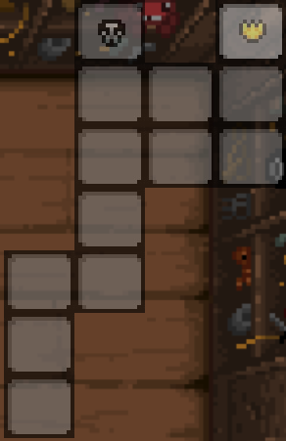

##### 

##### 

##### 

##### 

#### Magic

The magic class is solely used when the player uses the staff to create an ImageView. When W,A,S or D is pressed it creates a magic projectile at the end of the wand and removes it when it’s transition is finished.

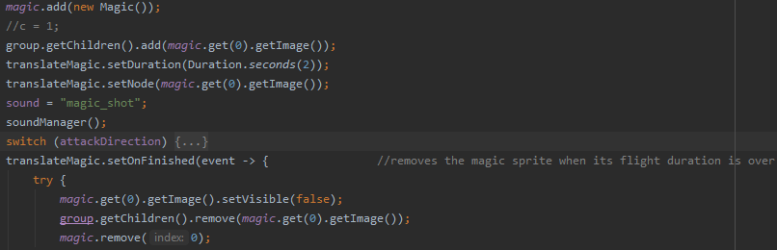

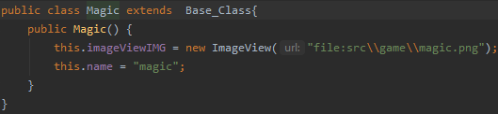

#### FireBalls

The Fireballs dynamic array is used alongside the fireBlast and fireCircle 1 Dimensional arrays.

When the boss battle starts it shoots 1 fireballs at the player every 5 seconds.

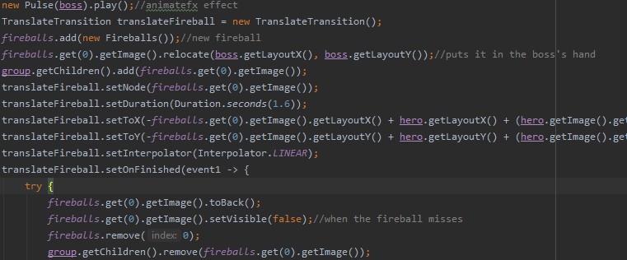

When the boss reaches 60% health, it changes it attacks to randomly choose between two new attacks.

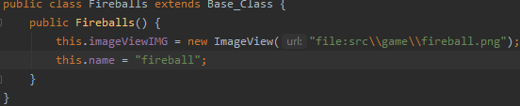

#### Base_Class

The Base Class contains all the constructors and variables that are used throughout the classes.

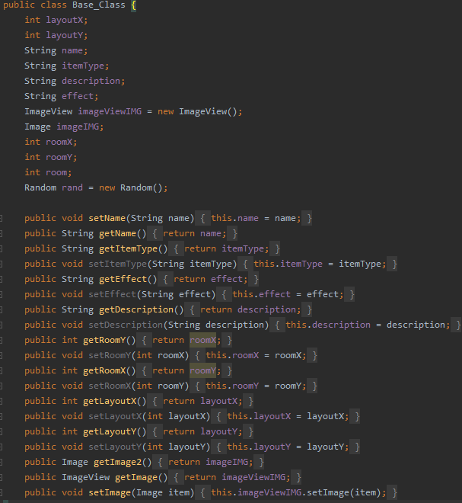

## Queries

### Retrieving and displaying data from a table

When the program runs, it retrieves the leaderboard from an SQL table and then sorts it into labels to be displayed in the game.

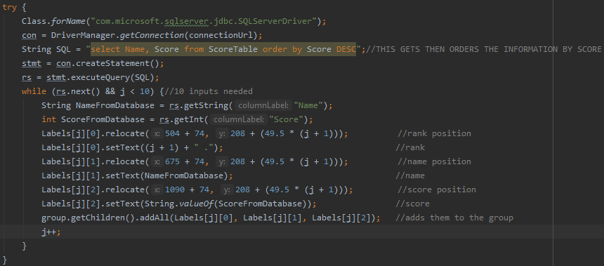

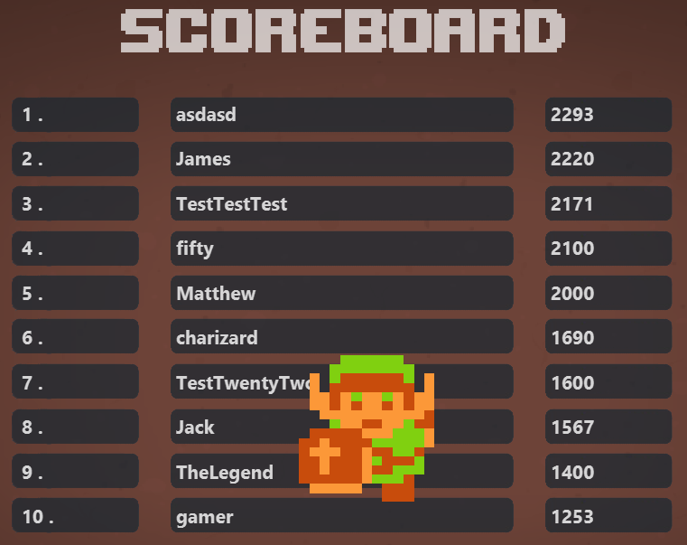

### Inserting, updating or deleting data from the table

When the game is beaten, the scoreSaver procedure is called.

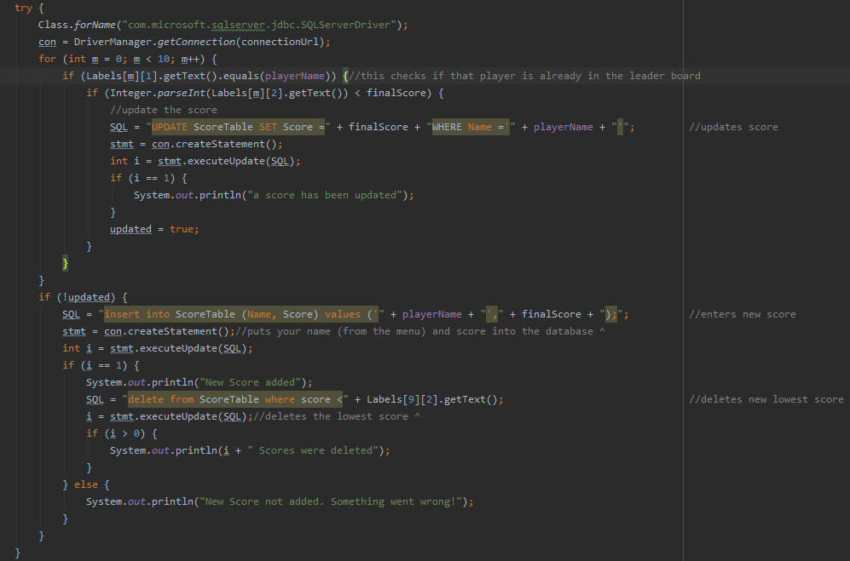

It first checks if the player is already in the leaderboard. if they are and they just got a new high score; their score will be updated, if it doesn’t beat their high score, nothing will happen. If it's a new name, it will create a new entry then delete the new lowest score to stop the table from getting cluttered.

# 

# Testing

The game video demo can be found here: <https://www.youtube.com/watch?v=FfmSxFfNhvw>

## Test Table

|  |  |  |  |  |  |  |  |
| --- | --- | --- | --- | --- | --- | --- | --- |
| **Test Number** | **Objective** | **Test Type** | **Test Data** | **Reason** | **Expected outcome** | **Actual outcome** | **Passed?** |
| 1 | Input Matthew as a username | valid | String | to see if it accepts it as a valid name (string and size between 4 and 15 characters) | it will accept it | it accepted the name and started the game | Yes |
| 2 | Input Matt as a username | borderline | String | to see if it accepts it as a valid name | it will accept it | it accepted the name and started the game | Yes |
| 3 | Input Mat as a username | borderline | String | to see if it accept it as a valid name | it will reject it | it displayed a message to the user asking for a longer name  see Fig 1 | Yes |
| 4 | Input 15{} as a username | errenonous | String | to see if it rejects the input | it will reject it | it displayed a message asking for an input with only letters  see Fig 1 | Yes |
| 5 | Press Space once game is loaded | valid | Key Input | to test what the character does | the character will attack | the character attacked  see Fig 2 | Yes |
| 6 | Press Up arrow, Left arrow, Right arrow, Down arrow once game loads | valid | Key Input | to see if the character moves | the character will move | the character moves | Yes |
| 7 | Rapidly press space | valid | Key Input | to test updated attack handler procedure | character will only attack every 2 seconds | character attacks every 2 seconds | Yes |
| 8 | Rapidly shoot the staff | valid | Key input | to test the staffShooter timer and procedure | Character will fire a projectile every 2 seconds | Character image updates but no sound effect or projectile | Yes |
| 9 | test map generation | valid | n/a | Once the menu shows, the map should generate in the background. | A random map will be generated | A unique map was produced  see Fig 3 | Yes |
| 10 | Enemy and item generation based on the map design | valid | n/a | After the map is generated an enemy and potion is put in each room excluding the shop and boss room | an enemy and potion should be in every room and have the same X and Y as the 1’s in the array | 1 enemy and 1 item were put in each room  see Fig 4 | Yes |
| 11 | test the background class by leaving the map. | invalid | n/a | I plan to allow interactions with invisible doors which will allow the player to leave the map. | The backgrounds will stay as it was and no enemies or items will be found. | The background remained the same while the player could leave the map  see Fig 5 | Yes |
| 12 | Testing that the background class correctly generates the images. | valid | n/a | to test if the background class correctly generates and places the backgrounds. | when a 1,2 or 3 appears it will generate the correct background. | The class generated the correct images for the correct array locations and array contents. | Yes |
| 13 | Test the mapItemMaker procedure and mapPieces class | valid | n/a | To see if it accurately takes the 2D array of numbers and creates a visible version. | It will create a replica of the 2D array in image form | it created the image form of the 2D array and correctly positioned it  see Fig 6,7 and 8 | Yes |
| 14 | test picking up items and item interactions | valid | n/a | To test if the item that the player picks up is added to their inventory | item will be moved from ground to inventory | item on the ground was removed and an item was added to the inventory  See Fig 9 and 10 | Yes |
| 15 | Display that door interactions work between doors | valid | n/a | To show that door interactions and dungeon navigation works | the door interactions will correctly work. | The player was able to traverse the dungeon from the starting room to the boss room.  See Fig 11 | Yes |
| 16 | test of inventory controls | valid | n/a | to display the inventory controls | controls should work as intended | controls performed as they should  See Fig 12 | Yes |
| 17 | test of enemy collisions and attacking enemies | valid | n/a | to display the enemy health system for when the player attacks | enemy health will decrease as it should when attacked | Enemy health decreased when hit as it should  see Fig 13 | Yes |
| 18 | Test the bosses health bar mechanics | valid | n/a | to accurately know that the bosses health reduces as it should | Boss should require 20 hits to defeat | Boss required 20 hits to defeat  See Fig 14 and 15 | Yes |
| 19 | Test boss phase two activation | valid | n/a | to determine when the boss enters phase two | boss should enter phase two when it reaches 60% of its health (after 8 hits) | The boss entered phase two after being hit 8 times by the player  See Fig 16 | Yes |
| 20 | Death screen showing at correct time | valid | n/a | to demonstrate what happens when the player reaches zero health | upon reaching zero health, the procedure called deathScreen will active | when the player was defeated the screen faded away and the end screen appeared.  See Fig 17 and 18 | Yes |
| 21 | Display of the SQL leaderboard outputting scores | valid | SQL table | to show that the top 10 names on the leaderboard are displayed | leaderboard will display top 10 names | When the game started it showed the top 10 scores  see Fig 19,20 and 21 | Yes |
| 22 | Display of the SQL leaderboard taking in scores. | valid - | SQL table | to show that when the game is beaten, the score will be saved.  When I play the game i will put in the name: TestTwentyTwo | it will add the score to database and delete the lowest score | When the game was beat a new score was added to the database.  See Fig 22 and 23 | Yes |
| 23 | Test enemy animation algorithm | valid | n/a |  | video? |  |  |
| 24 | Try to leave the viewable screen. | erroneous | Keyboard arrows | attempt to leave the screen just to see if you can | player will be pushed back and unable to leave the screen | due to the recursive nature of the Checkcollision procedure, being called when a key is pressed and released; the player cannot leave the screen | Yes |

## Image reference table

|  |  |  |
| --- | --- | --- |
| **Figure:** | **Image** | **Comment** |
| 1 |  | incorrect username message |
| 2 |  | left attack image |
| 3 |  | four randomly generated maps |
| 4 |  | items and enemies are generated when they should be. |
| 5 |  | test to see how leaving the map would affect the code’s performance |
| 6 |  | randomly generated map that will be made into an image |
| 7 |  | pos 179 in the MapPieces array contains a generic single room image, seen below |
| 8 |  | the image that has been made based on the random map |
| 9 |  | inventory before a potion has been picked up. |
| 10 |  | inventory after a potion has been picked up |
| 11 |  | This displays the players journey from the starting room to the boss room |
| 12 | Start ^ Pressed S Pressed D Pressed W  Pressed A | These images happen one after another |
| 13 |  | Display of enemy health |
| 14 |  | Boss health at full |
| 15 |  | Boss health after 1 hit |
| 16 |  | Display that phase 2 starts after the boss reaches 60% health |
| 17 |  | display that deathScreen is called when health is 0 |
| 18 |  | death screen after 8 seconds |
| 19 |  | SQL table containing top 10 scores |
| 20 |  | code that gets data from SQL table and places it in a scoreboard form |
| 21 |  | scoreboard when code is executed. |
| 22 |  | code that adds a new score to the leaderboard |
| 23 |  | In Fig 21 you could see “carl” at the bottom of the leaderboard, that score has now been deleted because a better score was added to the database. In Fig 21 you could see “fifty” in number 9, it's now in number 10. |

# Evaluation

## 

## Scoreboard

1. **Database will only hold 10 scores and show those 10 on the scoreboard -** Everytime a score is added to the database, it deletes the lowest low to remain at 10 scores.
2. **SQL queries will be used to Retrieve scores -** When the game is loaded; the top 10 scores are retrieved from the database and attach them to labels then displayed to the player.
3. **SQL queries will be used to Update scores -** When the game goes to save a score, it will first check if that player already has an entry in the table, if the new score is higher; it will update.
4. **SQL queries will be used to Delete scores** - When a new score is added, the lowest score will be deleted.

## Game Intuitivity

1. **Arrows keys used for movement** - arrow keys are used for movement.
2. **W, A, S and D keys used for range attacks** - W, A, S and D keys are used for ranged attacks and selecting an item to use in the inventory.
3. **Space key for melee attack** - Space is used for sword attacks.
4. **Tab key for inventory** - Tab key is used for opening/closing the inventory.
5. **E key to interact with surroundings** - E key is used to pick up items/use items as well as opening treasure chests.

## Random generation of items, enemies and the map

1. **There should be one enemy per room** - There is one enemy per room.
2. **There should be one item per room** - There is one item per room.
3. **Map should contain a boss and shop room** - The map always contains a boss and shop room.
4. **Map should be visible in the corner** - Map can be brought in the shop and will appear in the top right corner.

## Character’s attacks

1. **melee attacks** - The player can press Space to attack with their sword
2. **Ranged attacks** - The player can buy the staff from the shop then use it with W, A, S and D.

## Character animations

1. **Should be animations for attacking and moving in each direction** - There are animations for walking and attacking.
2. **Should be animations for a range of melee and ranged attacks** - There are animations for attacking with the sword and attacking with the staff.

## End game boss room

1. **Have a large health bar** - When entering the boss room, a large health bar appears at the top with a rectangle overlay that represents the health.
2. **Boss should have multiple attacks** - Boss has two phases and three attacks in total.
3. **Should be a reward for defeating the boss** - When the boss is defeated, The player can open the chest and receive a reward.

## Range of sound effects

1. **attacking** - There is a sound effect for missing an attack and landing an attack.
2. **walking** - There is a sound effect that plays on repeat when the player moves.
3. **game music** - There is music that plays when the game starts and dramatic music that plays when you enter the boss room.
4. **Background music** - There is background music.
5. **Boss room music** - There is boss room music.

## Arcade style leaderboard

1. **SQL database will be used** - The scores are stored in a table called ScoreBoard
2. **Name will be kept** - Name is entered at the menu, if they beat the game it is saved to the leaderboard.
3. **Score will be kept** - Score changes throughout the game and when complete, the score is saved along with the name to recognise the player of their achievement.
4. **Scoreboard will show player’s rank, name then score** - When the game starts it shows the leaderboard that is ordered by score.

## Menu before the game

1. **instructions** - The game controls are shown here so the player can familiarise themselves.
2. **Menu screen before the game** - The menu screen prompts the player for their name that will be saved to the scoreboard if they obtain a high enough score.

## Animate enemy movements

1. **Enemy movements should be animated** - Enemy movements are animated in each direction.

## Dungeon room design

1. **Backgrounds should have shadow overlays** - A seamless shadow overlay is added to the room that affects everything in the room.
2. **Random backgrounds for rooms** - The Background class randomly generates 1 of 3 backgrounds images for each room.

# Improvements

If i were to continue my project I would go on to implement several ideas from my end-user, such as a save function, multiple bosses, more complex attacks for enemies and bosses as well as more things in the room to interact with and multiple levels with increasing difficulty. In order to create a save function I would externally write the contents of all variables to a text file with the users name if they closed the program. Then create a ‘load save’ button on the menu. In order to implement another boss i would move my current boss to its own class where all boss related code is kept in the class to be more modular, i would then randomly choose a boss to spawn in the boss room.

# Code

## The_Lost_Dungeon

**package** com.company;

**import** animatefx.animation.FadeIn;

**import** animatefx.animation.FadeOut;

**import** animatefx.animation.Pulse;

**import** javafx.animation.Interpolator;

**import** javafx.animation.KeyFrame;

**import** javafx.animation.Timeline;

**import** javafx.animation.TranslateTransition;

**import** javafx.application.Application;

**import** javafx.scene.Cursor;

**import** javafx.scene.Group;

**import** javafx.scene.Scene;

**import** javafx.scene.control.Button;

**import** javafx.scene.control.Label;

**import** javafx.scene.control.TextField;

**import** javafx.scene.control.Tooltip;

**import** javafx.scene.image.Image;

**import** javafx.scene.image.ImageView;

**import** javafx.scene.input.KeyCode;

**import** javafx.scene.media.Media;

**import** javafx.scene.media.MediaPlayer;

**import** javafx.scene.paint.Color;

**import** javafx.scene.shape.Rectangle;

**import** javafx.scene.text.FontWeight;

**import** javafx.stage.Stage;

**import** javafx.util.Duration;

**import** java.awt.*;

**import** java.io.File;

**import** java.sql.Connection;

**import** java.sql.DriverManager;

**import** java.sql.ResultSet;

**import** java.sql.Statement;

**import** java.util.*;

**public class** The_Lost_Dungeon **extends** Application {

*//|| CTRL SHIFT H* ***TODO***

*//smaller annoying enemies in rooms.*

*//enemies drop items.*

*//chests in rooms.*

*//more items, more rooms.*

*//shop items should be generated in the items class, always keep at the end of array. pressing E branches into item name - more efficient.*

**static int** *positionX* = 9;*//the representation of this variable breaks if non global*

**static int** *positionY* = 9;*//the representation of this variable breaks if non global*

**private static** MediaPlayer *MEDIAWalking*;

**private static** MediaPlayer *MEDIABackground*;

**private static** MediaPlayer *MEDIABoss*;

**int musicVolume** = 1;*//the representation of this variable breaks if non global*

String **enemyAnimation** = **"b"**;*//the representation of this variable breaks if non global*

**boolean activeBoss** = **false**;

**static boolean** *activestaff* = **false**;

**static boolean** *activeAttackBoost* = **false**;

**static boolean** *activeMap* = **false**;

**static boolean** *defeatedBoss* = **false**;

String **direction** = **"down"**;*//the representation of this variable breaks if non global*

String **attackDirection** = **"down"**;*//the representation of this variable breaks if non global*

**int scoretimer** = 0;

**boolean attacking** = **false**;

**int walking** = 0;

**int i** = 0;

**int j** = 0;

**int l** = 0;

**int k** = 0;

**int q** = 0;

**int v** = 0;

**int y** = 0;

**int c** = 0;

**int s** = 0;

**int f** = 0;

**int n** = 0;

**int timePassed** = 0;

**int timepassed1** = 0;

**int timePassed2** = 0;

**int timePassed3** = 0;

**int timepassed7** = 0;

**int timepassed8** = 0;

**int defeatedEnemies** = 0;

**int number** = 0;

String **sound**;

Timeline **walkSounds**;

Timeline **EnemyMover**;

Timeline **subEnemy**;

Timeline **Bossroomtimeline**;

Timeline **Bossroomtimeline2**;

**double attackmultiplier** = 1;

**boolean up** = **false**;

**boolean right** = **false**;

**boolean left** = **false**;

**boolean down** = **false**;

*//health*

**int hero_Health** = 6;*//the representation of this int breaks if non global*

*//*

**int CoinNumber** = 0;*//the representation of this int breaks if non global*

*//*

**int Score** = 1000;*//the representation of this int breaks if non global*

String **playerName** = **""**;*//the representation of this String breaks if non global*

**public static void** main(String[] args) {

*launch*(args);

}

*//check if there are errors in physics engine*

@Override

**public void** start(Stage stage) {

Group group = **new** Group();

Scene scene = **new** Scene(group, 1920, 1080, Color.***BLACK***);

*//scene.setCursor(Cursor.NONE);//cursor manipulation*

*//*

ArrayList<Backgrounds> backgrounds = **new** ArrayList<>();

ArrayList<Enemy> enemies = **new** ArrayList<>();

ArrayList<Magic> magic = **new** ArrayList<>();

ArrayList<Fireballs> fireballs = **new** ArrayList<>();*//Dynamic arrays*

ArrayList<Inventory> inventory = **new** ArrayList<>();

ArrayList<Items> items = **new** ArrayList<>();

ArrayList<MapPieces> mapPieces = **new** ArrayList<>();

*//*

**int**[][] inventoryARR = **new int**[5][6];

**for** (**int** m = 0; m < 5; m++) {

**for** (**int** o = 0; o < 6; o++) {

inventoryARR[m][o] = 0;

}

}

System.***out***.println(**"monitor width: "** + Toolkit.*getDefaultToolkit*().getScreenSize().**width**); *//****TODO***

System.***out***.println(**"monitor height: "** + Toolkit.*getDefaultToolkit*().getScreenSize().**height**);*//****TODO***

*//laptop - 1600,900*

*//*

String animationHero = **"b"**;

*//incorrect username message.*

Label badUserName = **new** Label();

labelMaker(badUserName, **"Name cannot contain spaces, special characters and must have between 4 and 15 characters"**, 745, 1008, 16, Color.***WHITE***, **false**, 1);

*//*

Label itemName = **new** Label();

Label itemType = **new** Label();

Label itemDescription = **new** Label();

Label itemEffect = **new** Label();

*//*

labelMaker(itemName, **""**, 1075, 330, 21, Color.***WHITE***, **true**, 1);

labelMaker(itemType, **""**, 1035, 390, 21, Color.***ORANGE***, **true**, 1);

labelMaker(itemDescription, **""**, 1030, 430, 21, Color.***WHITE***, **true**, 1);

labelMaker(itemEffect, **""**, 1030, 570, 21, Color.***ORANGE***, **true**, 1);

*//*

group.getChildren().addAll(itemName, itemType, itemDescription, itemEffect);

*//*

TranslateTransition translate = **new** TranslateTransition();

**final** Group menuGroup = **new** Group();

menuGroup.getChildren().add(badUserName);

ImageView hero = **new** ImageView(**"file:src\\game\\link_running_down_1.png"**);

*//*

ImageView boss = **new** ImageView(**"file:src\\game\\Wizard.png"**);

Label enterName = **new** Label();

labelMaker(enterName, **"Enter Name Here:"**, 915, 926, 21, Color.***WHITE***, **true**, 1);

menuGroup.getChildren().add(enterName);

ImageView menu = **new** ImageView(**"file:src\\game\\Menu.png"**);

menuGroup.getChildren().add(menu);

menu.toBack();

ImageView title = **new** ImageView(**"file:src\\game\\Title.png"**);

menuGroup.getChildren().add(title);

title.relocate(560, 100);

title.toFront();

**final** Scene menuScene = **new** Scene(menuGroup, 1920, 1080);

menuGroup.getChildren().add(hero);

hero.relocate(940, 760);

TextField textField = **new** TextField();

textField.setPrefSize(180, 32);

textField.relocate(915, 958);

textField.getStylesheets().add(**"com/company/Style.css"**);*//https://docs.oracle.com/javase/8/javafx/api/javafx/scene/doc-files/cssref.html#typeeffect*

ImageView controls = **new** ImageView(**"file:src\\game\\controls.png"**);

controls.relocate(313, 368);

menuScene.setOnKeyPressed(event -> {

**if** (event.getCode() == KeyCode.***ENTER***) {*//if Enter is pressed on the menu screen, this runs*

**if** (!textField.getText().equalsIgnoreCase(**""**) && textField.getText().length() >= 4 && textField.getText().length() <= 15 && textField.getText().matches(**"[a-zA-Z]+"**)) {*//more than 4, less than 15*

stage.setScene(scene);

stage.setFullScreen(**true**);

**playerName** = textField.getText();

group.getChildren().addAll(hero);

hero.relocate(885, 540);

controls.setVisible(**false**);

group.getChildren().add(controls);

**new** FadeIn(group).play();

} **else** {

badUserName.setVisible(**true**);

}

}

});

*//*

Button enter = **new** Button(**"PLAY"**);

enter.getStylesheets().add(**"com/company/Style.css"**);

enter.relocate(1100, 958);

menuGroup.getChildren().addAll(textField, enter, controls);

stage.setScene(menuScene);

stage.setFullScreen(**true**);

enter.setOnAction(event -> {*//if the enter button is hit, this runs*

**if** (!textField.getText().equalsIgnoreCase(**""**) && textField.getText().length() >= 4 && textField.getText().length() <= 15 && textField.getText().matches(**"[a-zA-Z]+"**)) {*//more than 4, less than 15*

stage.setScene(scene);

stage.setFullScreen(**true**);

**playerName** = textField.getText();

group.getChildren().addAll(hero);

hero.relocate(885, 540);

controls.setVisible(**false**);

group.getChildren().add(controls);

**new** FadeIn(group).play();

} **else** {

badUserName.setVisible(**true**);

}

});

*//doors*

ImageView northDoor = **new** ImageView(**"file:src\\game\\door_up.png"**);

ImageView southDoor = **new** ImageView(**"file:src\\game\\door_down.png"**);

ImageView eastDoor = **new** ImageView(**"file:src\\game\\door_right.png"**);

ImageView westDoor = **new** ImageView(**"file:src\\game\\door_left.png"**);

ImageView bossDoor = **new** ImageView(**"file:src\\game\\door_boss_closed.png"**);

Image bossDoor_open = **new** Image(**"file:src\\game\\door_boss_open.png"**);

Image bossDoor_closed = **new** Image(**"file:src\\game\\door_boss_closed.png"**);

northDoor.relocate(879, 4);

bossDoor.relocate(879, 5);

southDoor.relocate(879, 1010);

westDoor.relocate(0, 460);

eastDoor.relocate(1850, 460);

bossDoor.setVisible(**false**);

group.getChildren().addAll(northDoor, southDoor, eastDoor, westDoor, bossDoor);

*//*

**int**[][] map = **new int**[19][19];*//*

*mapMaker*(mapPieces, backgrounds, items, enemies, group, map);*//****TODO***

*//*

ImageView shadow = **new** ImageView(**"file:src\\game\\floors\\shadow.png"**);

group.getChildren().add(shadow);

shadow.toFront();

*//*

stage.setFullScreen(**true**);

*//*

**sound** = **"background"**;

soundManager();*//****TODO***

*//shop related things*

ImageView shopkeeper = **new** ImageView(**"file:src\\game\\shopkeeper.png"**);

shopkeeper.relocate(885, 200);

shopkeeper.setVisible(**false**);

group.getChildren().add(shopkeeper);

ImageView staff = **new** ImageView(**"file:src\\game\\staff.png"**);

Tooltip.*install*(staff, **new** Tooltip(**"A powerful ranged weapon, use W,A,S,D to use"**));

staff.relocate(750, 500);

staff.setVisible(**false**);

*//t1.start(); https://dzone.com/articles/java-thread-tutorial-creating-threads-and-multithr*

ImageView coinIcon_staff = **new** ImageView(**"file:src\\game\\Coin Icon.png"**);

Label coinNumber_staff;

Label coinNumber_attackBoost;

Label coinNumber_mapItem;

coinNumber_staff = **new** Label();

labelMaker(coinNumber_staff, **"5"**, 745, 580, 21, Color.***WHITE***, **false**, 1);*//****TODO***

coinIcon_staff.relocate(763, 583);

coinIcon_staff.setVisible(**false**);

group.getChildren().addAll(staff, coinIcon_staff, coinNumber_staff);

*//*

ImageView mapItem = **new** ImageView(**"file:src\\game\\MapItem.png"**);

*//enter.setTooltip(new Tooltip("(Ctrl + S)"));*

Tooltip.*install*(mapItem, **new** Tooltip(**"reveals the dungeon layout"**));

mapItem.relocate(900, 480);

mapItem.setVisible(**false**);

ImageView coinIcon_mapItem = **new** ImageView(**"file:src\\game\\Coin Icon.png"**);

coinIcon_mapItem.relocate(945, 580);

coinIcon_mapItem.setVisible(**false**);

coinNumber_mapItem = **new** Label();

labelMaker(coinNumber_mapItem, **"2"**, 925, 577, 21, Color.***WHITE***, **false**, 1);

group.getChildren().addAll(coinNumber_mapItem, mapItem, coinIcon_mapItem);

*//*

ImageView attackBoost = **new** ImageView(**"file:src\\game\\attack boost.png"**);

Tooltip.*install*(attackBoost, **new** Tooltip(**"Makes you more powerful when consumed"**));

attackBoost.relocate(1050, 500);

attackBoost.setVisible(**false**);

ImageView coinIcon_attackBoost = **new** ImageView(**"file:src\\game\\Coin Icon.png"**);

coinNumber_attackBoost = **new** Label();

labelMaker(coinNumber_attackBoost, **"5"**, 1058, 578, 21, Color.***WHITE***, **false**, 1);

coinIcon_attackBoost.relocate(1075, 580);

coinIcon_attackBoost.setVisible(**false**);

group.getChildren().addAll(coinIcon_attackBoost, attackBoost, coinNumber_attackBoost);

*//sword hit boxes*

Rectangle usedSword = **new** Rectangle();

Rectangle sword_up = **new** Rectangle(0, 0, 25, 68);

Rectangle sword_right = **new** Rectangle(0, 0, 85, 31);

Rectangle sword_down = **new** Rectangle(0, 0, 26, 75);

Rectangle sword_left = **new** Rectangle(0, 0, 84, 28);

sword_up.setOpacity(0);

sword_right.setOpacity(0);

sword_down.setOpacity(0);

sword_left.setOpacity(0);

group.getChildren().addAll(sword_up, sword_right, sword_down, sword_left);

*//backgrounds*

ImageView background = **new** ImageView(**"file:src\\game\\floors\\floor1.png"**);

group.getChildren().add(background);

*backgroundChanger*(backgrounds, background);*//****TODO***

background.toBack();

*//chest*

ImageView chest = **new** ImageView(**"file:src\\game\\chest_closed.png"**);

Image chest_open = **new** Image(**"file:src\\game\\chest_open.png"**);

chest.relocate(885, 150);

chest.setVisible(**false**);

group.getChildren().add(chest);

ImageView bossHealthBar = **new** ImageView(**"file:src\\game\\HealthBarImage.png"**);

Rectangle bossHealthBarREC = **new** Rectangle(616, 87, 658, 48);

ImageView scoreIMG = **new** ImageView(**"file:src\\game\\score.png"**);

*//hearts*

ImageView hearts = **new** ImageView(**"file:src\\game\\hearts\\heart_3.png"**);

hearts.relocate(0, 0);

group.getChildren().addAll(hearts);

*//score*

Label score = **new** Label();

labelMaker(score, String.*valueOf*(**Score**), 1000, 90, 21, Color.***WHITE***, **true**, 0.3);

ImageView scoreBoard = **new** ImageView(**"file:src\\game\\ScoreBoard IMG.png"**);

Label[][] scoreboardLabels = **new** Label[10][3];

ScoreDisplayer(group, scoreBoard, scoreboardLabels);*//****TODO***

*//Coin Icon*

ImageView coinIcon = **new** ImageView(**"file:src\\game\\Coin Icon.png"**);

coinIcon.relocate(25, 100);

*//*

Label coinNumber = **new** Label(String.*valueOf*(**CoinNumber**));

labelMaker(coinNumber, String.*valueOf*(**CoinNumber**), 50, 98, 21, Color.***WHITE***, **true**, 1);

group.getChildren().addAll(coinNumber, coinIcon);

*//Score*

scoreIMG.relocate(845, 90);

scoreIMG.setOpacity(0.3);

*//BOSS*

boss.relocate(885, 459);

boss.setVisible(**false**);

group.getChildren().add(boss);

*//boss health*

bossHealthBar.relocate(500, 50);

bossHealthBar.setVisible(**false**);

bossHealthBarREC.setVisible(**false**);

bossHealthBarREC.setFill(Color.***RED***);

group.getChildren().addAll(bossHealthBar, bossHealthBarREC);

*//inventory*

**int** itemId = 0;

ImageView inventoryPIC = **new** ImageView(**"file:src\\game\\newInventory.png"**);

inventoryPIC.relocate(603, 275);

*//inventoryPIC.relocate(752, 325);*

inventoryPIC.setVisible(**false**);

ImageView selected = **new** ImageView(**"file:src\\game\\selected.png"**);

selected.relocate(643, 314);

selected.setVisible(**false**);

startTimers();*//starts the timers* ***TODO***

Rectangle northWall = **new** Rectangle(0, 0, 1920, 2);

Rectangle southWall = **new** Rectangle(0, 1080, 1920, 2);

Rectangle eastWall = **new** Rectangle(0, 0, 2, 1200);

Rectangle westWall = **new** Rectangle(1920, 0, 2, 1920);

northWall.setOpacity(0);

southWall.setOpacity(0);

eastWall.setOpacity(0);

westWall.setOpacity(0);

group.getChildren().addAll(northWall, southWall, eastWall, westWall);

*//logo*

stage.getIcons().add(**new** Image(**"file:src\\game\\Master Sword In Pedastol.png"**));

*//*

group.getChildren().addAll(inventoryPIC, selected, scoreIMG, score);

stage.setFullScreen(**true**);

*//swords*

Image link_sword_down = **new** Image(**"file:src\\game\\link_sword_down.png"**);

Image link_sword_left = **new** Image(**"file:src\\game\\link_sword_left.png"**);

Image link_sword_right = **new** Image(**"file:src\\game\\link_sword_right.png"**);

Image link_sword_up = **new** Image(**"file:src\\game\\link_sword_up.png"**);

*//staff / magic*

Image link_staff_down = **new** Image(**"file:src\\game\\link_staff_down.png"**);

Image link_staff_left = **new** Image(**"file:src\\game\\link_staff_left.png"**);

Image link_staff_right = **new** Image(**"file:src\\game\\link_staff_right.png"**);

Image link_staff_up = **new** Image(**"file:src\\game\\link_staff_up.png"**);

*//running 1*

Image link_running_down_1 = **new** Image(**"file:src\\game\\link_running_down_1.png"**);

Image link_running_left_1 = **new** Image(**"file:src\\game\\link_running_left_1.png"**);

Image link_running_up_1 = **new** Image(**"file:src\\game\\link_running_up_1.png"**);

Image link_running_right_1 = **new** Image(**"file:src\\game\\link_running_right_1.png"**);

*//running 2*

Image link_running_down_2 = **new** Image(**"file:src\\game\\link_running_down_2.png"**);

Image link_running_left_2 = **new** Image(**"file:src\\game\\link_running_left_2.png"**);

Image link_running_up_2 = **new** Image(**"file:src\\game\\link_running_up_2.png"**);

Image link_running_right_2 = **new** Image(**"file:src\\game\\link_running_right_2.png"**);

*//map indicator - shows what room the player is in*

ImageView indicator = **new** ImageView(**"file:src\\game\\Indicator.png"**);

InputManager(mapPieces, backgrounds, items, enemies, magic, fireballs, inventory, inventoryARR, animationHero, itemName, itemType, itemDescription, itemEffect, itemId, group, scene, translate, boss, hero, indicator, map, stage, northWall, eastWall, southWall, westWall, link_sword_down, link_sword_left, link_sword_right, link_sword_up, link_staff_down, link_staff_left, link_staff_right, link_staff_up, sword_down, sword_left, sword_right, sword_up, usedSword, bossDoor_closed, bossDoor_open, bossDoor, chest, chest_open, controls, bossHealthBar, bossHealthBarREC, scoreBoard, staff, attackBoost, coinIcon_staff, coinIcon_attackBoost, mapItem, coinIcon_mapItem, coinNumber_mapItem, hearts, inventoryPIC, selected, score, coinNumber_staff, coinNumber_attackBoost, coinNumber, scoreboardLabels, northDoor, eastDoor, southDoor, westDoor, background, link_running_down_1, link_running_left_1, link_running_right_1, link_running_up_1, shopkeeper, link_running_down_2, link_running_left_2, link_running_right_2, link_running_up_2);

swordMover(sword_down, sword_left, sword_right, sword_up, hero);*//****TODO TODO***

stage.setFullScreenExitHint(**""**);

stage.setFullScreen(**true**);

stage.setTitle(**"The Lost Dungeon"**);

*//stage.setScene(scene);*

doorChanger(map, northDoor, eastDoor, southDoor, westDoor, bossDoor);*// makes sure doors are correct in the starting room* ***TODO***

*itemChanger*(items);*//shows the correct item* ***TODO***

stage.show();

**int** i = 0;

**for** (MapPieces mappiece : mapPieces) {*//makes the map appear in front of EVERYTHING*

mappiece.getImage().toFront();

mappiece.getImage().setVisible(**false**);

i++;

**if** (i == 181) {*//array location of starting room*

indicator.relocate(mappiece.getImage().getLayoutX(), mappiece.getImage().getLayoutY());

group.getChildren().add(indicator);

indicator.setOpacity(0.3);

indicator.setVisible(**false**);

}

}

}

**private void** labelMaker(Label label, String text, **int** X, **int** Y, **int** fontSize, Color fontColor, **boolean** Visible, **double** opacity) {

*// labelMaker(badUserName,"Name cannot contain spaces, special characters and must have between 4 and 15 characters",735, 1008,"Upheaval", FontWeight.BOLD, 16, "WHITE", "false",1 );*

*//template ^*

label.setText(text);*//text*

label.relocate(X, Y);*//position*

label.setFont(javafx.scene.text.Font.*font*(**"Upheaval"**, FontWeight.***BOLD***, fontSize));*//font and such*

label.setTextFill(fontColor);*//color*

label.setVisible(Visible);*//visibility*

label.setOpacity(opacity);*//opacity*

}

**private void** bossRoom(**int**[][] inventoryARR,ArrayList<MapPieces> mapPieces, ArrayList<Backgrounds> backgrounds, ArrayList<Items> items, ArrayList<Enemy> enemies, ArrayList<Magic> magic, ArrayList<Fireballs> fireballs, ArrayList<Inventory> inventory, Group group, Scene scene, ImageView chest, ImageView bossHealthBar, Rectangle bossHealthBarREC, ImageView hearts, Label score, ImageView hero, ImageView boss, Stage stage, **int**[][] map, ImageView indicator, ImageView northDoor, ImageView eastDoor, ImageView southDoor, ImageView westDoor, ImageView bossDoor, Image bossDoor_closed, Image bossDoor_open, ImageView background, TranslateTransition translate) {

bossHealthBar.setVisible(**true**);

bossHealthBarREC.setVisible(**true**);*//shows the health bar*

bossHealthBarREC.setWidth(658);

**timePassed3** = 0;*//fireball cooldown timer*

*MEDIABackground*.stop(); *//stops the background music*

**sound** = **"boss"**;

soundManager();*//boss music*

**activeBoss** = **true**;

boss.setVisible(**true**);

**if** (**k** == 0) {

**Bossroomtimeline** = **new** Timeline(**new** KeyFrame(Duration.*seconds*(0.05), event -> {*//checks the time every 0.05 seconds to see*

**try** {

**if** (**timePassed3** >= 5 && boss.isVisible()) {

**k** = 1;

**new** Pulse(boss).play();*//animatefx effect*

TranslateTransition translateFireball = **new** TranslateTransition();

fireballs.add(**new** Fireballs());*//new fireball*

fireballs.get(0).getImage().relocate(boss.getLayoutX(), boss.getLayoutY());*//puts it in the boss's hand*

group.getChildren().add(fireballs.get(0).getImage());

translateFireball.setNode(fireballs.get(0).getImage());

translateFireball.setDuration(Duration.*seconds*(1.6));

translateFireball.setToX(-fireballs.get(0).getImage().getLayoutX() + hero.getLayoutX() + (hero.getImage().getWidth() / 2));

translateFireball.setToY(-fireballs.get(0).getImage().getLayoutY() + hero.getLayoutY() + (hero.getImage().getHeight() / 2));*//go to location*

translateFireball.setInterpolator(Interpolator.***LINEAR***);

translateFireball.setOnFinished(event1 -> {

**try** {

fireballs.get(0).getImage().toBack();

fireballs.get(0).getImage().setVisible(**false**);*//when the fireball misses*

fireballs.remove(0);

group.getChildren().remove(fireballs.get(0).getImage());

} **catch** (Exception e) {

*//System.out.println("Boss room timeline error");*

}

});

**sound** = **"fire_ball"**;

soundManager();

translateFireball.play();

**timePassed3** = 0;

*//timepassed4 = 0;*

}

**if** (hero.getBoundsInParent().intersects(fireballs.get(0).getImage().getBoundsInParent())) {*//hit the target*

**hero_Health**--;

String killedBy = **"boss"**;

healthChecker(inventoryARR,mapPieces, backgrounds, items, enemies, magic, fireballs, inventory, hearts, group, scene, stage, killedBy, map, indicator, northDoor, eastDoor, southDoor, westDoor, bossDoor, bossDoor_closed, bossDoor_open, hero, background, translate, score, bossHealthBar, bossHealthBarREC, boss);

fireballs.get(0).getImage().setVisible(**false**); *//collision detection for the player*

fireballs.remove(0);

group.getChildren().remove(fireballs.get(0).getImage());

}

**if** (**y** >= 8) {

System.***out***.println(**"Boss phase 2"**);

bossPhase2(inventoryARR,mapPieces, backgrounds, items, enemies, magic, fireballs, inventory, group, scene, chest, bossHealthBar, bossHealthBarREC, hearts, score, hero, boss, stage, map, indicator, northDoor, eastDoor, southDoor, westDoor, bossDoor, bossDoor_closed, bossDoor_open, background, translate);

}

} **catch** (Exception e) {

*//System.out.println("Boss room phase 1 error");*

}

}));

**Bossroomtimeline**.setCycleCount(Timeline.***INDEFINITE***);

**Bossroomtimeline**.play();

}

}

**private void** bossPhase2(**int**[][] inventoryARR,ArrayList<MapPieces> mapPieces, ArrayList<Backgrounds> backgrounds, ArrayList<Items> items, ArrayList<Enemy> enemies, ArrayList<Magic> magic, ArrayList<Fireballs> fireballs, ArrayList<Inventory> inventory, Group group, Scene scene, ImageView chest, ImageView bossHealthBar, Rectangle bossHealthBarREC, ImageView hearts, Label score, ImageView hero, ImageView boss, Stage stage, **int**[][] map, ImageView indicator, ImageView northDoor, ImageView eastDoor, ImageView southDoor, ImageView westDoor, ImageView bossDoor, Image bossDoor_closed, Image bossDoor_open, ImageView background, TranslateTransition translate) {*//phase 2 of the boss fight*

Random rand = **new** Random();

System.***out***.println(**"phase two"**);

TranslateTransition[] fireBlast = **new** TranslateTransition[3];*//*

**for** (**int** m = 0; m < 3; m++) {

fireBlast[m] = **new** TranslateTransition();

}

TranslateTransition[] fireCircle = **new** TranslateTransition[8];*//*

**for** (**int** m = 0; m < 8; m++) {

fireCircle[m] = **new** TranslateTransition();

}

**Bossroomtimeline**.stop();*//stops boos phase 1 timeline*

fireballs.get(0).getImage().setVisible(**false**);

fireballs.remove(0);

**timePassed3** = 5;

**Bossroomtimeline2** = **new** Timeline(**new** KeyFrame(Duration.*seconds*(0.05), event -> {

**int** constant = (**int**) ((hero.getLayoutY() - boss.getLayoutY()) / (hero.getLayoutX() - boss.getLayoutX()));*//gradient between the two*

**if** (**timePassed3** >= 5 && boss.isVisible()) {

**timePassed3** = 0;

*//timepassed4 = 0;*

**if** (rand.nextInt(5) < 3) {*//chooses between two attacks. (0,1,2) 3 fireball blast. (3,4) circle of fireballs.*

System.***out***.println(**"attack 1"**);

**for** (**int** m = 0; m < 3; m++) {

fireballs.add(**new** Fireballs());

fireballs.get(m).getImage().relocate(boss.getLayoutX(), boss.getLayoutY());*//sets the starting point to the bosses hand.*

group.getChildren().add(fireballs.get(m).getImage());

*//*

fireBlast[m].setNode(fireballs.get(m).getImage());

fireBlast[m].setDuration(Duration.*seconds*(2));

*//determines if the player is above or below the boss*

**if** ((hero.getLayoutX() > boss.getLayoutX() && (constant > -0.5 && constant < 0.5)) || hero.getLayoutX() < boss.getLayoutX() && (constant > -0.7 && constant < 0.6)) {*//left or right of the boss*

*//positioning for the fireBlast attack*

fireBlast[m].setToX(-fireballs.get(m).getImage().getLayoutX() + hero.getLayoutX() + (hero.getImage().getWidth() / 2));

fireBlast[m].setToY(-fireballs.get(m).getImage().getLayoutY() + hero.getLayoutY() + (hero.getImage().getHeight() / 2) + (((Math.*tan*(0.35) * Math.*abs*(hero.getLayoutX() - boss.getLayoutX()))) * (m - 1)));

} **else** {*//left or right of the boss, same logic as the enemy animator procedure.*

*//positioning for the fireBlast attack*

fireBlast[m].setToX(-fireballs.get(m).getImage().getLayoutX() + hero.getLayoutX() + (hero.getImage().getWidth() / 2) + (((Math.*tan*(0.35) * Math.*abs*(hero.getLayoutY() - boss.getLayoutY()))) * (m - 1)));

fireBlast[m].setToY(-fireballs.get(m).getImage().getLayoutY() + hero.getLayoutY() + (hero.getImage().getHeight() / 2));

}

fireBlast[m].setOnFinished(event1 -> {*//this removes the fireballs when they're done moving.*

**try** {

**for** (**int** n = 0; n < 3; n++) {

fireballs.get(n).getImage().toBack();

fireballs.get(n).getImage().setVisible(**false**);

group.getChildren().remove(fireballs.get(n).getImage());

fireballs.remove(n);

}

} **catch** (Exception e) {

*// System.out.println("fireBlast finished error");*

}

});

**sound** = **"fire_ball"**;

fireBlast[m].play();

}

**sound** = **"fire_ball"**;

soundManager();

} **else** {

System.***out***.println(**"attack 2"**);

**for** (**int** m = 0; m < 8; m++) {

fireballs.add(**new** Fireballs());

fireballs.get(m).getImage().relocate(boss.getLayoutX() + 75, boss.getLayoutY() + 75);

group.getChildren().add(fireballs.get(m).getImage());

*//*

fireCircle[m].setNode(fireballs.get(m).getImage());

fireCircle[m].setDuration(Duration.*seconds*(2.5));

fireCircle[m].setToX(-fireballs.get(m).getImage().getLayoutX() + 935 + (175 * (Math.*sin*(Math.*toRadians*(45) * (m + 1)))));*//creates the circle around the boss's center*

fireCircle[m].setToY(-fireballs.get(m).getImage().getLayoutY() + 520 + (175 * (Math.*cos*(Math.*toRadians*(45) * (m + 1)))));

fireCircle[m].setOnFinished(event1 -> {

**try** {

**for** (**int** n = 0; n < 8; n++) {

fireballs.get(n).getImage().toBack();

fireballs.get(n).getImage().setVisible(**false**);*//removes all 8 of the fireballs.*

group.getChildren().remove(fireballs.get(n).getImage());

fireballs.remove(n);

}

} **catch** (Exception e) {

*// System.out.println("Firecircle finished error");*

}

});

**new** Pulse(boss).play();

fireCircle[m].play();

}

**sound** = **"fire_ball"**;

soundManager();

}

}

**try** {

**for** (**int** m = 0; m < 8; m++) {*//collision detection*

**if** (hero.getBoundsInParent().intersects(fireballs.get(m).getImage().getBoundsInParent()) && fireballs.get(m).getImage().isVisible()) {

**hero_Health**--;

String killedBy = **"boss"**;

healthChecker(inventoryARR,mapPieces, backgrounds, items, enemies, magic, fireballs, inventory, hearts, group, scene, stage, killedBy, map, indicator, northDoor, eastDoor, southDoor, westDoor, bossDoor, bossDoor_closed, bossDoor_open, hero, background, translate, score, bossHealthBar, bossHealthBarREC, boss);

fireballs.get(m).getImage().setVisible(**false**);

group.getChildren().remove(fireballs.get(m).getImage());

fireballs.remove(m);

}

}

} **catch** (Exception e) {

*//System.out.println("Error removing fireballs, phase 2");*

}

**if** (bossHealthBarREC.getWidth() <= 0) {

**try** {

System.***out***.println(**"defeated"**);

bossHealthBarREC.setWidth(1);

bossHealthBarREC.setVisible(**false**);

**Score** = **Score** + 200;

score.setText(String.*valueOf*(**Score**));*//converts to atomic to deal with effectively final variables*

*MEDIABoss*.stop();

*defeatedBoss* = **true**;

boss.setVisible(**false**);

bossHealthBar.setVisible(**false**);

chest.setVisible(**true**);

**for** (**int** m = 0; m < 8; m++) {

fireballs.get(m).getImage().setVisible(**false**);

}

} **catch** (Exception e) {

*// System.out.println("Error updating boss health");*

}

}

}));

**Bossroomtimeline2**.setCycleCount(Timeline.***INDEFINITE***);

**Bossroomtimeline2**.play();

}

**private void** soundManager() {

**switch** (**sound**) { *//whenever soundManager is called, the String sound will be set to the sound that plays.*

**case "walking"**:

**if** (**l** == 0 && **walking** == 1) {

**walkSounds** = **new** Timeline(**new** KeyFrame(Duration.*seconds*(0.4), event -> {

**l** = 1;

File walkingFile = **new** File(**"src\\game\\sound\\walkingSound.wav"**);

Media walkingMedia = **new** Media(walkingFile.toURI().toString());

*MEDIAWalking* = **new** MediaPlayer(walkingMedia);

*MEDIAWalking*.setVolume(0.10 * **musicVolume**);

*MEDIAWalking*.setAutoPlay(**true**);

}));

**walkSounds**.setCycleCount(Timeline.***INDEFINITE***);

**walkSounds**.play();

}

**break**;

**case "swordMiss"**:*//sound effect for when the sword misses*

File f = **new** File(**"src\\game\\sound\\sword_miss.mp3"**);

Media media = **new** Media(f.toURI().toString());

MediaPlayer MEDIASwordMiss = **new** MediaPlayer(media);

MEDIASwordMiss.setVolume(0.05 * **musicVolume**);

MEDIASwordMiss.play();

**break**;

**case "swordHit"**:*//sound effect for when sword hits*

File f1 = **new** File(**"src\\game\\sound\\sword_hit.mp3"**);

Media media1 = **new** Media(f1.toURI().toString());

MediaPlayer MEDIASwordHit = **new** MediaPlayer(media1);

MEDIASwordHit.setVolume(0.05 * **musicVolume**);

MEDIASwordHit.play();

**break**;

**case "boss"**:*//boss music*

File f2 = **new** File(**"src\\game\\sound\\bossMusic.mp3"**);

Media media2 = **new** Media(f2.toURI().toString());

*MEDIABoss* = **new** MediaPlayer(media2);

*MEDIABoss*.setVolume(0.04 * **musicVolume**);

*MEDIABoss*.play();

*MEDIABoss*.setOnEndOfMedia(() -> {

*MEDIABoss*.seek(Duration.***ZERO***);

*MEDIABoss*.play();

});

**break**;

**case "background"**:*//background music*

File f3 = **new** File(**"src\\game\\sound\\background.mp3"**);

Media media3 = **new** Media(f3.toURI().toString());

*MEDIABackground* = **new** MediaPlayer(media3);

*MEDIABackground*.setVolume(0.04 * **musicVolume**);

*MEDIABackground*.play();

*MEDIABackground*.setOnEndOfMedia(() -> {

*MEDIABackground*.seek(Duration.***ZERO***);

*MEDIABackground*.play();

});

**break**;

**case "triforce"**:*//for when the end game chest is opened*

File f4 = **new** File(**"src\\game\\sound\\Triforce.mp3"**);

Media media4 = **new** Media(f4.toURI().toString());

MediaPlayer MEDIATriforce = **new** MediaPlayer(media4);

MEDIATriforce.setVolume(0.2 * **musicVolume**);

MEDIATriforce.play();

**break**;

**case "magic_shot"**:*//sound effect for when the staff is used*

File f5 = **new** File(**"src\\game\\sound\\magic_shot.mp3"**);

Media media5 = **new** Media(f5.toURI().toString());

MediaPlayer MEDIAMagic_Shot = **new** MediaPlayer(media5);

MEDIAMagic_Shot.setVolume(0.10 * **musicVolume**);

MEDIAMagic_Shot.play();

**break**;

**case "fire_ball"**:*//sound effect for when a fireball is shot*

File f6 = **new** File(**"src\\game\\sound\\Fireball.wav"**);

Media media6 = **new** Media(f6.toURI().toString());

MediaPlayer MEDIAFire_Ball = **new** MediaPlayer(media6);

MEDIAFire_Ball.setVolume(0.15 * **musicVolume**);

MEDIAFire_Ball.play();

**break**;

**case "Explosion"**:*//sound effect when a fireball meets a magic projectile*

File f7 = **new** File(**"src\\game\\sound\\Explosion.mp3"**);

Media media7 = **new** Media(f7.toURI().toString());

MediaPlayer MEDIAExplosion = **new** MediaPlayer(media7);

MEDIAExplosion.setVolume(0.15 * **musicVolume**);

MEDIAExplosion.play();

**break**;

**case "Death"**:*//sound effect for when the player dies*

File f8 = **new** File(**"src\\game\\sound\\death.mp4"**);

Media media8 = **new** Media(f8.toURI().toString());

MediaPlayer MEDIADeath = **new** MediaPlayer(media8);

MEDIADeath.setVolume(0.15 * **musicVolume**);

*//System.out.println("asdasd");*

MEDIADeath.play();

**break**;

}

}

**private void** ScoreDisplayer(Group group, ImageView scoreBoard, Label[][] ScoreBoard) {

scoreBoard.toFront();

**for** (**int** m = 0; m < 10; m++) {

**for** (**int** n = 0; n < 3; n++) {*//makes the 30 labels needed*

ScoreBoard[m][n] = **new** Label();

ScoreBoard[m][n].toFront();

labelMaker(ScoreBoard[m][n], **""**, 0, 0, 21, Color.***WHITE***, **true**, 0.8);*//sets up the labels*

}

}

**int** j = 0;

scoreBoard.relocate(590 - 100, 125);

scoreBoard.setOpacity(0.7);

group.getChildren().addAll(scoreBoard);

*//This reads from the database*

*//String connectionUrl = "jdbc:sqlserver://ks-sql-02:1433;" + "databaseName=db10;integratedSecurity=true";//school*

String connectionUrl = **"jdbc:sqlserver://DESKTOP-38akage:1433;"** + **"databaseName=master;integratedSecurity=true"**;*//home*

*//Declare the JDBC objects.*

Connection con = **null**;

Statement stmt = **null**;

ResultSet rs = **null**;

**try** {

Class.*forName*(**"com.microsoft.sqlserver.jdbc.SQLServerDriver"**);

con = DriverManager.*getConnection*(connectionUrl);

String SQL = **"use master; select Name, Score from ScoreTable order by Score DESC"**;*//THIS GETS THEN ORDERS THE INFORMATION BY SCORE*

stmt = con.createStatement();

rs = stmt.executeQuery(SQL);

**while** (rs.next() && j < 10) {*//reads top 10 scores needed*

String NameFromDatabase = rs.getString(**"Name"**);

**int** ScoreFromDatabase = rs.getInt(**"Score"**);

ScoreBoard[j][0].relocate(504 + 74, 208 + (49.5 * (j + 1))); *//rank position*

ScoreBoard[j][0].setText((j + 1) + **" ."**); *//rank*

ScoreBoard[j][1].relocate(675 + 74, 208 + (49.5 * (j + 1))); *//name position*

ScoreBoard[j][1].setText(NameFromDatabase); *//name*

ScoreBoard[j][2].relocate(1090 + 74, 208 + (49.5 * (j + 1))); *//score position*

ScoreBoard[j][2].setText(String.*valueOf*(ScoreFromDatabase)); *//score*

group.getChildren().addAll(ScoreBoard[j][0], ScoreBoard[j][1], ScoreBoard[j][2]); *//adds them to the group*

j++;

}

}

*//Handle any errors that may have occurred.*

**catch** (Exception e) {

System.***out***.println(**"Error showing scores"**);

e.printStackTrace();

} **finally** {

**if** (rs != **null**) **try** {

rs.close();

} **catch** (Exception e) {

}

**if** (stmt != **null**) **try** {

stmt.close();

} **catch** (Exception e) {

}

**if** (con != **null**) **try** {

con.close();

} **catch** (Exception e) {

}

}

}

**private void** swordMover(Rectangle sword_down, Rectangle sword_left, Rectangle sword_right, Rectangle sword_up, ImageView hero) {

sword_up.relocate(hero.getLayoutX() + 46, hero.getLayoutY() - 78);

sword_down.relocate(hero.getLayoutX() + 67, hero.getLayoutY() + 128);

sword_left.relocate(hero.getLayoutX() - 85, hero.getLayoutY() + 78); *//moves swords relative to the player*

sword_right.relocate(hero.getLayoutX() + 142, hero.getLayoutY() + 75);

}

**private final** TimerTask **timerIncrement** = **new** TimerTask() {*//can turn to a thread*

@Override

**public void** run() {

**timePassed**++; *//enemy invincible phase 0.75 sec / attack cool down*

**timepassed1**++; *//animation reset timer. 1 sec*

**timePassed2**++; *//hero invincible phase 2 secs*

**timePassed3**++; *//shooting fireball cool down 5 secs*

*//timepassed4++; //fireball flight time 2 secs*

*//timepassed5++; //boss cooldown hit 1 sec*

*//timepassed6++; //magic flight time*

**timepassed7**++; *//wand cooldown 2 secs*

**timepassed8**++;

}

};

**private void** startTimers() {

Timer timer = **new** Timer();*//starts the timers*

timer.scheduleAtFixedRate(**timerIncrement**, 1000, 1000);*//updates every second*

}

**private void** scoreCountdown(Label score, Label coinNumber) {

**if** (**scoretimer** == 0) {

scoreChanger(score, coinNumber);

**scoretimer** = 1;

}

}

**private void** scoreChanger(Label score, Label coinNumber) {

*//Score goes down 1 every second*

**if** (**q** == 0) {

Timeline scoreTimeline = **new** Timeline(**new** KeyFrame(Duration.*seconds*(1), event -> {

coinNumber.setText(String.*valueOf*(Integer.*parseInt*(String.*valueOf*(**CoinNumber**))));

**q** = 1;

**if** (!*defeatedBoss* && **Score** > 0) {*//when boss is defeated, the score stops going down.*

**Score**--;

}

score.setText(String.*valueOf*(**Score**));*//updates the label*

}));

scoreTimeline.setCycleCount(Timeline.***INDEFINITE***);

scoreTimeline.play();

}

}

**private void** heroMover(ImageView hero) {

**if** (**up** & **right**) {

hero.relocate(hero.getLayoutX() + 6, hero.getLayoutY() - 6);*//up and right*

}

**if** (**up** & !**right** & !**left** & !**down**) {

hero.relocate(hero.getLayoutX(), hero.getLayoutY() - 10);*//just up*

}

**if** (**up** & **left**) {

hero.relocate(hero.getLayoutX() - 6, hero.getLayoutY() - 6);*//up and left*

}

**if** (**left** & !**right** & !**down** & !**up**) {

hero.relocate(hero.getLayoutX() - 10, hero.getLayoutY());*//just left*

}

**if** (**down** & **right**) {

hero.relocate(hero.getLayoutX() + 6, hero.getLayoutY() + 6);*//down and right*

}

**if** (**right** & !**left** & !**down** & !**up**) {

hero.relocate(hero.getLayoutX() + 10, hero.getLayoutY());*//just right*

}

**if** (**down** & **left**) {

hero.relocate(hero.getLayoutX() - 6, hero.getLayoutY() + 6);*//down and left*

}

**if** (**down** & !**up** & !**left** & !**right**) {

hero.relocate(hero.getLayoutX(), hero.getLayoutY() + 10);*//just down*

}

}

**private void** AnimationManager(ImageView hero, String animation) {

**final** String[] anim = **new** String[1];*//deal with the effectively final issue*

anim[0] = animation;

**if** (**i** == 0) {

*//when holding an arrow key it swaps the image2 every 0.35 seconds*

Timeline animationTimeline = **new** Timeline(**new** KeyFrame(Duration.*seconds*(0.35), event -> {

**i** = 1;

**if** (!(**direction**.equals(**""**))) {

**if** (anim[0].equals(**"b"**)) {

Image image1 = **new** Image(**"file:src\\game\\link_running_"** + **direction** + **"_1.png"**);

hero.setImage(image1);

anim[0] = **"a"**;

} **else** {

Image image2 = **new** Image(**"file:src\\game\\link_running_"** + **direction** + **"_2.png"**);

hero.setImage(image2);

anim[0] = **"b"**;

}

**direction** = **""**;

}

}));

animationTimeline.setCycleCount(Timeline.***INDEFINITE***);

animationTimeline.play();

}

}

**private void** inventoryHider(ArrayList<Inventory> inventory, ImageView controls, ImageView inventoryPIC, ImageView selected, Label itemName, Label itemType, Label itemDescription, Label itemEffect) {

*//hides the inventory if you move while its open*

**if** (selected.isVisible()) {

selected.setVisible(**false**);

inventoryPIC.setVisible(**false**);

itemName.setVisible(**false**);

itemType.setVisible(**false**);

itemDescription.setVisible(**false**);

itemEffect.setVisible(**false**);

**for** (Inventory value : inventory) {

value.getImage().setVisible(**false**);

}

}

**if** (controls.isVisible()) {

controls.setVisible(**false**);

}

}

**private void** ScoreBoardHider(ImageView scoreBoard, Label[][] Labels) {

**try** {

**if** (Labels[0][0].isVisible()) {

**for** (**int** m = 0; m < 10; m++) {

**for** (**int** n = 0; n < 3; n++) {

Labels[m][n].setVisible(**false**);

}

}

scoreBoard.setVisible(**false**);

}

} **catch** (Exception e) {

*//System.out.println("Error when hiding score board");*

}

}

**private void** Checkcollision(Rectangle northWall, Rectangle eastWall, Rectangle southWall, Rectangle westWall, Rectangle sword_down, Rectangle sword_left, Rectangle sword_right, Rectangle sword_up, ImageView hero) {

*//pushes back from big box around the wall to stop from leaving the screen*

**if** (hero.getBoundsInParent().intersects(northWall.getBoundsInParent())) {

hero.setLayoutY(hero.getLayoutY() + 10);

swordMover(sword_down, sword_left, sword_right, sword_up, hero);

Checkcollision(northWall, eastWall, southWall, westWall, sword_down, sword_left, sword_right, sword_up, hero);

}

**if** (hero.getBoundsInParent().intersects(southWall.getBoundsInParent())) {

hero.setLayoutY(hero.getLayoutY() - 10);

swordMover(sword_down, sword_left, sword_right, sword_up, hero);

Checkcollision(northWall, eastWall, southWall, westWall, sword_down, sword_left, sword_right, sword_up, hero);

}

**if** (hero.getBoundsInParent().intersects(eastWall.getBoundsInParent())) {

hero.setLayoutX(hero.getLayoutX() + 10);

swordMover(sword_down, sword_left, sword_right, sword_up, hero);

Checkcollision(northWall, eastWall, southWall, westWall, sword_down, sword_left, sword_right, sword_up, hero);

}

**if** (hero.getBoundsInParent().intersects(westWall.getBoundsInParent())) {

hero.setLayoutX(hero.getLayoutX() - 10);

swordMover(sword_down, sword_left, sword_right, sword_up, hero);

Checkcollision(northWall, eastWall, southWall, westWall, sword_down, sword_left, sword_right, sword_up, hero);

}

}

**private void** inventoryManager(Scene scene, ArrayList<Inventory> inventory, ImageView inventoryPIC, ImageView selected, Label itemName, Label itemType, Label itemDescription, Label itemEffect) {

**if** (!inventoryPIC.isVisible()) {

*//scene.setCursor(Cursor.DEFAULT);*

itemInformation(inventory, selected, itemName, itemType, itemDescription, itemEffect);

inventoryPIC.setVisible(**true**);

inventoryPIC.toFront();

selected.setVisible(**true**);

selected.toFront();

**new** FadeIn(inventoryPIC).play();

**new** FadeIn(selected).play();

**new** FadeIn(itemName).play();

*//*

itemName.toFront();

**new** FadeIn(itemType).play();

itemType.toFront();

**new** FadeIn(itemDescription).play();

itemDescription.toFront();

**new** FadeIn(itemEffect).play();

itemEffect.toFront();

**for** (Inventory value : inventory) {

value.getImage().setVisible(**true**);

**if** (value.getImage().getOpacity() > 0) {

**new** FadeIn(value.getImage()).play();

}

value.getImage().toFront();

}

} **else** {

*//scene.setCursor(Cursor.NONE);*

inventoryPIC.setVisible(**false**);

selected.setVisible(**false**);

selected.relocate(643, 314);

**for** (Inventory value : inventory) {

value.getImage().setVisible(**false**);

}

itemName.setVisible(**false**);

itemType.setVisible(**false**);

itemDescription.setVisible(**false**);

itemEffect.setVisible(**false**);

}

}

**private void** Base_Procedure(**int**[][] inventoryARR,ArrayList<MapPieces> mapPieces, ArrayList<Backgrounds> backgrounds, ArrayList<Items> items, ArrayList<Enemy> enemies, ArrayList<Magic> magic, ArrayList<Fireballs> fireballs, ArrayList<Inventory> inventory, Label coinNumber, String animation, Label itemName, Label itemType, Label itemDescription, Label itemEffect, Group group, Scene scene, TranslateTransition translate, ImageView boss, ImageView hero, ImageView indicator, Rectangle northWall, Rectangle eastWall, Rectangle southWall, Rectangle westWall, Rectangle sword_down, Rectangle sword_left, Rectangle sword_right, Rectangle sword_up, Rectangle usedSword, ImageView controls, ImageView scoreBoard, ImageView inventoryPIC, ImageView selected, Label score, Label[][] Labels, **int**[][] map, ImageView hearts, ImageView northDoor, ImageView eastDoor, ImageView southDoor, ImageView westDoor, ImageView bossDoor, Image bossDoor_closed, Image bossDoor_open, ImageView chest, ImageView bossHealthBar, Rectangle bossHealthBarREC, ImageView background, ImageView shopkeeper, ImageView staff, ImageView attackBoost, ImageView coinIcon_staff, ImageView coinIcon_attackBoost, Label coinNumber_attackBoost, Label coinNumber_staff, ImageView mapItem, ImageView coinIcon_mapItem, Label coinNumber_mapItem, Stage stage) {

heroMover(hero);

**sound** = **"walking"**;

scoreCountdown(score, coinNumber);

swordMover(sword_down, sword_left, sword_right, sword_up, hero);

AnimationManager(hero, animation);

**walking**++;

soundManager();

Checkcollision(northWall, eastWall, southWall, westWall, sword_down, sword_left, sword_right, sword_up, hero);

inventoryHider(inventory, controls, inventoryPIC, selected, itemName, itemType, itemDescription, itemEffect);

ScoreBoardHider(scoreBoard, Labels);

roomChanger(inventoryARR,mapPieces, backgrounds, items, enemies, magic, fireballs, inventory, group, scene, translate, boss, indicator, map, hearts, northDoor, eastDoor, southDoor, westDoor, bossDoor, bossDoor_closed, bossDoor_open, chest, bossHealthBar, bossHealthBarREC, score, background, shopkeeper, staff, attackBoost, coinIcon_staff, coinIcon_attackBoost, coinNumber_attackBoost, coinNumber_staff, mapItem, coinIcon_mapItem, coinNumber_mapItem, hero, stage);

}

**private void** InputManager(ArrayList<MapPieces> mapPieces, ArrayList<Backgrounds> backgrounds, ArrayList<Items> items, ArrayList<Enemy> enemies, ArrayList<Magic> magic, ArrayList<Fireballs> fireballs, ArrayList<Inventory> inventory, **int**[][] inventoryARR, String animation, Label itemName, Label itemType, Label itemDescription, Label itemEffect, **int** itemId, Group group, Scene scene, TranslateTransition translate, ImageView boss, ImageView hero, ImageView indicator, **int**[][] map, Stage stage, Rectangle northWall, Rectangle eastWall, Rectangle southWall, Rectangle westWall, Image link_sword_down, Image link_sword_left, Image link_sword_right, Image link_sword_up, Image link_staff_down, Image link_staff_left, Image link_staff_right, Image link_staff_up, Rectangle sword_down, Rectangle sword_left, Rectangle sword_right, Rectangle sword_up, Rectangle usedSword, Image bossDoor_closed, Image bossDoor_open, ImageView bossDoor, ImageView chest, Image chest_open, ImageView controls, ImageView bossHealthBar, Rectangle bossHealthBarREC, ImageView scoreBoard, ImageView staff, ImageView attackBoost, ImageView coinIcon_staff, ImageView coinIcon_attackBoost, ImageView mapItem, ImageView coinIcon_mapItem, Label coinNumber_mapItem, ImageView hearts, ImageView inventoryPic, ImageView selected, Label score, Label coinNumber_staff, Label coinNumber_attackBoost, Label coinNumber, Label[][] Labels, ImageView northDoor, ImageView eastDoor, ImageView southDoor, ImageView westDoor, ImageView background, Image link_running_down_1, Image link_running_left_1, Image link_running_right_1, Image link_running_up_1, ImageView shopkeeper, Image link_running_down_2, Image link_running_left_2, Image link_running_right_2, Image link_running_up_2) {

**final** String[] killedBy = **new** String[1];

**try** {

scene.setOnKeyPressed(event -> {

**switch** (event.getCode()) {

**case *UP***:*//moves up*

**if** (hero.getImage() == link_staff_up || hero.getImage() == link_sword_up) {

hero.setLayoutY(hero.getLayoutY() + 100);

hero.setImage(link_running_up_1);

**attacking** = **false**;

}

**up** = **true**;

**direction** = **"up"**;

**attackDirection** = **"up"**;

Base_Procedure(inventoryARR,mapPieces, backgrounds, items, enemies, magic, fireballs, inventory, coinNumber, animation, itemName, itemType, itemDescription, itemEffect, group, scene, translate, boss, hero, indicator, northWall, eastWall, southWall, westWall, sword_down, sword_left, sword_right, sword_up, usedSword, controls, scoreBoard, inventoryPic, selected, score, Labels, map, hearts, northDoor, eastDoor, southDoor, westDoor, bossDoor, bossDoor_closed, bossDoor_open, chest, bossHealthBar, bossHealthBarREC, background, shopkeeper, staff, attackBoost, coinIcon_staff, coinIcon_attackBoost, coinNumber_attackBoost, coinNumber_staff, mapItem, coinIcon_mapItem, coinNumber_mapItem, stage);

**break**;

**case *DOWN***:*//moves down*

**attacking** = **false**;

**down** = **true**;

**direction** = **"down"**;

**attackDirection** = **"down"**;

Base_Procedure(inventoryARR,mapPieces, backgrounds, items, enemies, magic, fireballs, inventory, coinNumber, animation, itemName, itemType, itemDescription, itemEffect, group, scene, translate, boss, hero, indicator, northWall, eastWall, southWall, westWall, sword_down, sword_left, sword_right, sword_up, usedSword, controls, scoreBoard, inventoryPic, selected, score, Labels, map, hearts, northDoor, eastDoor, southDoor, westDoor, bossDoor, bossDoor_closed, bossDoor_open, chest, bossHealthBar, bossHealthBarREC, background, shopkeeper, staff, attackBoost, coinIcon_staff, coinIcon_attackBoost, coinNumber_attackBoost, coinNumber_staff, mapItem, coinIcon_mapItem, coinNumber_mapItem, stage);

**break**;

**case *LEFT***:*//moves left*

**if** ((hero.getImage() == link_staff_left) || (hero.getImage() == link_sword_left)) {

hero.setLayoutX(hero.getLayoutX() + 100);

hero.setImage(link_running_left_1);

**attacking** = **false**;

}

**left** = **true**;

**direction** = **"left"**;

**attackDirection** = **"left"**;

Base_Procedure(inventoryARR,mapPieces, backgrounds, items, enemies, magic, fireballs, inventory, coinNumber, animation, itemName, itemType, itemDescription, itemEffect, group, scene, translate, boss, hero, indicator, northWall, eastWall, southWall, westWall, sword_down, sword_left, sword_right, sword_up, usedSword, controls, scoreBoard, inventoryPic, selected, score, Labels, map, hearts, northDoor, eastDoor, southDoor, westDoor, bossDoor, bossDoor_closed, bossDoor_open, chest, bossHealthBar, bossHealthBarREC, background, shopkeeper, staff, attackBoost, coinIcon_staff, coinIcon_attackBoost, coinNumber_attackBoost, coinNumber_staff, mapItem, coinIcon_mapItem, coinNumber_mapItem, stage);

**break**;

**case *RIGHT***:*//moves right*

**attacking** = **false**;

**right** = **true**;

**direction** = **"right"**;

**attackDirection** = **"right"**;

Base_Procedure(inventoryARR,mapPieces, backgrounds, items, enemies, magic, fireballs, inventory, coinNumber, animation, itemName, itemType, itemDescription, itemEffect, group, scene, translate, boss, hero, indicator, northWall, eastWall, southWall, westWall, sword_down, sword_left, sword_right, sword_up, usedSword, controls, scoreBoard, inventoryPic, selected, score, Labels, map, hearts, northDoor, eastDoor, southDoor, westDoor, bossDoor, bossDoor_closed, bossDoor_open, chest, bossHealthBar, bossHealthBarREC, background, shopkeeper, staff, attackBoost, coinIcon_staff, coinIcon_attackBoost, coinNumber_attackBoost, coinNumber_staff, mapItem, coinIcon_mapItem, coinNumber_mapItem, stage);

**break**;

**case *SPACE***:*//attacks - sword*

swordMover(sword_down, sword_left, sword_right, sword_up, hero);

**if** (**up** || **right** || **left** || **down**) {*//this stops the walking sound when you attack*

**walking** = 0;

**walkSounds**.stop();

*MEDIAWalking*.stop();

**l** = 0;

}

AttackHandler(enemies, magic, fireballs, score, group, translate, boss, link_sword_down, link_sword_left, link_sword_right, link_sword_up, link_staff_down, link_staff_left, link_staff_right, link_staff_up, sword_down, sword_left, sword_right, sword_up, usedSword, bossDoor_closed, bossDoor_open, bossDoor, bossHealthBar, bossHealthBarREC, coinNumber, link_running_down_1, link_running_left_1, link_running_right_1, link_running_up_1, hero, link_running_down_2, link_running_left_2, link_running_right_2, link_running_up_2);

inventoryHider(inventory, controls, inventoryPic, selected, itemName, itemType, itemDescription, itemEffect);

ScoreBoardHider(scoreBoard, Labels);

**break**;

**case *TAB***:*//opens inventory*

inventoryManager(scene, inventory, inventoryPic, selected, itemName, itemType, itemDescription, itemEffect);

itemInformation(inventory, selected, itemName, itemType, itemDescription, itemEffect);

**break**;

**case *EQUALS***:*//raises volume*

**if** (**musicVolume** < 10) {

**musicVolume**++;

VolumeChanger();

}

**break**;

**case *MINUS***:*//lowers volume*

**if** (**musicVolume** > 0) {

**musicVolume**--;

VolumeChanger();

}

**break**;

**case *O***:

**CoinNumber**++;

coinNumber.setText(String.*valueOf*(**CoinNumber**));

**hero_Health**++;

**if** (**hero_Health** > 6) {

**hero_Health** = 6;

}

ScoreBoardHider(scoreBoard, Labels);

killedBy[0] = **"cheats"**;

healthChecker(inventoryARR,mapPieces, backgrounds, items, enemies, magic, fireballs, inventory, hearts, group, scene, stage, killedBy[0], map, indicator

, northDoor, eastDoor, southDoor, westDoor, bossDoor, bossDoor_closed, bossDoor_open, hero, background, translate, score, bossHealthBar, bossHealthBarREC, boss);

**break**;

**case *L***:

**hero_Health**--;

**if** (**hero_Health** < 0) {

**hero_Health** = 0;

}

ScoreBoardHider(scoreBoard, Labels);

killedBy[0] = **"cheats"**;

healthChecker(inventoryARR,mapPieces, backgrounds, items, enemies, magic, fireballs, inventory, hearts, group, scene, stage, killedBy[0], map, indicator

, northDoor, eastDoor, southDoor, westDoor, bossDoor, bossDoor_closed, bossDoor_open, hero, background, translate, score, bossHealthBar, bossHealthBarREC, boss);

**break**;

**case *F***:*//full screen*

**if** (stage.isFullScreen()) {

stage.setFullScreen(**false**);

} **else** {

stage.setFullScreen(**true**);

}

**break**;

*//inventory controls*

**case *W***:

*//System.out.println(selected.getLayoutX() + " " + selected.getLayoutY());*

**if** (!selected.isVisible()) {*//shoots a projectile up*

**if** (*activestaff*) {

**attackDirection** = **"up_staff"**;

AttackHandler(enemies, magic, fireballs, score, group, translate, boss, link_sword_down, link_sword_left, link_sword_right, link_sword_up, link_staff_down, link_staff_left, link_staff_right, link_staff_up, sword_down, sword_left, sword_right, sword_up, usedSword, bossDoor_closed, bossDoor_open, bossDoor, bossHealthBar, bossHealthBarREC, coinNumber, link_running_down_1, link_running_left_1, link_running_right_1, link_running_up_1, hero, link_running_down_2, link_running_left_2, link_running_right_2, link_running_up_2);

}

} **else** {*//moves the selected up, in the inventory*

selected.setLayoutY(selected.getLayoutY() - 67);

**if** (selected.getLayoutY() <= 314) {

selected.setLayoutY(314);

}

itemInformation(inventory, selected, itemName, itemType, itemDescription, itemEffect);

}

**break**;

**case *A***:

*//System.out.println(selected.getLayoutX() + " " + selected.getLayoutY());*

**if** (!selected.isVisible()) {*//shoots a projectile left*

**if** (*activestaff*) {

**attackDirection** = **"left_staff"**;

AttackHandler(enemies, magic, fireballs, score, group, translate, boss, link_sword_down, link_sword_left, link_sword_right, link_sword_up, link_staff_down, link_staff_left, link_staff_right, link_staff_up, sword_down, sword_left, sword_right, sword_up, usedSword, bossDoor_closed, bossDoor_open, bossDoor, bossHealthBar, bossHealthBarREC, coinNumber, link_running_down_1, link_running_left_1, link_running_right_1, link_running_up_1, hero, link_running_down_2, link_running_left_2, link_running_right_2, link_running_up_2);

}

} **else** {*//moves the selected left, in the inventory*

selected.setLayoutX(selected.getLayoutX() - 68);

**if** (selected.getLayoutX() <= 643) {

selected.setLayoutX(643);

}

itemInformation(inventory, selected, itemName, itemType, itemDescription, itemEffect);

}

**break**;

**case *S***:

*//System.out.println(selected.getLayoutX() + " " + selected.getLayoutY());*

**if** (!selected.isVisible()) {*//shoots a projectile down*

**if** (*activestaff*) {

**attackDirection** = **"down_staff"**;

AttackHandler(enemies, magic, fireballs, score, group, translate, boss, link_sword_down, link_sword_left, link_sword_right, link_sword_up, link_staff_down, link_staff_left, link_staff_right, link_staff_up, sword_down, sword_left, sword_right, sword_up, usedSword, bossDoor_closed, bossDoor_open, bossDoor, bossHealthBar, bossHealthBarREC, coinNumber, link_running_down_1, link_running_left_1, link_running_right_1, link_running_up_1, hero, link_running_down_2, link_running_left_2, link_running_right_2, link_running_up_2);

}

} **else** {*//moves the selected down, in the inventory*

selected.setLayoutY(selected.getLayoutY() + 67);

**if** (selected.getLayoutY() >= 649) {

selected.setLayoutY(649);

}

itemInformation(inventory, selected, itemName, itemType, itemDescription, itemEffect);

}

**break**;

**case *D***:

*//System.out.println(selected.getLayoutX() + " " + selected.getLayoutY());*

**if** (!selected.isVisible()) {*//shoots a projectile right*

**if** (*activestaff*) {

**attackDirection** = **"right_staff"**;

AttackHandler(enemies, magic, fireballs, score, group, translate, boss, link_sword_down, link_sword_left, link_sword_right, link_sword_up, link_staff_down, link_staff_left, link_staff_right, link_staff_up, sword_down, sword_left, sword_right, sword_up, usedSword, bossDoor_closed, bossDoor_open, bossDoor, bossHealthBar, bossHealthBarREC, coinNumber, link_running_down_1, link_running_left_1, link_running_right_1, link_running_up_1, hero, link_running_down_2, link_running_left_2, link_running_right_2, link_running_up_2);

}

} **else** {*//moves the selected right, in the inventory*

selected.setLayoutX(selected.getLayoutX() + 68);

**if** (selected.getLayoutX() >= 915) {

selected.setLayoutX(915);

}

itemInformation(inventory, selected, itemName, itemType, itemDescription, itemEffect);

}

**break**;

**case *E***:

itemInteraction(mapPieces, backgrounds, items, enemies, magic, fireballs, inventory, inventoryARR, itemId, group, scene, hero, indicator, chest, chest_open, staff, attackBoost, coinIcon_staff, coinIcon_attackBoost, hearts, inventoryPic, selected, coinNumber_staff, coinNumber_attackBoost, coinNumber, Labels, mapItem, coinIcon_mapItem, coinNumber_mapItem, stage, score, itemName, itemType, itemDescription, itemEffect, map, northDoor, eastDoor, southDoor, westDoor, bossDoor, bossDoor_closed, bossDoor_open, background, translate, bossHealthBar, bossHealthBarREC, boss);

*//for picking up and using items*

**break**;

**case *I***:

*/\**

*for (int m = 0; m < 6; m++) {*

*for (int o = 0; o < 5; o++) {*

*System.out.print(inventoryARR[o][m]);*

*System.out.print(" ");*

*}*

*System.out.println("");*

*}*

*\*/*

**if** (!controls.isVisible()) {

controls.setVisible(**true**);*//shows the inventory controls*

} **else** {

controls.setVisible(**false**);*//hides the inventory controls*

}

**break**;

**case *M***:

MusicControls();*//mutes or un-mutes the music*

**break**;

}

});

scene.setOnKeyReleased(event -> {

**try** {

**switch** (event.getCode()) {

**case *UP***:

**up** = **false**;

**case *DOWN***:

**down** = **false**;

**case *LEFT***:

**left** = **false**;

**case *RIGHT***:

**right** = **false**;

**walking** = 0;

**walkSounds**.stop(); *//stops the weird sound glitch*

*MEDIAWalking*.stop();

**l** = 0;

*//*

heroMover(hero);

Checkcollision(northWall, eastWall, southWall, westWall, sword_down, sword_left, sword_right, sword_up, hero);

**break**;

}

} **catch** (Exception e) {

*//System.out.println("");*

}

});

*/\**

*scene.setOnMouseMoved(event -> {*

*if (scene.getCursor() == Cursor.DEFAULT) {*

*}*

*});*

*\*/*

} **catch** (Exception e) {

System.***out***.println(**"input manager error"**);

}

}

**private void** itemInformation(ArrayList<Inventory> inventory, ImageView selected, Label itemName, Label itemType, Label itemDescription, Label itemEffect) {

**for** (**int** i1 = 0; i1 < inventory.size(); i1++) {*//checks the items until it finds the correct one*

Inventory item = inventory.get(i1);

**if** (selected.getBoundsInParent().intersects(item.getImage().getBoundsInParent()) && item.getImage().isVisible() && item.getImage().getOpacity() > 0) {

itemName.setText(item.getName());

itemType.setText(item.getItemType());

itemDescription.setText(item.getDescription()); *//sets text for the item*

itemEffect.setText(item.getEffect());

itemName.setVisible(**true**);

itemType.setVisible(**true**);

itemDescription.setVisible(**true**);*//fades in*

itemEffect.setVisible(**true**);

i1 = inventory.size();*//stops the for when it finds the item*

} **else** {

itemName.setText(**""**);

itemType.setText(**""**);

itemDescription.setText(**""**);*//clears text*

itemEffect.setText(**""**);

}

}

}

**private void** MusicControls() {

**if** (!**activeBoss**) { *//decides if the background music or boss music is playing*

**if** (!*MEDIABackground*.isMute()) {

*MEDIABackground*.setMute(**true**);

} **else** {

*MEDIABackground*.setMute(**false**);

}

} **else** {

**if** (!*MEDIABoss*.isMute()) {

*MEDIABoss*.setMute(**true**);

} **else** {

*MEDIABoss*.setMute(**false**);

}

}

}

**private void** scoreSaver(Label[][] Labels) {

**boolean** updated = **false**;

**int** finalScore = **Score** + (**CoinNumber** * 10);*// 1 coin = 10 Score when the boss is defeated.*

System.***out***.println(**playerName**);

String SQL;

*//this writes to the database*

*//String connectionUrl = "jdbc:sqlserver://ks-sql-02:1433;" + "databaseName=db10;integratedSecurity=true";//connection*

String connectionUrl = **"jdbc:sqlserver://DESKTOP-38akage:1433;"** + **"databaseName=master;integratedSecurity=true"**;*//home*

*// Declare the JDBC objects.*

Connection con = **null**;

Statement stmt = **null**;

ResultSet rs = **null**;

**try** {

Class.*forName*(**"com.microsoft.sqlserver.jdbc.SQLServerDriver"**);

con = DriverManager.*getConnection*(connectionUrl);

**for** (**int** m = 0; m < 10; m++) {

**if** (Labels[m][1].getText().equals(**playerName**)) {*//this checks if that player is already in the leader board*

**if** (Integer.*parseInt*(Labels[m][2].getText()) < finalScore) {

*//update the score*

SQL = **"use master; UPDATE ScoreTable SET Score ="** + finalScore + **"WHERE Name ='"** + **playerName** + **"'"**; *//updates score*

stmt = con.createStatement();

**int** i = stmt.executeUpdate(SQL);

**if** (i == 1) {

System.***out***.println(**"a score has been updated"**);

}

updated = **true**;

}

}

}

**if** (!updated) {

SQL = **"use master; insert into ScoreTable (Name, Score) values ('"** + **playerName** + **"',"** + finalScore + **");"**; *//enters new score*

stmt = con.createStatement();*//puts your name (from the menu) and score into the database ^*

**int** i = stmt.executeUpdate(SQL);

**if** (i == 1) {

System.***out***.println(**"New Score added"**);

SQL = **"use master; delete from ScoreTable where score <"** + Labels[9][2].getText(); *//deletes new lowest score*

i = stmt.executeUpdate(SQL);*//deletes the lowest score ^*

**if** (i > 0) {

System.***out***.println(i + **" Scores were deleted"**);

}

} **else** {

System.***out***.println(**"New Score not added. Something went wrong!"**);

}

}

}

*// Handle any errors that may have occurred.*

**catch** (Exception e) {

*//System.out.println("Error saving scores");*

*//e.printStackTrace();*

} **finally** {

**if** (rs != **null**) **try** {

rs.close();

} **catch** (Exception e) {

}

**if** (stmt != **null**) **try** {

stmt.close();

} **catch** (Exception e) {

}

**if** (con != **null**) **try** {

con.close();

} **catch** (Exception e) {

}

}

}

**private void** itemInteraction(ArrayList<MapPieces> mapPieces, ArrayList<Backgrounds> backgrounds, ArrayList<Items> items, ArrayList<Enemy> enemies, ArrayList<Magic> magic, ArrayList<Fireballs> fireballs, ArrayList<Inventory> inventory, **int**[][] inventoryARR, **int** itemId, Group group, Scene scene, ImageView hero, ImageView indicator, ImageView chest, Image chest_open, ImageView staff, ImageView attackBoost, ImageView coinIcon_staff, ImageView coinIcon_attackBoost, ImageView hearts, ImageView inventoryPIC, ImageView selected, Label coinNumber_staff, Label coinNumber_attackBoost, Label coinNumber, Label Labels[][], ImageView mapItem, ImageView coinIcon_mapItem, Label coinNumber_mapItem, Stage stage, Label score, Label itemName, Label itemType, Label itemDescription, Label itemEffect, **int**[][] map, ImageView northDoor, ImageView eastDoor, ImageView southDoor, ImageView westDoor, ImageView bossDoor, Image bossDoor_closed, Image bossDoor_open, ImageView background, TranslateTransition translate, ImageView bossHealthBar, Rectangle bossHealthBarREC, ImageView boss) {

**if** (hero.getBoundsInParent().intersects(mapItem.getBoundsInParent()) && mapItem.isVisible() && **CoinNumber** >= 2) {*//map*

*//buys the map from the shop*

*activeMap* = **true**;

mapItem.setVisible(**false**);

coinNumber_mapItem.setVisible(**false**);

coinIcon_mapItem.setVisible(**false**);

**CoinNumber** = **CoinNumber** - 2;

coinNumber.setText(String.*valueOf*(**CoinNumber**));

**new** Pulse(hero).play();

**for** (**int** m = 0; m < 361; m++) {

mapPieces.get(m).getImage().setVisible(**true**);

}

indicator.setVisible(**true**);

}

**if** (hero.getBoundsInParent().intersects(staff.getBoundsInParent()) && staff.isVisible() && **CoinNumber** >= 5) {*//staff*

*//buys the staff from the shop*

*activestaff* = **true**;

staff.setVisible(**false**);

coinNumber_staff.setVisible(**false**);

coinIcon_staff.setVisible(**false**);

**CoinNumber** = **CoinNumber** - 5;

coinNumber.setText(String.*valueOf*(**CoinNumber**));

**new** Pulse(hero).play();

}

**if** (hero.getBoundsInParent().intersects(attackBoost.getBoundsInParent()) && attackBoost.isVisible() && **CoinNumber** >= 5) {*//attack boost item*

*//buys the attack boost from the shop*

*activeAttackBoost* = **true**;

attackBoost.setVisible(**false**);

coinNumber_attackBoost.setVisible(**false**);

coinIcon_attackBoost.setVisible(**false**);

**CoinNumber** = **CoinNumber** - 5;

coinNumber.setText(String.*valueOf*(**CoinNumber**));

**new** Pulse(hero).play();

itemId = 2;

inventory.add(**new** Inventory(itemId));

**for** (**int** m = 0; m < 6; m++) {

**for** (**int** o = 0; o < 5; o++) {

**if** (inventoryARR[o][m] == 0) {*//finds the first free slot in the inventory*

inventory.get(inventory.size() - 1).getImage().relocate((643 + (68 * (o))), 314 + (67 * (m)));

inventory.get(inventory.size() - 1).getImage().setVisible(**false**);

inventoryARR[o][m] = inventory.get(inventory.size() - 1).getID();

o = 5;

m = 6;

}

}

}

**for** (Inventory anInventory : inventory) {

anInventory.getImage().setOnMouseClicked(event -> usingItems(mapPieces, backgrounds, items, enemies, magic, fireballs, inventory, inventoryARR, score, group, scene, anInventory, hearts, stage, selected, itemName, itemType, itemDescription, itemEffect, map, indicator, northDoor, eastDoor, southDoor, westDoor, bossDoor, bossDoor_closed, bossDoor_open, hero, background, translate, bossHealthBar, bossHealthBarREC, boss));

}

group.getChildren().add(inventory.get(inventory.size() - 1).getImage());

}

**if** (chest.isVisible() && hero.getBoundsInParent().intersects(chest.getBoundsInParent())) {

**if** (**f** == 0) {

**f** = 1;

*//opens the chest after the boss fight*

chest.setImage(chest_open);

Image link_holding_triforce = **new** Image(**"file:src\\game\\link_holding_triforce.png"**);

hero.setImage(link_holding_triforce);

**new** Pulse(hero).play();

**sound** = **"triforce"**;

soundManager();

scoreSaver(Labels);

}

}

**if** (!inventoryPIC.isVisible()) {

*//picking up an item/imageViewIMG*

**for** (Items image : items) {

**if** (hero.getBoundsInParent().intersects(image.getImage().getBoundsInParent()) && image.getImage().getOpacity() > 0 && image.getImage().isVisible()) {*//checks if you're touching any potions*

image.getImage().setOpacity(0);

*//the item is removed from the 'items' class and the same item is added to the 'inventory' class*

String item = image.getName();

System.***out***.println(item);

*// Tooltip.install(staff,new Tooltip("A powerful ranged weapon"));*

inventory.add(**new** Inventory(image.getID()));*//adds an item to the inventory*

**for** (Inventory anInventory : inventory) {

anInventory.getImage().setOnMouseClicked(event -> usingItems(mapPieces, backgrounds, items, enemies, magic, fireballs, inventory, inventoryARR, score, group, scene, anInventory, hearts, stage, selected, itemName, itemType, itemDescription, itemEffect, map, indicator, northDoor, eastDoor, southDoor, westDoor, bossDoor, bossDoor_closed, bossDoor_open, hero, background, translate, bossHealthBar, bossHealthBarREC, boss));

}

**for** (**int** m = 0; m < 6; m++) {

**for** (**int** o = 0; o < 5; o++) {

**if** (inventoryARR[o][m] == 0) {*//finds the first free slot in the inventory*

inventory.get(inventory.size() - 1).getImage().relocate((643 + (68 * (o))), 314 + (67 * (m)));

*//positions it relative the first 0 that it found*

inventory.get(inventory.size() - 1).getImage().setVisible(**false**);

inventoryARR[o][m] = inventory.get(inventory.size() - 1).getID();*//updates the array*

o = 5;

m = 6;*//stops the for when it finds its first zero*

}

}

}

group.getChildren().add(inventory.get(inventory.size() - 1).getImage());

}

}

} **else** {

*//using an item/imageViewIMG*

**for** (Inventory anInventory : inventory) {*//*

**if** (selected.getBoundsInParent().intersects(anInventory.getImage().getBoundsInParent()) && anInventory.getImage().getOpacity() > 0 && anInventory.getImage().isVisible()) {

usingItems(mapPieces, backgrounds, items, enemies, magic, fireballs, inventory, inventoryARR, score, group, scene, anInventory, hearts, stage, selected, itemName, itemType, itemDescription, itemEffect, map, indicator, northDoor, eastDoor, southDoor, westDoor, bossDoor, bossDoor_closed, bossDoor_open, hero, background, translate, bossHealthBar, bossHealthBarREC, boss);

}

}

}

}

**private void** usingItems(ArrayList<MapPieces> mapPieces, ArrayList<Backgrounds> backgrounds, ArrayList<Items> items, ArrayList<Enemy> enemies, ArrayList<Magic> magic, ArrayList<Fireballs> fireballs, ArrayList<Inventory> inventory, **int**[][] inventoryARR, Label score, Group group, Scene scene, Inventory anInventory, ImageView hearts, Stage stage, ImageView selected, Label itemName, Label itemType, Label itemDescription, Label itemEffect, **int**[][] map, ImageView indicator, ImageView northDoor, ImageView eastDoor, ImageView southDoor, ImageView westDoor, ImageView bossDoor, Image bossDoor_closed, Image bossDoor_open, ImageView hero, ImageView background, TranslateTransition translate, ImageView bossHealthBar, Rectangle bossHealthBarREC, ImageView boss) {

**if** (anInventory.getImage().getOpacity() > 0 && anInventory.getImage().isVisible()) {

**Score** = **Score** - 25;

**int** i = 0;

**int** j = 0;

System.***out***.println(anInventory.getImage().getLayoutX() + **" "** + anInventory.getImage().getLayoutY());

System.***out***.println(selected.getLayoutX() + **" "** + selected.getLayoutY());

**while** (anInventory.getImage().getLayoutX() > 643) {

anInventory.getImage().setLayoutX(anInventory.getImage().getLayoutX() - 68);

i++;

}

**while** (anInventory.getImage().getLayoutY() > 314) {

anInventory.getImage().setLayoutY(anInventory.getImage().getLayoutY() - 67);

j++;

}

inventoryARR[i][j] = 0;

score.setText(String.*valueOf*(**Score**));

anInventory.getImage().setOpacity(0);

anInventory.getImage().setVisible(**false**);

group.getChildren().remove(anInventory.getImage());

String relativeItemName = anInventory.getName();

System.***out***.println(relativeItemName + **" used"**);

**switch** (relativeItemName) {

**case "Health potion"**:*//uses a health potion*

**hero_Health** = **hero_Health** + 2;

String killedBy = **""**;

healthChecker(inventoryARR,mapPieces, backgrounds, items, enemies, magic, fireballs, inventory, hearts, group, scene, stage, killedBy, map, indicator, northDoor, eastDoor, southDoor, westDoor, bossDoor, bossDoor_closed, bossDoor_open, hero, background, translate, score, bossHealthBar, bossHealthBarREC, boss);

**if** (**hero_Health** >= 6) {

**hero_Health** = 6;

healthChecker(inventoryARR,mapPieces, backgrounds, items, enemies, magic, fireballs, inventory, hearts, group, scene, stage, killedBy, map, indicator, northDoor, eastDoor, southDoor, westDoor, bossDoor, bossDoor_closed, bossDoor_open, hero, background, translate, score, bossHealthBar, bossHealthBarREC, boss);

}

**break**;

**case "Attack boost"**:*//uses an attack boost*

anInventory.getImage().setOpacity(0);

group.getChildren().remove(anInventory.getImage());

**attackmultiplier** = 1.25;

System.***out***.println(**"attack is now "** + **attackmultiplier**);

**break**;

}

itemInformation(inventory, selected, itemName, itemType, itemDescription, itemEffect);

}

}

**private void** VolumeChanger() {

**if** (!**activeBoss**) {

*MEDIABackground*.setVolume(0.05 * **musicVolume**);

} **else** {

*MEDIABoss*.setVolume(0.05 * **musicVolume**);

}

System.***out***.println(**"Volume is: "** + **musicVolume**);

}

**private void** healthChecker(**int**[][] inventoryARR,ArrayList<MapPieces> mapPieces, ArrayList<Backgrounds> backgrounds, ArrayList<Items> items, ArrayList<Enemy> enemies, ArrayList<Magic> magic, ArrayList<Fireballs> fireballs, ArrayList<Inventory> inventory, ImageView hearts, Group group, Scene scene, Stage stage, String killedBy, **int**[][] map, ImageView indicator, ImageView northDoor, ImageView eastDoor, ImageView southDoor, ImageView westDoor, ImageView bossDoor, Image bossDoor_closed, Image bossDoor_open, ImageView hero, ImageView background, TranslateTransition translate, Label score, ImageView bossHealthBar, Rectangle bossHealthBarREC, ImageView boss) {

**switch** (**hero_Health**) {

**case** 0:

Image heart_0 = **new** Image(**"file:src\\game\\hearts\\heart_0.png"**);

hearts.setImage(heart_0);

System.***out***.println(**"Player has died"**);

deathScreen(inventoryARR,mapPieces, backgrounds, items, enemies, magic, fireballs, inventory, hearts, group, scene, stage, killedBy, map, indicator

, northDoor, eastDoor, southDoor, westDoor, bossDoor, bossDoor_closed, bossDoor_open, hero, background, translate, score, bossHealthBar, bossHealthBarREC, boss);

**break**;

**case** 1:

Image heart_05 = **new** Image(**"file:src\\game\\hearts\\heart_05.png"**);

hearts.setImage(heart_05);

**break**;

**case** 2:

Image heart_1 = **new** Image(**"file:src\\game\\hearts\\heart_1.png"**);

hearts.setImage(heart_1);

**break**;

**case** 3:

Image heart_15 = **new** Image(**"file:src\\game\\hearts\\heart_15.png"**);

hearts.setImage(heart_15);

**break**;

**case** 4:

Image heart_2 = **new** Image(**"file:src\\game\\hearts\\heart_2.png"**);

hearts.setImage(heart_2);

**break**;

**case** 5:

Image heart_25 = **new** Image(**"file:src\\game\\hearts\\heart_25.png"**);

hearts.setImage(heart_25);

**break**;

**case** 6:

Image heart_3 = **new** Image(**"file:src\\game\\hearts\\heart_3.png"**);

hearts.setImage(heart_3);

**break**;

}

}

**private void** deathScreen(**int**[][] inventoryARR,ArrayList<MapPieces> mapPieces, ArrayList<Backgrounds> backgrounds, ArrayList<Items> items, ArrayList<Enemy> enemies, ArrayList<Magic> magic, ArrayList<Fireballs> fireballs, ArrayList<Inventory> inventory, ImageView hearts, Group group, Scene scene, Stage stage, String killedBy, **int**[][] map, ImageView indicator, ImageView northDoor, ImageView eastDoor, ImageView southDoor, ImageView westDoor, ImageView bossDoor, Image bossDoor_closed, Image bossDoor_open, ImageView hero, ImageView background, TranslateTransition translate, Label score, ImageView bossHealthBar, Rectangle bossHealthBarREC, ImageView boss) {

Group deathGroup = **new** Group();

Scene deathSceen = **new** Scene(deathGroup, Color.***BLACK***);

**if** (**activeBoss**) {

*MEDIABoss*.stop();

} **else** { *//stops the music*

*MEDIABackground*.stop();

}

**sound** = **"Death"**;

soundManager(); *//starts the Death music*

**final int**[] number = {0};

**new** FadeOut(group).play(); *//fades everything out for a smooth transition*

ImageView paper = **new** ImageView(**"file:src\\game\\paper.png"**);

paper.relocate(290, 89);

deathSceen.setOnKeyPressed(event1 -> { *//resets key inputs*

**switch** (event1.getCode()) {

**case *ESCAPE***:*//closes game*

System.*exit*(30);

**break**; *//new key listener for the new buttons*

**case *SPACE***:*//resets game*

gameReset(inventoryARR,mapPieces, backgrounds, items, enemies, magic, fireballs, inventory, hearts, group, scene, stage, killedBy, map, indicator, northDoor, eastDoor, southDoor, westDoor, bossDoor, bossDoor_closed, bossDoor_open, hero, background, translate, score, bossHealthBar, bossHealthBarREC, boss);

**break**;

}

});

Timeline deathTimeline = **new** Timeline(**new** KeyFrame(Duration.*seconds*(0.5), event -> {

number[0]++;

**switch** (number[0]) {

**case** 4: *//2 seconds in the paper will appear*

stage.setScene(deathSceen);

stage.setFullScreen(**true**);

deathGroup.getChildren().add(paper);

**new** FadeIn(deathGroup).play();

**break**;

**case** 7: *//3.5 seconds in the 'you died' text will appear*

ImageView deathText = **new** ImageView(**"file:src\\game\\DeathText.png"**);

deathText.relocate(398, 150);

deathGroup.getChildren().add(deathText);

**new** FadeIn(deathText).play();

**break**;

**case** 10: *//5 seconds in the 'killed by' message appears*

ImageView deathText2 = **new** ImageView(**"file:src\\game\\DeathText222.png"**);

deathText2.relocate(448, 414);

deathGroup.getChildren().add(deathText2);

**new** FadeIn(deathText2).play();

*//*

ImageView killedbyEnemy = **new** ImageView(); *//gets the enemy that killed the player.*

**switch** (killedBy) {

**case "sword_enemy"**:

killedbyEnemy = **new** ImageView(**"file:src\\game\\sword_enemy_down_1.png"**);

**break**;

**case "troll"**:

killedbyEnemy = **new** ImageView(**"file:src\\game\\troll_down_1.png"**);

**break**;

**case "cheats"**:

killedbyEnemy = **new** ImageView(**"file:src\\game\\missing.png"**);

**break**;

**case "boss"**:

killedbyEnemy = **new** ImageView(**"file:src\\game\\Wizard.png"**);

**break**;

}

killedbyEnemy.relocate(1289, 446);

deathGroup.getChildren().add(killedbyEnemy);

**new** FadeIn(killedbyEnemy).play();

**break**;

**case** 16: *//8 seconds in the buttons will appear*

ImageView exit = **new** ImageView(**"file:src\\game\\Exit button.png"**);

exit.relocate(0, 1080 - 338);

deathGroup.getChildren().add(exit);

**new** FadeIn(exit).play();

exit.setOnMouseClicked(event1 -> System.*exit*(12));*//closes the program if the exit image is clicked*

*//*

ImageView restart = **new** ImageView(**"file:src\\game\\Restart button.png"**);

restart.relocate(1920 - 468, 1080 - 438);

deathGroup.getChildren().add(restart);

**new** FadeIn(restart).play();

restart.setOnMouseClicked(event1 -> {*//restart button*

gameReset(inventoryARR,mapPieces, backgrounds, items, enemies, magic, fireballs, inventory, hearts, group, scene, stage, killedBy, map, indicator, northDoor, eastDoor, southDoor, westDoor, bossDoor, bossDoor_closed, bossDoor_open, hero, background, translate, score, bossHealthBar, bossHealthBarREC, boss);

});

}

}));

deathTimeline.setCycleCount(17); *//16 cycles of 0.5 seconds = 8 seconds for the death screen to complete*

deathTimeline.play();

}

**private void** gameReset(**int**[][] inventoryARR,ArrayList<MapPieces> mapPieces, ArrayList<Backgrounds> backgrounds, ArrayList<Items> items, ArrayList<Enemy> enemies, ArrayList<Magic> magic, ArrayList<Fireballs> fireballs, ArrayList<Inventory> inventory, ImageView hearts, Group group, Scene scene, Stage stage, String Killedby, **int**[][] map, ImageView indicator, ImageView northDoor, ImageView eastDoor, ImageView southDoor, ImageView westDoor, ImageView bossDoor, Image bossDoor_closed, Image bossDoor_open, ImageView hero, ImageView background, TranslateTransition translate, Label score, ImageView bossHealthBar, Rectangle bossHealthBarREC, ImageView boss) {

hero.relocate(885, 540);

**sound** = **"background"**;

soundManager();

**if** (**activeBoss**) {

bossHealthBar.setVisible(**false**);

bossHealthBarREC.setVisible(**false**);

boss.setVisible(**false**);

}

{

*positionX* = 9;

*positionY* = 9;

**enemyAnimation** = **"b"**;

**activeBoss** = **false**;

*activestaff* = **false**;

*activeAttackBoost* = **false**;

*activeMap* = **false**;

*defeatedBoss* = **false**;

**direction** = **"down"**;*//the representation of this variable breaks if non global*

**attackDirection** = **"down"**;*//the representation of this variable breaks if non global*

**scoretimer** = 0;

**attacking** = **false**;

**walking** = 0;

**i** = 0;

**j** = 0;

**l** = 0;

**k** = 0;

**q** = 0;

**v** = 0;

**y** = 0;

**c** = 0;

**s** = 0;

**f** = 0;

**n** = 0;

**timePassed** = 0;

**timepassed1** = 0;

**timePassed2** = 0;

**timePassed3** = 0;

**timepassed7** = 0;

**timepassed8** = 0;

**defeatedEnemies** = 0;

**number** = 0;

**attackmultiplier** = 1;

**up** = **false**;

**right** = **false**;

**left** = **false**;

**down** = **false**;

}*//resets global variables*

System.***out***.println(**"Game reset"**);

**for** (Inventory value : inventory) {

value.getImage().setVisible(**false**); *//resets inventory array*

group.getChildren().remove(value.getImage());

}

inventory.clear();

**for** (Fireballs fireball : fireballs) {

fireball.getImage().setVisible(**false**); *//resets fireballs array*

group.getChildren().remove(fireball.getImage());

}

fireballs.clear();

**for** (Magic value : magic) {

value.getImage().setVisible(**false**); *//resets magic array*

group.getChildren().remove(value.getImage());

}

magic.clear();

**for** (Enemy enemy : enemies) {

enemy.getImage().setVisible(**false**); *//resets enemies array*

group.getChildren().remove(enemy.getImage());

}

enemies.clear();

**for** (Items item : items) {

item.getImage().setVisible(**false**); *//resets items array*

group.getChildren().remove(item.getImage());

}

items.clear();

backgrounds.clear(); *//resets backgrounds array*

*//because the array doesn't add anything to the group, a for isn't needed*

**for** (MapPieces mapPiece : mapPieces) {

mapPiece.getImage().setVisible(**false**); *//resets mapPieces array*

group.getChildren().remove(mapPiece.getImage());

}

**for** (**int** m = 0; m <5 ; m++) {

**for** (**int** j = 0; j <6 ; j++) { *//resets the inventoryARR array*

inventoryARR[m][j]=0;

}

}

mapPieces.clear();

**CoinNumber** = 0;*//resets coins*

*mapMaker*(mapPieces, backgrounds, items, enemies, group, map);*//makes a new map*

stage.setScene(scene);

stage.setFullScreen(**true**);

**new** FadeIn(group).play();

**hero_Health** = 6;*//resets health*

healthChecker(inventoryARR,mapPieces, backgrounds, items, enemies, magic, fireballs, inventory, hearts, group, scene, stage, Killedby, map, indicator

, northDoor, eastDoor, southDoor, westDoor, bossDoor, bossDoor_closed, bossDoor_open, hero, background, translate, score, bossHealthBar, bossHealthBarREC, boss);

**Score** = 1000;*//resets score*

*//sets up the starting room again*

doorChanger(map, northDoor, eastDoor, southDoor, westDoor, bossDoor);

*enemyChanger*(enemies);

*backgroundChanger*(backgrounds, background);

enemyMover(inventoryARR,mapPieces, backgrounds, items, enemies, magic, fireballs, inventory, score, translate, hearts, map, hero, group, scene, stage, indicator, northDoor, eastDoor, southDoor, westDoor, bossDoor, bossDoor_closed, bossDoor_open, background, bossHealthBar, bossHealthBarREC, boss);

*itemChanger*(items);

*//sets up the starting room again*

**int** i = 0;

**for** (MapPieces mappiece : mapPieces) {*//makes the map appear in front of EVERYTHING*

mappiece.getImage().toFront();

mappiece.getImage().setVisible(**false**);

i++; *//resets map position*

**if** (i == 181) {*//array location of starting room*

indicator.relocate(mappiece.getImage().getLayoutX(), mappiece.getImage().getLayoutY());

indicator.setOpacity(0.3);

indicator.setVisible(**false**);

}

}

}

**private void** staffShooter(ArrayList<Enemy> enemies, ArrayList<Magic> magic, ArrayList<Fireballs> fireballs, Label score, Group group, TranslateTransition translate, ImageView boss, Image bossDoor_open, ImageView bossDoor, Rectangle bossHealthBarREC, Label coinNumber, ImageView hero) {

**try** {

TranslateTransition translateMagic = **new** TranslateTransition();

magic.add(**new** Magic());

*//c = 1;*

group.getChildren().add(magic.get(0).getImage());

translateMagic.setDuration(Duration.*seconds*(2));

translateMagic.setNode(magic.get(0).getImage());

**sound** = **"magic_shot"**;

soundManager();

**switch** (**attackDirection**) {*//sets the direction of the projectile*

**case "up_staff"**:

magic.get(0).getImage().relocate(hero.getLayoutX() + 50, hero.getLayoutY());

translateMagic.setToX(-magic.get(0).getImage().getLayoutX() + hero.getLayoutX());

translateMagic.setToY(-magic.get(0).getImage().getLayoutY());

**break**;

**case "left_staff"**:

magic.get(0).getImage().relocate(hero.getLayoutX(), hero.getLayoutY() + 55);

translateMagic.setToX(-magic.get(0).getImage().getLayoutX());

translateMagic.setToY(-magic.get(0).getImage().getLayoutY() + hero.getLayoutY());

**break**;

**case "right_staff"**:

magic.get(0).getImage().relocate(hero.getLayoutX() + 235, hero.getLayoutY() + 90);

translateMagic.setToX(-magic.get(0).getImage().getLayoutX() + 1900);

translateMagic.setToY(-magic.get(0).getImage().getLayoutY() + (hero.getLayoutY() + 60));

**break**;

**case "down_staff"**:

magic.get(0).getImage().relocate(hero.getLayoutX() + 80, hero.getLayoutY() + 270);

translateMagic.setToX(-magic.get(0).getImage().getLayoutX() + (hero.getLayoutX() + 60));

translateMagic.setToY(-magic.get(0).getImage().getLayoutY() + 1060);

**break**;

}

translateMagic.setOnFinished(event -> { *//removes the magic sprite when its flight duration is over*

**try** {

magic.get(0).getImage().setVisible(**false**);

group.getChildren().remove(magic.get(0).getImage());

magic.remove(0);

} **catch** (Exception e) {

*// System.out.println("Error removing magic when finished");*

}

});

translateMagic.play();

**if** (**c** == 0) {

Timeline magicShooterTimeline = **new** Timeline(**new** KeyFrame(Duration.*seconds*(0.05), event -> {

**c** = 1;

**try** {

**if** (!**activeBoss**) {

**for** (**int** m = 0; m < enemies.size(); m++) {

Enemy enemy = enemies.get(m);

**if** (magic.get(0).getImage().getBoundsInParent().intersects(enemy.getImage().getBoundsInParent()) && enemy.getRoomY() == *positionY* && enemy.getRoomX() == *positionX* && enemy.getImage().isVisible() && enemy.getImage().getOpacity() > 0 && **timePassed** >= 1) {

translate.stop();

**if** (enemies.get(m).getImage().getOpacity() == 0.5) {

enemies.get(m).getImage().setOpacity(0);

magic.get(0).getImage().setVisible(**false**);

magic.remove(0);

**Score** = **Score** + 50;

score.setText(String.*valueOf*(**Score**));*//converts to atomic to deal with effectively final variable*

**CoinNumber** = **CoinNumber** + 1;

coinNumber.setText(String.*valueOf*(**CoinNumber**));

**defeatedEnemies**++;

System.***out***.println(**defeatedEnemies** + **" out of "** + (enemies.size() - 1));

**if** (**defeatedEnemies** == enemies.size() - 1) {

bossDoor.setImage(bossDoor_open);

System.***out***.println(**"Boss door open"**);

}

} **else** {

enemies.get(m).getImage().setOpacity(0.5);

magic.get(0).getImage().setVisible(**false**);

magic.remove(0);

}

}

}

} **else** {*//boss is active.*

**if** (magic.get(0).getImage().getBoundsInParent().intersects(boss.getBoundsInParent()) && boss.isVisible()) {*//when you hit the boss*

magic.get(0).getImage().setVisible(**false**);

magic.remove(0);

**y**++;

System.***out***.println(**"hit boss"**);

bossHealthBarREC.setWidth(658 - (((65.8) / 2 * **y**)) * **attackmultiplier**);

System.***out***.println(**"The boss has "** + Math.*floor*(bossHealthBarREC.getWidth()) + **" Health left"**);

System.***out***.println(**"hit boss "** + **y** + **" times"**);

} **else** {*//when the magic hits the fireball*

**for** (**int** m = 0; m < fireballs.size(); m++) {

**if** (magic.get(0).getImage().getBoundsInParent().intersects(fireballs.get(m).getImage().getBoundsInParent()) && fireballs.get(m).getImage().isVisible() && fireballs.get(m).getImage().getOpacity() > 0) {

**timepassed7** = 2;

System.***out***.println(**"collision with fireball"**);

**sound** = **"Explosion"**;

soundManager();

magic.get(0).getImage().setVisible(**false**);

magic.get(0).getImage().toBack();

group.getChildren().remove(magic.get(0).getImage());

magic.remove(0);

fireballs.get(m).getImage().setVisible(**false**);

fireballs.get(m).getImage().toBack();

group.getChildren().remove(fireballs.get(m).getImage());

fireballs.remove(m);

*//timepassed7=2;*

}

}

}

}

} **catch** (Exception e) {

*//System.out.println("Error in magic timeline");*

}

}));

magicShooterTimeline.setCycleCount(Timeline.***INDEFINITE***);

magicShooterTimeline.play();

}

} **catch** (Exception e) {

*//System.out.println("Error in staff shooter timeline");*

}

}

**private void** attackingEnemies(ArrayList<Enemy> enemies, Label score, TranslateTransition translate, ImageView boss, Rectangle sword_down, Rectangle sword_left, Rectangle sword_right, Rectangle sword_up, Rectangle usedSword, Image bossDoor_closed, Image bossDoor_open, ImageView bossDoor, ImageView bossHealthBar, Rectangle bossHealthBarREC, Label coinNumber) {

**try** {

**if** (**activeBoss**) {*//attacking the boss*

**if** (**timePassed** >= 1 && usedSword.getBoundsInParent().intersects(boss.getBoundsInParent())) {

**timePassed** = 0;

**y**++;

System.***out***.println(**"hit boss"**);

bossHealthBarREC.setWidth(658 - (((65.8) / 2 * **y**)) * **attackmultiplier**);*//updates boss health bar*

System.***out***.println(**"The boss has "** + Math.*floor*(bossHealthBarREC.getWidth()) + **" Health left"**);

System.***out***.println(**"Boss has been hit "** + **y** + **" times"**);

*//timepassed5 = 0;*

**sound** = **"swordHit"**;*//hit the boss*

soundManager();

}

} **else if** (!**activeBoss**) {*//attacking enemies*

**for** (**int** i = 0; i < enemies.size(); i++) {

Enemy enemy = enemies.get(i);

**if** (enemy.getRoomY() == *positionY* && enemy.getRoomX() == *positionX*) {*//finds the enemy in your room*

**if** (usedSword.getBoundsInParent().intersects(enemy.getImage().getBoundsInParent()) && enemy.getImage().isVisible() && enemy.getImage().getOpacity() > 0 && **timePassed** >= 1) {

*//^^^detects if the sword is intersecting the enemy*

**sound** = **"swordHit"**;

soundManager();*//hit the enemy*

System.***out***.println(**"hit enemy in room "** + *positionY* + **" "** + *positionX*);

translate.stop();*//stops the enemy if its moving*

**if** (enemy.getImage().getOpacity() == 0.5) {*//enemy hit twice therefore defeated*

enemy.getImage().setOpacity(0);

**Score** = **Score** + 50;

score.setText(String.*valueOf*(**Score**));*//updates score*

**CoinNumber** = **CoinNumber** + 1;

coinNumber.setText(String.*valueOf*(**CoinNumber**));*//updates coin number*

**defeatedEnemies**++;

System.***out***.println(**defeatedEnemies** + **" out of "** + (enemies.size() - 1));

**if** (**defeatedEnemies** == enemies.size() - 1) {

*//boss door opens if all enemies are defeated*

bossDoor.setImage(bossDoor_open);

System.***out***.println(**"boos door open"**);

}

} **else** {*//enemy hit once*

enemy.getImage().setOpacity(0.5);

}

**timePassed** = 0;

} **else** {

*//not hitting an enemy*

**sound** = **"swordMiss"**;

soundManager();

}

}

}

}

} **catch** (Exception e) {

*// System.out.println("Difficulty attacking enemies");*

**sound** = **"swordMiss"**;

soundManager();

}

}

**private void** enemyMover(**int**[][] inventoryARR,ArrayList<MapPieces> mapPieces, ArrayList<Backgrounds> backgrounds, ArrayList<Items> items, ArrayList<Enemy> enemies, ArrayList<Magic> magic, ArrayList<Fireballs> fireballs, ArrayList<Inventory> inventory, Label score, TranslateTransition translate, ImageView hearts, **int**[][] map, ImageView hero, Group group, Scene scene, Stage stage, ImageView indicator, ImageView northDoor, ImageView eastDoor, ImageView southDoor, ImageView westDoor, ImageView bossDoor, Image bossDoor_closed, Image bossDoor_open, ImageView background, ImageView bossHealthBar, Rectangle bossHealthBarREC, ImageView boss) {

translate.setDuration(Duration.*seconds*(3.3));*//takes 3.3 seconds to move to its end cords*

**if** (**s** == 0) {

**for** (Enemy enemy : enemies) {

**if** (enemy.getRoomY() == *positionY* && enemy.getRoomX() == *positionX*) {

enemyAnimater(enemy, hero, translate);*//starts the enemy's animation*

}

}

**EnemyMover** = **new** Timeline(**new** KeyFrame(Duration.*seconds*(0.1), event -> {

**s** = 1;

**if** (map[*positionY*][*positionX*] == 1) {

**for** (Enemy enemy : enemies) {

**if** (enemy.getRoomY() == *positionY* && enemy.getRoomX() == *positionX*) {

translate.setNode(enemy.getImage());

translate.setToX(-enemy.getLayoutX() + hero.getLayoutX());

translate.setToY(-enemy.getLayoutY() + hero.getLayoutY());*//tells the enemy where to go*

translate.setInterpolator(Interpolator.***LINEAR***);

**if** (!(enemy.getImage().isVisible())) {

translate.stop();

}

translate.play();

translate.setOnFinished(event1 -> {

**if** (**n** == 1) {

**subEnemy**.stop();

}

enemyAnimater(enemy, hero, translate);*//starts animating the enemy again when it stops*

});

**if** (hero.getBoundsInParent().intersects(enemy.getImage().getBoundsInParent()) && **timePassed2** >= 2 && enemy.getImage().getOpacity() > 0 && enemy.getImage().isVisible() && (!**attacking**)) {

**hero_Health** = **hero_Health** - 1;

String killedBy = enemy.getName();

healthChecker(inventoryARR,mapPieces, backgrounds, items, enemies, magic, fireballs, inventory, hearts, group, scene, stage, killedBy, map, indicator, northDoor, eastDoor, southDoor, westDoor, bossDoor, bossDoor_closed, bossDoor_open, hero, background, translate, score, bossHealthBar, bossHealthBarREC, boss);

**timePassed2** = 0;

}

}

}

}

}));

**EnemyMover**.setCycleCount(Timeline.***INDEFINITE***);

**EnemyMover**.play();

}

}

**private void** enemyAnimater(Enemy enemy, ImageView hero, TranslateTransition translate) {

**int** num = 0;

**double** Gradient = (hero.getLayoutY() - ((enemy.getImage().getLayoutY() - 82) + enemy.getImage().getTranslateY())) / (hero.getLayoutX() - ((enemy.getImage().getLayoutX() - 75) + enemy.getImage().getTranslateX()));

**int** horizontalDistance = (**int**) (hero.getLayoutX() - enemy.getImage().getTranslateX()) - 780 - 105;*//accounts for a bug where h d is 105 when it should be 0*

**int** verticalDistance = (**int**) ((hero.getLayoutY() - enemy.getImage().getTranslateY())) - 540 + 75;*//accounts for a bug where v d is -75 when it should be 0*

String name = enemy.getName();

*//Gradient = Math.floor(Gradient);*

**if** (horizontalDistance > 0 && (Gradient < 0.51 && Gradient > -0.51) && num == 0) {

*//System.out.println("horizontal distance: " + horizontalDistance + " Vertical distance: " + verticalDistance + " Gradient: " + Gradient + " Direction: right");*

Image right_1 = **new** Image(**"file:src\\game\\"** + name + **"_right_1.png"**);

Image right_2 = **new** Image(**"file:src\\game\\"** + name + **"_right_2.png"**);

enemy.setImage(right_2);

num = 1;

subEnemyAnimater(enemy, right_1, right_2, translate);

}

**if** (horizontalDistance < 0 && (Gradient > -0.51 && Gradient < 0.51) && num == 0) {

*//System.out.println("horizontal distance: " + horizontalDistance + " Vertical distance: " + verticalDistance + " Gradient: " + Gradient + " Direction: left");*

Image left_1 = **new** Image(**"file:src\\game\\"** + name + **"_left_1.png"**);

Image left_2 = **new** Image(**"file:src\\game\\"** + name + **"_left_2.png"**);

enemy.setImage(left_2);

num = 1;

subEnemyAnimater(enemy, left_1, left_2, translate);

}

**if** (verticalDistance < 0 && (Gradient > -105 && Gradient < 105) && num == 0) {

*//System.out.println("horizontal distance: " + horizontalDistance + " Vertical distance: " + verticalDistance + " Gradient: " + Gradient + " Direction: up");*

Image up_1 = **new** Image(**"file:src\\game\\"** + name + **"_up_1.png"**);

Image up_2 = **new** Image(**"file:src\\game\\"** + name + **"_up_2.png"**);

enemy.setImage(up_2);

num = 1;

subEnemyAnimater(enemy, up_1, up_2, translate);

}

**if** (verticalDistance > 0 && (Gradient > -105 && Gradient < 105) && num == 0) {

*//System.out.println("horizontal distance: " + horizontalDistance + " Vertical distance: " + verticalDistance + " Gradient: " + Gradient + " Direction: down");*

Image down_1 = **new** Image(**"file:src\\game\\"** + name + **"_down_1.png"**);

Image down_2 = **new** Image(**"file:src\\game\\"** + name + **"_down_2.png"**);

enemy.setImage(down_2);

num = 1;

subEnemyAnimater(enemy, down_1, down_2, translate);

}

}

**private void** subEnemyAnimater(Enemy enemy, Image direction_1, Image direction_2, TranslateTransition translate) {

**subEnemy** = **new** Timeline(**new** KeyFrame(Duration.*seconds*(0.4), event -> {*//swaps images every 0.4 seconds*

**n** = 1;

**switch** (**enemyAnimation**) {

**case "a"**:

enemy.setImage(direction_2);

**enemyAnimation** = **"b"**;

**break**;*// this will swap between two images*

**case "b"**:

enemy.setImage(direction_1);

**enemyAnimation** = **"a"**;

**break**;

}

translate.setOnFinished(event1 -> {

**subEnemy**.stop();

**n** = 0;

});

}));

**subEnemy**.setCycleCount(Timeline.***INDEFINITE***);

**subEnemy**.play();

}

**private void** AttackHandler(ArrayList<Enemy> enemies, ArrayList<Magic> magic, ArrayList<Fireballs> fireballs, Label score, Group group, TranslateTransition translate, ImageView boss, Image link_sword_down, Image link_sword_left, Image link_sword_right, Image link_sword_up, Image link_staff_down, Image link_staff_left, Image link_staff_right, Image link_staff_up, Rectangle sword_down, Rectangle sword_left, Rectangle sword_right, Rectangle sword_up, Rectangle usedSword, Image bossDoor_closed, Image bossDoor_open, ImageView bossDoor, ImageView bossHealthBar, Rectangle bossHealthBarREC, Label coinNumber, Image link_running_down_1, Image link_running_left_1, Image link_running_right_1, Image link_running_up_1, ImageView hero, Image link_running_down_2, Image link_running_left_2, Image link_running_right_2, Image link_running_up_2) {

**switch** (**attackDirection**) {

**case "up"**:

**case "right"**:

**case "left"**:

**case "down"**:

**if** ((hero.getImage() != link_sword_up) && (hero.getImage() != link_sword_left) && (hero.getImage() != link_sword_right) && (hero.getImage() != link_sword_down)) {

**switch** (**attackDirection**) {

**case "up"**:

hero.setImage(link_sword_up);

hero.setLayoutY(hero.getLayoutY() - 100);*//accounts for image skew*

usedSword = sword_up;

**break**;

**case "down"**:

hero.setImage(link_sword_down);

usedSword = sword_down;

**break**;

**case "left"**:

hero.setImage(link_sword_left);

hero.setLayoutX(hero.getLayoutX() - 100);*//accounts for image skew*

usedSword = sword_left;

**break**;

**case "right"**:

hero.setImage(link_sword_right);

usedSword = sword_right;

**break**;

}

**attacking** = **true**;

attackingEnemies(enemies, score, translate, boss, sword_down, sword_left, sword_right, sword_up, usedSword, bossDoor_closed, bossDoor_open, bossDoor, bossHealthBar, bossHealthBarREC, coinNumber);

**timepassed1** = 0;

}

**break**;

*//*

*//staff handler hero -> staff*

*//*

**case "left_staff"**:

**case "right_staff"**:

**case "up_staff"**:

**case "down_staff"**:

**if** (hero.getImage() != link_staff_down && hero.getImage() != link_staff_up && hero.getImage() != link_staff_left && hero.getImage() != link_staff_right) {

**switch** (**attackDirection**) {

**case "up_staff"**:

hero.setImage(link_staff_up);

hero.setLayoutY(hero.getLayoutY() - 100);

**break**;

**case "left_staff"**:

hero.setImage(link_staff_left);

hero.setLayoutX(hero.getLayoutX() - 100);

**break**;

**case "right_staff"**:

hero.setImage(link_staff_right);

**break**;

**case "down_staff"**:

hero.setImage(link_staff_down);

**break**;

}

**if** (**timepassed7** >= 2) {

staffShooter(enemies, magic, fireballs, score, group, translate, boss, bossDoor_open, bossDoor, bossHealthBarREC, coinNumber, hero);

**timepassed7** = 0;

**timepassed1** = 0;

}

}

**break**;

}

**if** (**j** == 0) {

Timeline animationReverser = **new** Timeline(**new** KeyFrame(Duration.*seconds*(0.05), event -> {

**j** = 1;

**if** (**timepassed1** >= 1) {

**switch** (**attackDirection**) {

**case "up"**:

**case "down"**:

**case "left"**:

**case "right"**:

**if** (hero.getImage() == link_sword_down || hero.getImage() == link_sword_up || hero.getImage() == link_sword_left || hero.getImage() == link_sword_right) {

**switch** (**attackDirection**) {

**case "up"**:

hero.setImage(link_running_up_1);

hero.setLayoutY(hero.getLayoutY() + 100);

**break**;

**case "down"**:

hero.setImage(link_running_down_1);

**break**;

**case "left"**:

hero.setImage(link_running_left_1);

hero.setLayoutX(hero.getLayoutX() + 100);

**break**;

**case "right"**:

hero.setImage(link_running_right_1);

**break**;

}

**attacking** = **false**;

swordMover(sword_down, sword_left, sword_right, sword_up, hero);

}

*//*

*//staff handler, staff -> hero*

*//*

**case "up_staff"**:

**case "left_staff"**:

**case "right_staff"**:

**case "down_staff"**:

**if** (hero.getImage() == link_staff_down || hero.getImage() == link_staff_left || hero.getImage() == link_staff_up || hero.getImage() == link_staff_right) {

**switch** (**attackDirection**) {

**case "up_staff"**:

hero.setImage(link_running_up_1);

hero.setLayoutY(hero.getLayoutY() + 100);

**break**;

**case "left_staff"**:

hero.setImage(link_running_left_1);

hero.setLayoutX(hero.getLayoutX() + 100);

**break**;

**case "right_staff"**:

hero.setImage(link_running_right_1);

**break**;

**case "down_staff"**:

hero.setImage(link_running_down_1);

**break**;

}

swordMover(sword_down, sword_left, sword_right, sword_up, hero);

**attackDirection** = **attackDirection**.substring(0, **attackDirection**.length() - 6);*//this gets rid of the _staff, leaving just the direction*

}

}

}

}));

animationReverser.setCycleCount(Timeline.***INDEFINITE***);

animationReverser.play();

}

}

**private void** roomChanger(**int**[][] inventoryARR,ArrayList<MapPieces> mapPieces, ArrayList<Backgrounds> backgrounds, ArrayList<Items> items, ArrayList<Enemy> enemies, ArrayList<Magic> magic, ArrayList<Fireballs> fireballs, ArrayList<Inventory> inventory, Group group, Scene scene, TranslateTransition translate, ImageView boss, ImageView indicator, **int**[][] map, ImageView hearts, ImageView northDoor, ImageView eastDoor, ImageView southDoor, ImageView westDoor, ImageView bossDoor, Image bossDoor_closed, Image bossDoor_open, ImageView chest, ImageView bossHealthBar, Rectangle bossHealthBarREC, Label score, ImageView background, ImageView shopkeeper, ImageView staff, ImageView attackBoost, ImageView coinIcon_staff, ImageView coinIcon_attackBoost, Label coinNumber_attackBoost, Label coinNumber_staff, ImageView mapItem, ImageView coinIcon_mapItem, Label coinNumber_mapItem, ImageView hero, Stage stage) {

**if** (hero.getBoundsInParent().intersects(bossDoor.getBoundsInParent()) */*&& bossDoor.getImage()==bossDoor_open*/* && bossDoor.isVisible() && Objects.*equals*(**direction**, **"up"**)) {

System.***out***.println(**"entering boss room"**);

*positionY* = *positionY* - 1;

indicator.relocate(indicator.getLayoutX(), indicator.getLayoutY() - 64);

*backgroundChanger*(backgrounds, background);

**EnemyMover**.stop();

hero.relocate((960) - 75, 750);

northDoor.setVisible(**false**);

bossDoor.setVisible(**false**);

eastDoor.setVisible(**false**);

southDoor.setVisible(**false**);

westDoor.setVisible(**false**);

**if** (**v** == 0) {

**activeBoss** = **true**;

bossRoom(inventoryARR,mapPieces, backgrounds, items, enemies, magic, fireballs, inventory, group, scene, chest, bossHealthBar, bossHealthBarREC, hearts, score, hero, boss, stage, map, indicator, northDoor, eastDoor, southDoor, westDoor, bossDoor, bossDoor_closed, bossDoor_open, background, translate);

**v** = 1;

}

**for** (Items image : items) {

image.getImage().setVisible(**false**);

}

**for** (Enemy enemy : enemies) {

enemy.getImage().setVisible(**false**);

}

}

**if** (hero.getBoundsInParent().intersects(northDoor.getBoundsInParent()) && northDoor.isVisible() && Objects.*equals*(**direction**, **"up"**)) {

System.***out***.println(**"north door"**);

*positionY* = *positionY* - 1;

indicator.relocate(indicator.getLayoutX(), indicator.getLayoutY() - 64);

hero.relocate((960) - 75, 750);

Base_Procedure2(inventoryARR,mapPieces, backgrounds, items, enemies, magic, fireballs, inventory, score, translate, hero, map, northDoor, eastDoor, southDoor, westDoor, bossDoor, bossDoor_closed, bossDoor_open, background, hearts, shopkeeper, staff, attackBoost, coinIcon_staff, coinIcon_attackBoost, coinNumber_attackBoost, coinNumber_staff, mapItem, coinIcon_mapItem, coinNumber_mapItem, group, scene, stage, indicator, bossHealthBar, bossHealthBarREC, boss);

}

**if** (hero.getBoundsInParent().intersects(southDoor.getBoundsInParent()) && southDoor.isVisible() && Objects.*equals*(**direction**, **"down"**)) {

System.***out***.println(**"south door"**);

*positionY* = *positionY* + 1;

indicator.relocate(indicator.getLayoutX(), indicator.getLayoutY() + 64);

hero.relocate((960) - 75, 150);

Base_Procedure2(inventoryARR,mapPieces, backgrounds, items, enemies, magic, fireballs, inventory, score, translate, hero, map, northDoor, eastDoor, southDoor, westDoor, bossDoor, bossDoor_closed, bossDoor_open, background, hearts, shopkeeper, staff, attackBoost, coinIcon_staff, coinIcon_attackBoost, coinNumber_attackBoost, coinNumber_staff, mapItem, coinIcon_mapItem, coinNumber_mapItem, group, scene, stage, indicator, bossHealthBar, bossHealthBarREC, boss);

}

**if** (hero.getBoundsInParent().intersects(eastDoor.getBoundsInParent()) && eastDoor.isVisible() && Objects.*equals*(**direction**, **"right"**)) {

System.***out***.println(**"west door"**);

*positionX* = *positionX* + 1;

indicator.relocate(indicator.getLayoutX() + 72, indicator.getLayoutY());

hero.relocate(150 - 75, 400 + 81);

Base_Procedure2(inventoryARR,mapPieces, backgrounds, items, enemies, magic, fireballs, inventory, score, translate, hero, map, northDoor, eastDoor, southDoor, westDoor, bossDoor, bossDoor_closed, bossDoor_open, background, hearts, shopkeeper, staff, attackBoost, coinIcon_staff, coinIcon_attackBoost, coinNumber_attackBoost, coinNumber_staff, mapItem, coinIcon_mapItem, coinNumber_mapItem, group, scene, stage, indicator, bossHealthBar, bossHealthBarREC, boss);

}

**if** (hero.getBoundsInParent().intersects(westDoor.getBoundsInParent()) && westDoor.isVisible() && Objects.*equals*(**direction**, **"left"**)) {

System.***out***.println(**"east door"**);

*positionX* = *positionX* - 1;

indicator.relocate(indicator.getLayoutX() - 72, indicator.getLayoutY());

hero.relocate(1765 - 75, 400 + 81);

Base_Procedure2(inventoryARR,mapPieces, backgrounds, items, enemies, magic, fireballs, inventory, score, translate, hero, map, northDoor, eastDoor, southDoor, westDoor, bossDoor, bossDoor_closed, bossDoor_open, background, hearts, shopkeeper, staff, attackBoost, coinIcon_staff, coinIcon_attackBoost, coinNumber_attackBoost, coinNumber_staff, mapItem, coinIcon_mapItem, coinNumber_mapItem, group, scene, stage, indicator, bossHealthBar, bossHealthBarREC, boss);

}

}

**private void** Base_Procedure2(**int**[][] inventoryARR,ArrayList<MapPieces> mapPieces, ArrayList<Backgrounds> backgrounds, ArrayList<Items> items, ArrayList<Enemy> enemies, ArrayList<Magic> magic, ArrayList<Fireballs> fireballs, ArrayList<Inventory> inventory, Label score, TranslateTransition translate, ImageView hero, **int**[][] map, ImageView northDoor, ImageView eastDoor, ImageView southDoor, ImageView westDoor, ImageView bossDoor, Image bossDoor_closed, Image bossDoor_open, ImageView background, ImageView hearts, ImageView shopkeeper, ImageView staff, ImageView attackBoost, ImageView coinIcon_staff, ImageView coinIcon_attackBoost, Label coinNumber_attackBoost, Label coinNumber_staff, ImageView mapItem, ImageView coinIcon_mapItem, Label coinNumber_mapItem, Group group, Scene scene, Stage stage, ImageView indicator, ImageView bossHealthBar, Rectangle bossHealthBarREC, ImageView boss) {

doorChanger(map, northDoor, eastDoor, southDoor, westDoor, bossDoor);

*enemyChanger*(enemies);

*backgroundChanger*(backgrounds, background);

enemyMover(inventoryARR,mapPieces, backgrounds, items, enemies, magic, fireballs, inventory, score, translate, hearts, map, hero, group, scene, stage, indicator, northDoor, eastDoor, southDoor, westDoor, bossDoor, bossDoor_closed, bossDoor_open, background, bossHealthBar, bossHealthBarREC, boss);

*itemChanger*(items);

*shopChecker*(enemies, map, shopkeeper, staff, attackBoost, coinIcon_staff, coinIcon_attackBoost, coinNumber_attackBoost, coinNumber_staff, mapItem, coinIcon_mapItem, coinNumber_mapItem);

System.***out***.println(**"now in room "** + *positionY* + **" "** + *positionX*);

System.***out***.println(map[*positionY*][*positionX*]);

}

**private void** doorChanger(**int**[][] map, ImageView northDoor, ImageView eastDoor, ImageView southDoor, ImageView westDoor, ImageView bossDoor) {

**if** (map[*positionY* - 1][*positionX*] == 1 || map[*positionY* - 1][*positionX*] == 2) {*//checks above*

northDoor.setVisible(**true**);

} **else** {

northDoor.setVisible(**false**);

}

**if** (map[*positionY* - 1][*positionX*] == 3) {*//checks above for the boss room*

bossDoor.setVisible(**true**);

} **else** {

bossDoor.setVisible(**false**);

}

**if** ((map[*positionY* + 1][*positionX*] == 1) || map[*positionY* + 1][*positionX*] == 2) {*//checks below*

southDoor.setVisible(**true**);

} **else** {

southDoor.setVisible(**false**);

}

**if** ((map[*positionY*][*positionX* + 1] == 1) || map[*positionY*][*positionX* + 1] == 2) {*//checks right*

eastDoor.setVisible(**true**);

} **else** {

eastDoor.setVisible(**false**);

}

**if** ((map[*positionY*][*positionX* - 1] == 1) || map[*positionY*][*positionX* - 1] == 2) {*//checks left*

westDoor.setVisible(**true**);

} **else** {

westDoor.setVisible(**false**);

}

}

**private static void** enemyChanger(ArrayList<Enemy> enemies) {

**for** (Enemy enemy : enemies) {

**if** (*positionX* == enemy.getRoomX() && *positionY* == enemy.getRoomY()) {

enemy.getImage().setVisible(**true**);*//changes the visible enemy*

} **else** {

enemy.getImage().setVisible(**false**);

}

}

}

**private static void** shopChecker(ArrayList<Enemy> enemies, **int**[][] map, ImageView shopkeeper, ImageView staff, ImageView attackBoost, ImageView coinIcon_staff, ImageView coinIcon_attackBoost, Label coinNumber_attackBoost, Label coinNumber_staff, ImageView mapItem, ImageView coinIcon_mapItem, Label coinNumber_mapItem) {

**if** (map[*positionY*][*positionX*] == 2) {*//checks if the current room is a shop*

System.***out***.println(**"Entered the shop"**);

shopkeeper.setVisible(**true**);

**if** (!*activestaff*) {

staff.setVisible(**true**);

coinIcon_staff.setVisible(**true**);

coinNumber_staff.setVisible(**true**);

}

**if** (!*activeAttackBoost*) {

attackBoost.setVisible(**true**);

coinIcon_attackBoost.setVisible(**true**);

coinNumber_attackBoost.setVisible(**true**);

}

**if** (!*activeMap*) {

mapItem.setVisible(**true**);

coinIcon_mapItem.setVisible(**true**);

coinNumber_mapItem.setVisible(**true**);

}

**for** (Enemy enemy : enemies) {

enemy.getImage().setVisible(**false**);

}

} **else** { *//if its not a shop it does this*

shopkeeper.setVisible(**false**);

*//*

staff.setVisible(**false**);

coinIcon_staff.setVisible(**false**);

coinNumber_staff.setVisible(**false**);

*//*

attackBoost.setVisible(**false**);

coinIcon_attackBoost.setVisible(**false**);

coinNumber_attackBoost.setVisible(**false**);

*//*

mapItem.setVisible(**false**);

coinIcon_mapItem.setVisible(**false**);

coinNumber_mapItem.setVisible(**false**);

}

}

**private static void** itemChanger(ArrayList<Items> items) {

**for** (Items item : items) {

**if** (*positionX* == item.getRoomX() && *positionY* == item.getRoomY()) {

item.getImage().setVisible(**true**);*//changes the visible imageViewIMG*

} **else** {

item.getImage().setVisible(**false**);

}

}

}

**private static void** backgroundChanger(ArrayList<Backgrounds> backgrounds, ImageView background) {

**for** (Backgrounds value : backgrounds) {

**if** (*positionX* == value.getRoomX() && *positionY* == value.getRoomY()) {*//finds the correct background*

background.setImage(value.getImage2());*//changes the background image2*

} **else** {

}

}

}

**private static void** mapMaker(ArrayList<MapPieces> mapPieces, ArrayList<Backgrounds> backgrounds, ArrayList<Items> items, ArrayList<Enemy> enemies, Group group, **int**[][] map) {

Random rand = **new** Random();

**boolean** boss = **false**;*//set true when a boss room is added*

**boolean** shop = **false**;*//set true when a shop room is added*

**do** {*//do while repeats if a map is made without shop or boss room*

**for** (Enemy enemy : enemies) {

enemy.getImage().setVisible(**false**);

group.getChildren().remove(enemy.getImage());

}

enemies.clear();

**for** (Items item : items) { *//this empties the enemy and item array if there is something in it.*

item.getImage().setVisible(**false**);

group.getChildren().remove(item.getImage());

}

items.clear();

backgrounds.clear();

**int** localRooms = 0;

**for** (**int** i = 0; i < 19; i++) {

**for** (**int** j = 0; j < 19; j++) {*//sets all the positions to 0*

map[i][j] = 0;

}

}

map[9][9] = 1;*//starting room*

**int** distanceFromNodeX = -1;*//First room is always above the starting point*

**int** distanceFromNodeY = 0;

**int** NoOfRooms = 1;

*mapGenerator*(map, distanceFromNodeX, distanceFromNodeY, rand, NoOfRooms);

*//^^^^^^ recursive procedure that creates the map*

**int** k = 0;

*//counts rooms and adds shop room*

**for** (**int** i = 0; i < 19; i++) {

**for** (**int** j = 0; j < 19; j++) {

**if** (map[i][j] == 1) {

enemies.add(**new** Enemy(i, j));*//creates a new instance of an enemy*

items.add(**new** Items(i, j));*//creates a new instance of an item*

localRooms++;

}

**if** (map[i][j] == 1 && k == 0) {*//creates a boss room*

map[i - 1][j] = 3;

boss = **true**;

k = 1;

localRooms++;

}

*//0 empty*

*//1 room*

*//2 SHOP*

*//3 BOSS*

**if** (map[i][j] == 1 && k == 1 && map[i - 1][j] == 0 && localRooms > 3) {*//creates a shop room, after the boss room is created.*

map[i - 1][j] = 2;

shop = **true**;

k = 2;

localRooms++;

}

}

}

**for** (**int** i = 0; i < 19; i++) {

**for** (**int** j = 0; j < 19; j++) {

**if** (map[i][j] == 1 || map[i][j] == 2 || map[i][j] == 3) {*//this if cannot be in the for above, boss and shop backgrounds will not work*

backgrounds.add(**new** Backgrounds(i, j, map[i][j]));*//creates the backgrounds for each room*

}

}

}

**for** (Items item : items) {

item.getImage().relocate(item.getLayoutX(), item.getLayoutY());*//creates the items*

item.getImage().setVisible(**false**);

group.getChildren().add(item.getImage());

}

**for** (Enemy enemy : enemies) {

**if** (!(enemy.getRoomY() == 9 && enemy.getRoomX() == 9)) {*//stops there being an enemy in the starting room.*

enemy.getImage().relocate(enemy.getLayoutX(), enemy.getLayoutY());*//creates the enemies*

enemy.getImage().setVisible(**false**);

group.getChildren().add(enemy.getImage());

}

}

System.***out***.println(**"O 1 2 3 4 5 6 7 8 9 10 11 12 13 14 15 16 17 18 COLUMN/ J"**);*//outputs the map*

**for** (**int** i = 0; i < 19; i++) {

**for** (**int** j = 0; j < 19; j++) {

System.***out***.print(map[i][j] + **" "**);

}

System.***out***.println(**""**);

}

System.***out***.println(localRooms + **" Rooms"**);

*mapItemMaker*(mapPieces, group, map, localRooms);*//creates the map that appears in the top right corner*

} **while** (!boss || !shop);

}

**private static void** mapGenerator(**int**[][] map, **int** distanceFromNodeX, **int** distanceFromNodeY, Random rand, **int** NoOfRooms) {*//creates the map*

**if** (NoOfRooms < 12) {*//when this is false the recursion ends therefore the map is generated.*

**int** direction = rand.nextInt(4);

map[9 + distanceFromNodeX][9 + distanceFromNodeY] = 1;

NoOfRooms++;

**switch** (direction) {*//randomly chooses a direction*

**case** 0:

distanceFromNodeX = distanceFromNodeX - 1; *//left*

**break**;

**case** 1:

distanceFromNodeX = distanceFromNodeX + 1; *//right*

**break**;

**case** 2:

distanceFromNodeY = distanceFromNodeY - 1; *//down*

**break**;

**case** 3:

distanceFromNodeY = distanceFromNodeY + 1; *//up*

**break**;

}

*mapGenerator*(map, distanceFromNodeX, distanceFromNodeY, rand, NoOfRooms);

}

}

**private static void** mapItemMaker(ArrayList<MapPieces> mapPieces, Group group, **int**[][] map, **int** NoOfRooms) {*//this creates the physical map that appears in he corner*

**int** localRooms = 0;

**int** l = 0;

**int** ii = 0;

**int** topI = 0;

**int** rightJ = 0;

**for** (MapPieces piece : mapPieces) {

piece.getImage().setVisible(**false**);

group.getChildren().remove(piece.getImage());

}

mapPieces.clear();

**for** (**int** i = 0; i < 19; i++) {

**for** (**int** j = 0; j < 19; j++) {

mapPieces.add(**new** MapPieces(j, i, map[i][j]));*//sends 19^2 to the MapPieces class*

}

}

**for** (MapPieces mappiece : mapPieces) {

mappiece.getImage().relocate(mappiece.getLayoutX(), mappiece.getLayoutY());*//this creates the map*

mappiece.getImage().setOpacity(0.6);

group.getChildren().add(mappiece.getImage());

}

**for** (**int** i = 0; i < 19; i++) {*//this gets the top and right most room into order to move the map to the top right corner*

**for** (**int** j = 0; j < 19; j++) {

**if** (!(map[i][j] == 0) && l == 0) {

topI = i;*//highest room*

l = 1;

}

**if** (!(map[j][i] == 0)) {

localRooms++;

}

**if** (localRooms == NoOfRooms) {

localRooms++;

rightJ = i;*//right most room*

}

}

}

**for** (**int** i = 0; i < 361; i++) {*//moves the map*

ii++;

**if** (ii == 19) {

ii = 0;

}

mapPieces.get(i).getImage().relocate(mapPieces.get(i).getImage().getLayoutX() + (1920 - (rightJ * 72)) - 72, mapPieces.get(i).getImage().getLayoutY() - (64 * topI));

*//moves all the map pieces to the top right corner*

}

}

}

## Base_Class

**package** com.company;

**import** javafx.scene.image.Image;

**import** javafx.scene.image.ImageView;

**import** java.util.Random;

**public class** Base_Class {

**int layoutX**;

**int layoutY**;

String **name**;

String **itemType**;

String **description**;

String **effect**;

**int ID**;

ImageView **imageViewIMG** = **new** ImageView();

Image **imageIMG**;

**int roomX**;

**int roomY**;

**int room**;

Random **rand** = **new** Random();

**public int** getID() {

**return ID**;

}

**public void** setID(**int** ID) {

**this**.**ID** = ID;

}

**public void** setName(String name) {

**this**.**name** = name;

}

**public** String getName() {

**return name**;

}

**public** String getItemType() {

**return itemType**;

}

**public void** setItemType(String itemType) {

**this**.**itemType** = itemType;

}

**public** String getEffect() {

**return effect**;

}

**public void** setEffect(String effect) {

**this**.**effect** = effect;

}

**public** String getDescription() {

**return description**;

}

**public void** setDescription(String description) {

**this**.**description** = description;

}

**public int** getRoomY() {

**return roomX**;

}

**public int** getRoomX() {

**return roomY**;

}

**public int** getLayoutX() {

**return layoutX**;

}

**public void** setLayoutX(**int** layoutX) {

**this**.**layoutX** = layoutX;

}

**public int** getLayoutY() {

**return layoutY**;

}

**public void** setLayoutY(**int** layoutY) {

**this**.**layoutY** = layoutY;

}

**public** Image getImage2() {

**return imageIMG**;

}

**public** ImageView getImage() {

**return imageViewIMG**;

}

**public void** setImage(Image item) {

**this**.**imageViewIMG**.setImage(item);

}

}

## Backgrounds

**package** com.company;

**import** javafx.scene.image.Image;

**public class** Backgrounds **extends** Base_Class {

**public** Backgrounds(**int** roomX, **int** roomY, **int** room) {

*//roomX and roomY are indicates for the 2D array*

*//room will be 1,2 or 3*

**switch** (room) {

**case** 1:*//normal room*

**switch** (**rand**.nextInt(7)) {

**case** 0:

**imageIMG** = **new** Image(**"file:src\\game\\floors\\floor3.png"**);*//room with vines 14%*

**break**;

**case** 1:

**imageIMG** = **new** Image(**"file:src\\game\\floors\\floor4.png"**);*//room with wall carvings 14%*

**break**;

**case** 2:

**case** 3:

**case** 4:

**case** 5:

**case** 6:

**imageIMG** = **new** Image(**"file:src\\game\\floors\\floor2.png"**);*//basic room 72%*

**break**;

}

**break**;

**case** 2:*//shop*

**imageIMG** = **new** Image(**"file:src\\game\\floors\\floor7.png"**);*//shop*

**break**;

**case** 3:*//boss*

**imageIMG** = **new** Image(**"file:src\\game\\floors\\floor6.png"**);*//boss*

**break**;

}

**this**.**roomX** = roomX;

**this**.**roomY** = roomY;

}

}

## Enemy

**package** com.company;

**import** javafx.scene.image.ImageView;

**public class** Enemy **extends** Base_Class {

**public** Enemy(**int** roomX, **int** roomY) {

**this**.**layoutX** = 885;

**this**.**layoutY** = 465;

**switch** (**rand**.nextInt(2)) {

**case** 0:

**this**.**imageViewIMG** = **new** ImageView(**"file:src\\game\\sword_enemy_down_1.png"**);

**this**.**name** = **"sword_enemy"**;

**break**;

**case** 1:

**this**.**imageViewIMG** = **new** ImageView(**"file:src\\game\\troll_down_1.png"**);

**this**.**name** = **"troll"**;

**break**;

}

**this**.**roomX** = roomX;

**this**.**roomY** = roomY;

}

}

## Fireballs

**package** com.company;

**import** javafx.scene.image.ImageView;

**public class** Fireballs **extends** Base_Class {

**public** Fireballs() {

**this**.**imageViewIMG** = **new** ImageView(**"file:src\\game\\fireball.png"**);

**this**.**name** = **"fireball"**;

}

}

## Inventory

**package** com.company;

**import** javafx.scene.image.ImageView;

**public class** Inventory **extends** Base_Class {

**public** Inventory(**int** Id) {

**switch** (Id) {

**case** 1:

**this**.**imageViewIMG** = **new** ImageView(**"file:src\\game\\health potion.png"**);

**this**.**name** = **"Health potion"**;

**this**.**itemType** = **"Consumable"**;

**this**.**description** = **" A revitalizing drink to\n heal the wounds of\n weary travelers."**;

**this**.**effect** = **"+2 Health"**;

**this**.**ID** = 1;

**break**;

**case** 2:

**this**.**imageViewIMG** = **new** ImageView(**"file:src\\game\\attack boost.png"**);

**this**.**name** = **"Attack boost"**;

**this**.**itemType** = **"Consumable"**;

**this**.**description** = **" You feel stronger when\n holding this item, just\n imagine how you'll feel\n when you eat it."**;

**this**.**effect** = **"+25% attack"**;

**this**.**ID** = 2;

**break**;

}

}

}

## Items

**package** com.company;

**import** javafx.scene.control.Tooltip;

**import** javafx.scene.image.ImageView;

**public class** Items **extends** Base_Class {

**public** Items(**int** roomX, **int** roomY) {*//for random generation*

**this**.**layoutX** = **rand**.nextInt(1640) + 100;

**this**.**layoutY** = **rand**.nextInt(850) + 100;

**switch** (**rand**.nextInt(2)) {

**case** 0:

**this**.**imageViewIMG** = **new** ImageView(**"file:src\\game\\health potion.png"**);

**this**.**name** = **"health potion"**;

**this**.**ID** = 1;

**break**;

**case** 1:

**this**.**imageViewIMG** = **new** ImageView(**"file:src\\game\\health potion.png"**);*//place holder for new item / imageViewIMG*

**this**.**name** = **"health potion"**;

**this**.**ID** = 1;

**break**;

}

**this**.**roomX** = roomX;

**this**.**roomY** = roomY;

}

}

## Magic

**package** com.company;

**import** javafx.scene.image.ImageView;

**public class** Magic **extends** Base_Class{

**public** Magic() {

**this**.**imageViewIMG** = **new** ImageView(**"file:src\\game\\magic.png"**);

**this**.**name** = **"magic"**;

}

}

## MapPieces

**package** com.company;

**import** javafx.scene.image.ImageView;

**public class** MapPieces **extends** Base_Class{*//WIDTH: 72 HEIGHT: 64*

**public** MapPieces(**int** i, **int** j, **int** room) {

**this**.**layoutX** = (72 * i);

**this**.**layoutY** = (64 * j);

**this**.**room** = room;

**switch** (room) {

**case** 1:

**this**.**imageViewIMG** = **new** ImageView(**"file:src\\game\\Room.png"**);

**break**;

**case** 2:

**this**.**imageViewIMG** = **new** ImageView(**"file:src\\game\\ShopRoom.png"**);

**break**;

**case** 3:

**this**.**imageViewIMG** = **new** ImageView(**"file:src\\game\\BossRoom.png"**);

**break**;

}

}

}

## Style.css

.**button** {

**-fx-background-color**: **#090a0c**,

**linear-gradient**(**#38424b** 0%, **#1f2429** 20%, **#191d22** 100%),

**linear-gradient**(**#20262b**, **#191d22**),

**radial-gradient**(**center** 50% 0%, **radius** 100%, **rgba**(114, 131, 148, 0.9), **rgba**(255, 255, 255, 0));

**-fx-background-radius**: 5, 4, 3, 5;

**-fx-background-insets**: 0, 1, 2, 0;

**-fx-text-fill**: **white**;

**-fx-effect**: **dropshadow**(**three-pass-box**, **rgba**(0, 0, 0, 0.6), 5, 0.0, 0, 1);

**-fx-font-family**: **"Arial"**;

**-fx-text-fill**: **linear-gradient**(**white**, **#d0d0d0**);

**-fx-font-size**: 12**px**;

**-fx-padding**: 10 20 10 20;

}

.**button**:**text** {

**-fx-effect**: **dropshadow**(**one-pass-box**, **rgba**(0, 0, 0, 0.9), 1, 0.0, 0, 1);

}

.**button**:**hover** {

**-fx-effect**: **innershadow**(**gaussian**, **rgba**(0, 0, 0, 0.7), 20, 0, 0, 0);

}

.**button**:**pressed** {

**-fx-background-color**: **linear-gradient**(**#191d22** 0%, **#1f2429** 20%, **#38424b** 100%) **linear-gradient**(**#191d22**, **#20262**)

}

.**text-field** {

**-fx-background-color**: **#090a0c**,

**linear-gradient**(**#38424b** 0%, **#1f2429** 20%, **#191d22** 100%),

**linear-gradient**(**#20262b**, **#191d22**),

**radial-gradient**(**center** 50% 0%, **radius** 100%, **rgba**(114, 131, 148, 0.9), **rgba**(255, 255, 255, 0));

**-fx-text-fill**: **white**;

}

.**text-field**:**text** {

**-fx-effect**: **dropshadow**(**one-pass-box**, **rgba**(0, 0, 0, 0.9), 1, 0.0, 0, 1);

**-fx-font-weight**: **bold**;

**-fx-font-size**: 14**px**;

}

.**text-field**:**focused** {

**-fx-background-color**: **#090a0c**,

**linear-gradient**(**#38424b** 0%, **#1f2429** 20%, **#191d22** 100%),

**linear-gradient**(**#20262b**, **#191d22**),

**radial-gradient**(**center** 50% 0%, **radius** 100%, **rgba**(114, 131, 148, 0.9), **rgba**(255, 255, 255, 0));

**-fx-background-insets**: 0 -1 -1 -1, 0 0 0 0, -1 -1 3 -1;

}